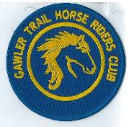
June 2019 Newsletter
Club Postal Address
P.O. Box 55
Gawler SA 5118
athra.com.au Email: Gawler.THRC@gmail.com
President - Julie Jackson 0419850793 Vice President -Tamara Godfrey 0417869695 Treasurer - Sandra East 0400884402 Secretary - Kath McCullagh 08 82807046
General Committee Maria Pearce & Lisa Rothe

GENERAL MEETING (1st Thursday of the month) 8pm Thursday 6 June 2019

All welcome Southern Hotel (next to Cafe Nova)
Come early for tea – 7pm

May Meeting
- Ride Calendar
- Trail Boss Accreditation (15 & 16 June Waikerie)
- Insurance Query

Members for 2019 Welcome
Welcome to New Members:
- Rob Scott
& hope you enjoy may days of riding (& socialising) with the club

Coming Events

June Ride: MT CRAWFORD - 9TH June (Note date changed from June 16)

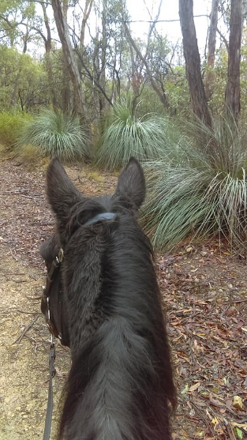
*** NOTE This is a members only ride ***

Host & Trail Boss is Sandra Sampson
Arrive 9am 9th June for departure at 10am (Please gather for 9.50am Ride Briefing without your horse)
RSVP by 5th June 2019 to: gawler.thrc@gmail.com
The Ride : (time is approx. 2 to 3 hours).
There are a few steep areas but nothing serious. I'd happily take a weekend hack on this ride with no extra work. Pace will be mostly walking with a trot here and there if riders wish.

Hazards : possible kangaroos, emus, walkers, minor motor traffic in certain areas of the national park.

Directions : Further information & directions will be supplied to those who RSVP nearer the ride date.

Cost : ATHRA member $2 Ride fee. Please bring the correct change & place in tin at sign on book

June Ride – MT BELVIDERE CAMP – Sat & Sun 29th & 30th June 2019

Host and Trail Boss is Richard Grimson
Arrive 10am Saturday 29th June / Depart Sunday 30th afternoon
RSVP by 26th June to: gawler.thrc@gmail.com

Ride Description: 2 days with approx. 2-3 hours riding each day. Hilly and flat terrain.
You need to be fully self-contained – ie bring your own everything. Water (for you & your horse), feed, yards, electric fencing etc.
Warm clothing & wet weather gear for riding and sitting around the camp fire.
Long drop loo on site only.
Arrive from 10.00am onwards and set up your camp. Have lunch. Ride out during the afternoon.

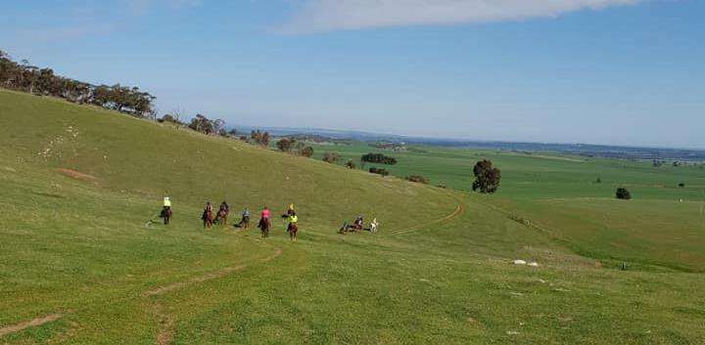
Ride Grade: Mainly walking. Some steep, rocky sections with other areas sandy. Seasoned bare foot horses should be ok.

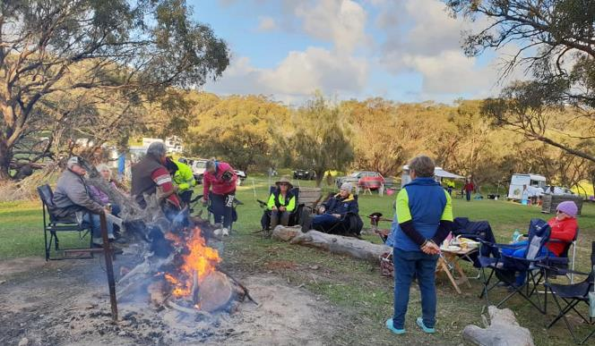
Hazards – Wildlife.

Directions: Further information & directions will be supplied to those who RSVP nearer the ride date.

Cost:- ATHRA member $2 Ride fee. Only limited Non ATHRA member riding visitors: fee $25/day (please be advised that if you are not a member of ATHRA you will need to be sponsored by an ATHRA member to ride & pre-register as a day member 3 days prior with ATHRA online - $15 direct to ATHRA & $10 to club on the day). Please bring the correct change & place in tin at sign on book

July – ROSEDALE TO SEPPELTSFIELD – Sat 20th July 2019

Hosts: Lisa Crinion & Maria Pearce; Trail Boss - TBC
Arrive 9am Saturday 20th July – ride out 10am
RSVP by 17th July to: gawler.thrc@gmail.com

Ride Description
Ride is approximately 17 kms long travelling along a bit of bitumen – riding on through vineyards, dry weather only roads and a small part of white metal roadway to wind our way over towards Seppeltsfield – the ride journey should be pleasantly quiet as there are only back roads/tracks basically used. There is one bitumen main road crossing on this ride. A Winery stop off with a wine tasting and cheeses at a cost of $9 per person is available. Other nibbles can be purchased at this winery but the stop will not be for any great length.
As the ride will take approx. 3.5 hours, you may like to bring your own nibbles for the journey in your saddlebag.
A further hour and a half riding will find you at the destination where we can relax and have some hot food and tea/ coffee.
As it will be necessary to take a couple of cars back to collect your floats it is necessary to have halters/tie up string on you at all times (for the Winery stop and for the destination arrival). Also you need to bring a hay net & horse rug that can be placed in the backup vehicle to take to the destination point ready for your horse. Horses will be hitched safely on individual posts within a very large working arena fully fenced whilst you are ferried back to get your float. The waiting horses will be supervised at all times whilst you are absent. (This should only take about 45 mins.)

Directions: Further information & directions will be supplied to those who RSVP nearer the ride date.

Cost:- ATHRA member $2 Ride fee. Only limited Non ATHRA member riding visitors: fee $25/day (please be advised that if you are not a member of ATHRA you will need to be sponsored by an ATHRA member to ride & pre-register as a day member 3 days prior with ATHRA online - $15 direct to ATHRA & $10 to club on the day). Please bring the correct change & place in tin at sign on book

RIDE CALENDAR FOR 2019

Rides are usually held on the 3rd weekend (Sunday calculated) & 5th Sunday of the month (if there is one).
Camps held ~1st or 5th weekend of the month (negotiable) Meeting dates are held on the 1st Thursday of the month

The following is a work in progress – dates, location & hosts to be continually confirmed
Please nominate a date if you have nominated to host rides

Ride Date | Location | Host | Club Meeting Dates for 2019
June 9 | Mt Crawford | Sandra Sampson | 6 June
June 29 & 30 | Belvidere Camp | Richard Grimson
July 20 | Rosedale to Seppeltsfield | Lisa Crinion/M Pearce | 4 July
Aug 18 | Truro Gorge | Julie Jackson | 1 Aug
Sept 14/15 | Leasingham | Sandy Jones | 5 Sept
Sept 27-30 | Camp – Southern Flinders? | Kath McCullagh
Oct 19 & 20 | Owen Camp & obstacle day | Julie Jackson | 3 Oct
Nov | Forest Ride/Camp – Kuitpo (not 16-17/11) | Lainie Ray | 7 Nov
Dec 7 (Sat) | Christmas Dinner (TBC) |  | 5 December
Dec 14/15 | Christmas ride (TBC)

Past Events

April Ride – Chateau Yaldara Winery Ride – Sunday 27th April 2019 – (Lisa Bates’s ride)

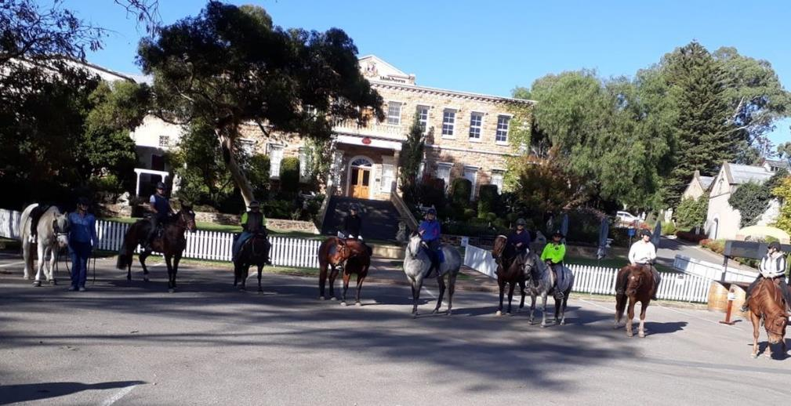

Chateau Yaldara Winery Post Ride Report (1) report by Gail Bates (Mum of Lisa)
There was movement at the Chateau, for the word had passed around,
A ride had been planned for members, as new tracks and roads had been found,
Nine took up the challenge, the weather was ever so fine
The ride was steady and fun, with the promise of pizza and wine,
Maria was one of the riders, and fast she was on her horse,
In a haste to get back to the Chateau, it was her birthday that day of course,
Many thanks to Lisa C and Maria P, who found the roads to trek,
A great day was had by all, as no-one hit the deck!!

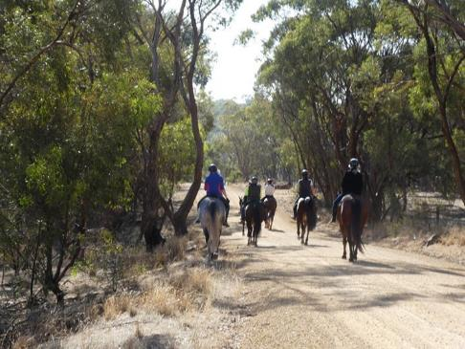 | 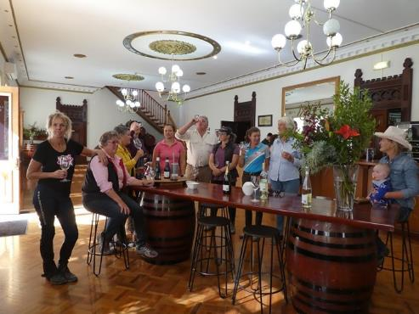

Chateau Yaldara Winery Post Ride Report (2) Report by Di Schaefer
The weather forecast was for a very pleasant day for the Trail Ride from the Helipad at Chateau Yaldara at Lyndoch, hosted by Lisa Bates and lead by Tamara.
Unfortunately, even though I live relatively close to Lyndoch, I was not able to attend the actual Trail Ride (?) however, Sandra East and I did discuss going along to join the riders upon their return.
One of the joys of being a ‘new’ grandmother, Sandra had been allocated baby-sitting duties, but she decided to come along and bring baby Pheonix with her.
My aim was to photograph the riders returning to their floats, but alas, not only did I miss the (early) start of the Trail Ride, but somehow I missed the riders’ return as well…..!!!!
The riders were grooming and watering their horses when we arrived. The car and float parking area was most suitable, and fortunately no helicopters were scheduled to land on the helipad that day, just as well, as there wouldn’t have been much room.
Upon ride return Lisa Bates ushered us all over to luxurious bean-bags under big shady umbrellas on the beautifully manicured lawns in front of the Chateau. As we made ourselves comfortable, Lisa took orders for gourmet pizzas which were made on site. She then invited us all into the Chateau wine tasting room to enjoy a wonderful (and generous) wine tasting, and gave a professional address of the wine descriptions and food combinations, and a concise history of the Chateau up until the present owners.
We all had an opportunity a join together and sing a very boisterous Happy Birthday and toast to Maria’s good health and to wish her many future horse riding exploits.

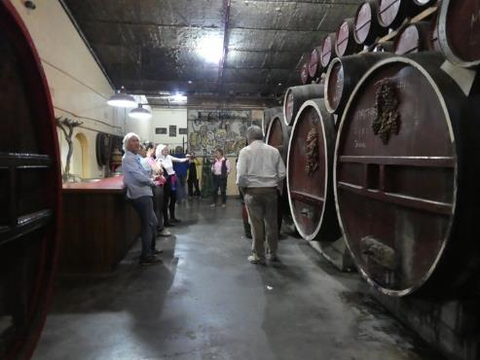 | 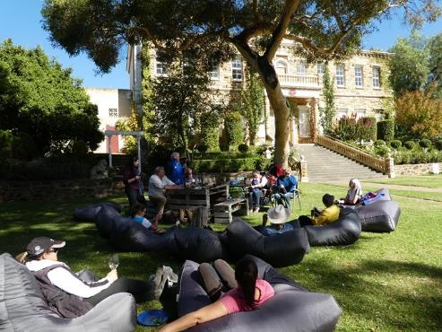

Lisa led us into down into the cellars under the Chateau and gave us some very informative information about Herrmann Thumm, an iconic Barossa Valley pioneer and the original builder and owner of Chateau Yaldara. We were privileged to be shown some beautifully carved huge wooden wine barrels and Lisa gave us the history of the Bavarian carvings.
We all returned to the wine tasting area, made purchases and then ventured back out onto the lawn, where Lisa arranged a delicious cheese platter, followed soon after by the various pizzas, all expertly delivered to our picnic tables.
This was an absolutely superb afternoon. The day was sunny, but mild, the lawns and garden of the Chateau were glorious. The wine tasting experience was above excellent. The pizzas were scrumptious.
Hey, did someone say “horses”? And yes, they were all very well behaved and still calmly tied up to the floats….and no sign of a helicopter wanting to land….!!!!
A huge Thank You to Lisa, for organizing such a fantastic Rally Day. Although I didn’t join the actual ride, I, and quite a few other friends and partners of the riders, had a wonderful, relaxed, lovely afternoon together in picturesque Lyndoch.

Appreciation also to the Chateau for the catering and allowing us the use of their facilities.
The Bar has been raised to new dizzy heights!!!!!!! Well Done Lisa!!!!!

May Ride – Kapunda – Sunday 19th May 2019 - by Sandy Jones

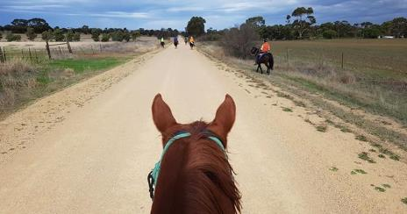
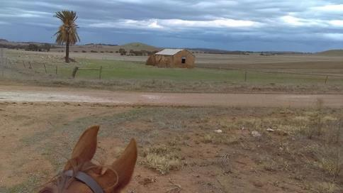
Although the weather forecast was for strong winds, overcast conditions, thunder and lightning, it wasn’t too bad when I got to the trotting track. All fears of not being able to get a park were unwarranted as the Pony Club used the inside of the trotting track.
Just after 10am, the 9 brave souls who turned up despite the weather left for this ride. Fortunately we didn’t have to contend with any trucks but a combine harvester did give us something to think about as it headed towards us on Moyle Road. Luckily he turned off before us and we followed on for a long way behind it.
On reaching the dry creek, Spook had his cart unhooked and was led across by Julie while Teena dragged the cart across. Thankfully there was enough room for the cart. Everyone else managed to cross without any problems.
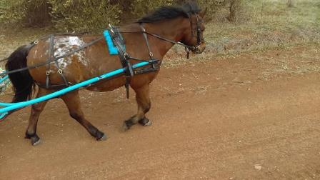
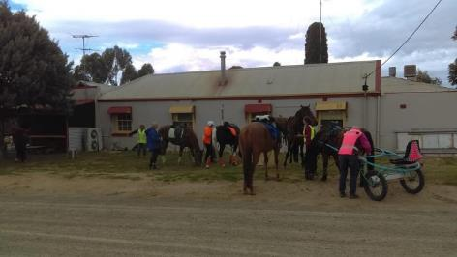
Past the pub, across the Marrabel Road, past a few cows which made a few horses look at, and continuing on to a big loop back to the pub for a well-earned drink. The publican Mark very kindly offered us a stool from inside to use as a mounting block which was much appreciated by all.
After our stop at the hotel for drinks, a repeat performance crossing the creek bed again with no hassles and on homewards we headed. Unfortunately the weather didn’t hold and the first drops of rain were felt. With only about five minutes to home it really started to rain and there was a mad dash to get everything away before we were all soaked.

My shortish ride turned into a bit longer ride but the weather was great for most of the day. I do apologise for not suggesting a lunch be take along though on this ride.

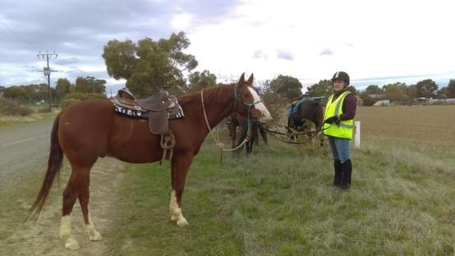
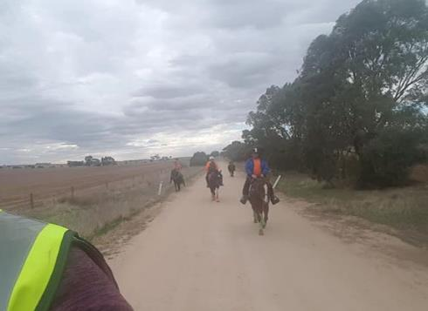

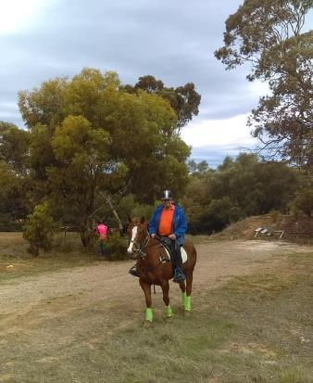 | 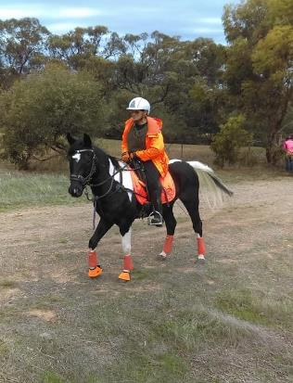

NEWSLETTER DEADLINE
The deadline for any items that members want printed in the July 2019 newsletter will be Tuesday 25 June so please ensure that your emails reach Maria Pearce marchris4@yahoo.com.au before that date to avoid disappointment.

Policies
A reminder to all members that our club has some policies that we endorse. These include a NON SMOKING, SAFETY & HOT WEATHER policy. These can all be viewed on the ATHRA web site, via the state page - www.athra.com.au.
Previous Newsletters, photos & club information can also be viewed at any time on the ATHRA web site.
WEATHER
The ride host/leader for the day will have the final say regarding weather (including inclement weather).
The hot weather policy states, if the weather forecast in ELIZABETH for the next day is to be over 32 deg (as per the news the night before) the club rally/ride will be cancelled (unless the ride is scheduled to commence prior to 9am or after 6pm). This is for the safety of all riders and horses. Also, any club rides in FOREST areas on TOTAL FIRE BAN days will be cancelled.
Please check with the Trail Boss if in any doubt. They have the final word!
CLUB UNIFORM
Our club uniform currently comprises of a lime yellow high-vis shirt (long or short sleeve), club badges available for $12. Gawler Club Members & their visitors are required to wear Safety Helmets whilst mounted - helmet must be no more than five years old from Date of Manufacture.
RIDE FEE & DAY MEMBERS
ATHRA members - a ride fee of $2 per ride is applicable.
Non ATHRA Members (Day Members) – a ride fee of $25/person/day is applicable ($10 to club on the day & $15 to ATHRA with pre-registration) (Non-refundable fee, maximum 2 days as a day member).
The important things to note: 1. Day Members must be sponsored and accompanied at all times by an ATHRA member during the ride or event.
2. The Sponsoring member must make the Day Member aware of ATHRA rules and requirements of the Code of Conduct.
3. They may only sponsor 1 Day Member per ride.
4. By participating as a sponsor, the sponsoring member acknowledges responsibility for the conduct and behaviour of the Day Member
5. Day Members must contact the trail boss to discuss attendance & then pre-register with ATHRA Online at least 3 days prior to ride.
RIDE HOST CHECKLIST
A ride host’s checklist is in the green bag, in which is kept the sign in book, ride fee tin, saddle bags, first aid kits, safety vests, etc. Trail Bosses are to check the list to make sure all is in order prior to your ride. It is also the Hosts responsibility to ensure a ride report is arranged to be submitted to Newsletter Editor prior to next publication date.

DISCLAIMER
The material in this newsletter is for the benefit and information of our members. The items are in the nature of general comments only and are not to be used, relied or acted upon without written permission of GTHRC. The club accepts no responsibility for any errors or omissions or for any damage suffered as a result of any person acting without written advice. All opinions and views in the newsletter are not necessarily the view of the club, but are personal opinions only.

Will it Ever Rain Again?

Feeding Horses in Times of Drought

Kentucky Equine Research: Melbourne 03 8562 7000, Nutrition Advice 1800 772 198 Email: advice@ker.com
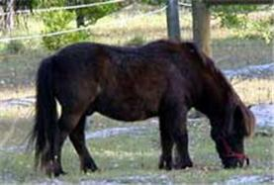
Your once green pasture is starting to resemble an arid desert savannah. Feed and grain prices are climbing and the price of chaff and hay (if you can buy it at all) is going through the roof! Your horses need feeding but with what? If you can’t get hay and you have no pasture, what on earth are you supposed to do?
This is the yearly dilemma of the Australian horse owner. Drought, in its varying degrees of severity, is something we just have to learn to live with. As with most things, it helps to be prepared, but if like many you wonder through life with the 'She’ll be right, mate' attitude, then a freak severe drought could catch you out, and what then?
The most noticeable effect of drought hits you in the wallet. If you’ve been a good boy scout, and are lucky enough to have plenty of storage space then you might have it a bit easier, but for the most part, the economic squeeze of a severe drought will affect even the most diligent of horse owners.
This article will explore the priorities that need to be addressed when feeding horses in moderate drought conditions and will explore the options available to help you out of a dry spot, with your horses and your wallet, not to mention your sanity, intact!

Forage
One of the biggest problems in drought is a lack of forage. If you have been well prepared, you may have a good store of hay to help you through, but in extended periods of drought, there will likely be a time when you run out. Furthermore, Murphy’s Law dictates that this particular time will be precisely the time that hay prices are peaking and availability is next to non-existent. For many, a good relationship with a farmer or produce store can help tremendously at these times, but failing that there are a couple of ways that hay can be rationed out to go a little further whilst maintaining healthy gut function.
Horses need at least 1% of their body weight as dry forage each day. That’s 5kg for a 500kg horse. This is non-negotiable, and falling below this amount has its associated dangers in the form of colic, laminitis, gastric ulcers and loss of condition. Traditionally the forage allowance is made up of hay, pasture and chaff. It is very important to provide sufficient bulk and enough fibre to keep the digestive system moving along. During times of drought, the nutritive value of the roughage is less important than the physical bulk of it, as poor quality, low energy roughage can be supplemented with hard feed to fill the gaps.
It may be more economical to buy large square or round bales of hay rather than the small bales and to bulk buy where possible to ensure a good supply as well as getting the best possible price. But where hay is extremely difficult to source, you may need to look to alternatives to supply a good chunk of the fibre and roughage in the diet. Care must be taken not to feed mouldy or uncured hay, but other than that, even a substandard long stem grass hay will do where nothing else is available.
Even unconventional forages such as sorghum stubble, pea straw and good quality silage can be used where it is available. Silage can be a very good and nutritious feed for horses, it is high in energy, so can be fed in small amounts diluted with other hay or forage types. Be careful to buy only what can be used in a few days, to prevent mould, and introduce horses to it slowly to allow the digestive system to adapt. There is a risk of botulism with silage that has not been made with horses in mind so care needs to be taken to ensure that the bale has not been pierced and has been cured correctly.
Be very careful when using unusual types of forage and be aware of those areas of the diet that will need to be balanced by feeding them. If you require assistance or advice on using a type of forage you are unfamiliar with, make efforts to contact a horse nutritionist for some professional advice and assistance. This service is available free of charge, year round from Kentucky Equine Research on 1800 772 198.
In terms of bucket feed, there are a couple of high fibre ingredients that can be added to increase the bulk of the diet and supplement limited hay intakes:
Grain and seed hulls: the polished hulls of oats, lupins, soybeans and sunflowers can become available during times of drought and some can be used to increase the roughage content of the diet. Whilst many of these by products have little digestible fibre or dietary energy, they do add bulk and can replace some of the chaff that would usually be used to bulk out the hard feed ration. Hulls can be dusty, so must be dampened prior to feeding and may need the addition of a little molasses to increase palatability and intake. They should be mixed well with the grain and chaff mix. Oat hulls should be avoided since they are sharp and can pierce the horses’ gums and cause mouth ulcers and infection. Rice hulls should also be avoided as they can cause impaction colic in horses.
Bran and pollard: A traditional feed for horses, bran and pollard has a couple of problems to do with the high phosphorus and low calcium levels. Bran has very little digestible energy, has less fibre than oats on a volume basis and is only really useful to add volume to a ration. Pollard has a little more energy but has even lower fibre levels than bran and needs careful balancing for calcium. If bran and pollard are to be used as a bulker, then a calcium supplement such as di-calcium phosphate should be added to balance calcium levels and they should not be used for extensive periods of time.
Equibix is a preferable, safer product designed to replace bran and/or pollard in a horse’s diet since it is higher in fibre, is more digestible, is balanced for calcium and phosphorus and is lower in starch. Equibix contains a number of high fibre ingredients and has been cooked to increase fibre digestibility and thus increase the energy value of the feed. Equibix is a useful addition to diets if chaff is limited and you want to reduce the necessity of grains.
Commercial fibre mixes: These are available in the form of sweet-feeds with a high proportion of added chaff e.g. Barastoc Completo or Winner. The sweet-feeds have a vitamin and mineral premix added to help fill the gaps left by straight hay and grains, and the advantage is that whilst local supplies of chaff may dwindle, larger manufacturers such as Ridley AgriProducts will usually have the buying power to maintain supplies of chaff, making these feeds a good alternative where supplies of chaff and hay are poor.
These types of commercial feeds can be used to partly replace some of the hay or chaff that would normally be fed. Check the fibre content on the bag tag, and chose a feed with a fibre content of around 10-15% or more if the sole aim is to increase fibre and bulk. Be careful to adhere to the manufacturers recommended feeding rates, and if you have any questions about maximum feeding rates for your type of horse, contact the manufacturer for guidance.
Bread: During drought some people get the idea to use the old bread discarded by bakeries as a cheap way of feeding their horses. Whilst bread may provide extra dietary energy, it should only be used in moderation and with a good knowledge of the dangers associated with feeding it. Bread is high in carbohydrates, and very low in fibre. It should only be fed in small amounts as a part of each meal. Feeding too much bread may lead to behavioural and clinical problems more commonly associated with high grain diets. If bread makes up a large part of the diet, the risk of laminitis and colic is increased. Bread also contains a large amount of gluten, which when wet forms a sticky ball that can cause choke, colic and possibly impactions. For this reason, it is better to feed bread stale rather than fresh, and mix well with other fibre sources before feeding.
Cardboard: Believe it or not, some people resort to feeding their horses torn up cardboard during drought. The fibres in cardboard are totally indigestible to horses, and can swell in the stomach. Cardboard is very difficult to chew effectively, meaning that large portions may be swallowed whole risking choke and impactions. There is absolutely no nutritive value in cardboard for horses, and with all the dangers, it is best to avoid as a food source.

Energy
To keep horses healthy and in good condition you will need to provide sufficient dietary energy. Because this energy is not available from pasture and may be limited from available forages, most horses in drought conditions will need supplementary feeding in order to maintain condition. After forage, most horse owners look to grains to provide energy. The dangers of too much starch (i.e. too much grain) will be discussed shortly, but suffice to say that when hard feed is provided, it is best to try and minimise grain, and use energy sources that are considered to be ‘safer’ such as fats and digestible fibres.
Whether you decide to make up your own grain mix, or buy a commercial pre-mixed feed, care must be taken to introduce new feeds slowly and in sensible amounts.
Commercial feeds can be an economical and hassle free way of providing a balanced diet safely through periods of drought. Prices may increase slightly through dry periods, but not by the same margin as forages. Whichever feed you decide on, use one with energy levels designed for horses in the level and type of work that your horse is doing. If you have a spelling horse, then a feed designed for racehorses or broodmares probably won’t be suitable and vice versa. For spelling horses, one of the high chaff feeds may be suitable, fed at a level that provides sufficient energy and bulk to make up for hay and pasture deficiencies. If in doubt as to how much is safe to feed, contact the manufacturer or an equine nutritionist for advice specific to your horse and situation.
Fat supplements such as oil and rice bran (Equi-Jewel) can be very useful for drought feeding. The energy in fat is considered a ‘cool’ and ‘safe’ energy as it does not make horses go silly, and can replace some of the grain. The energy is also three times more concentrated than from carbohydrate sources such as oats, so a little goes a long way. Just 1-2 cups of oil, or 500g-1kg of Equi-Jewel added to the hard feed ration will make a significant impact on those horses that are losing weight due to drought conditions. One great thing about fat is that, usually during drought, whilst grain prices begin to soar, the price of fats and oils remain fairly stable, making them a viable part of a cost effective diet.
Low starch grains such as lupins can be a valuable source of fibre and protein and can help to minimise the carbohydrate content of the diet. Up to 1.5kg per day of lupins is suitable for a 500kg horse, but use only as required. Whole or cracked lupins should be soaked overnight prior to being fed since they absorb moisture and expand considerably.
Grains provide quick release energy, and are an important part of the diet for horses at work, or those that are losing condition due to poor forage. The safest grain to feed is oats, as they have a relatively high fibre content, are easily digested and are very palatable. Barley and corn can also be used in a grain blend to assist weight maintenance but these grains should be heat processed to increase digestibility and feeding efficiency. Unusual grains such as wheat and triticale are often fed to horses during times of drought. They increase the digestible energy density of the feed and increase the weight of the dipper when used in a blend with other grains.
Wheat is a very high energy grain, with a low fibre content and should be processed prior to feeding. Wheat should be fed in moderation due to the high gluten content which may cause the formation of a glutinous mass in the mouth or stomach, and the high starch/ low fibre content which may increase the risks of hind gut overflow and ensuing laminitis and/or colic. Most horses seem to do alright on triticale, as long as it is fed sensibly as a part of the total diet. Both of these grains should be introduced slowly to the ration over 7-10 days.
Molasses and honey: These simple sugars do provide energy to the horse, but should be fed with great care. Overwhelming the system with sugar will have the same effect as overloading with grain or rich pasture, in that the hind gut will become compromised with ensuing in colic, laminitis and scouring a likely result. These sugars contain no fibre and so act as a quick energy rush which can cause a large spike in blood sugar which may be undesirable for behaviour. Molasses or honey should be mixed with a feed containing sufficient bulk and fibre if it is to be used as an energy supplement. It will increase palatability of feeds which may be very useful in drought where unconventional feeds are being used, but can ferment in particularly hot weather so needs to be stored correctly.
Vitamin and mineral supplements will likely be required as dry hay and grains are deficient in these important physiological substrates. A broad spectrum multi vitamin product that contains macro and trace minerals such as EQUIVIT Nutrequin will work well to fill in the gaps of a drought feeding program for horses that are spelling or in light to moderate work. Horses in heavy training will require a little more support and a supplement such as EQUIVIT Perform should be used if a straight grain diet is being fed.
A supplement such as EQUIVIT All-Phase provides good quality protein, in addition to vitamins and minerals as well as yeast culture. Yeast culture has been associated with improved fibre digestion and may help horses on tough stemmy forages and limited dry pick to get the most out of the forage that they have.

Protein Supplements
Most classes of horse except the adult spelling horse may require a protein supplement during times of drought where poor quality, low protein forage is used. The most important of these are pregnant and lactating mares, young growing horses and old horses. Good quality protein is vital for healthy development and growth of the foetus and young horse. Requirements for the essential amino acid lysine must be met to avoid developmental abnormalities. Signs of a protein deficiency include loss of muscle mass and tone and a ‘pot’ belly, especially in young horses. Generally, if lucerne hay and good quality pasture is fed, these requirements will be met, but in times of drought, where this is not possible there are a number of supplements that may be used to meet these requirements:
Soy & full fat soy: Full fat soy contains around 38% protein, where soy beans contain around 40-48% protein. Soy is possibly the best source of vegetable protein, containing almost all of the essential amino acids including lysine at appreciable levels. Extruded full fat soybean meal is a popular supplement for young growing horses the world over providing cool energy in the form of fat as well as plenty of good quality protein. Feeding rates of up to 600g per day may be required in drought periods.
Canola meal: Contains around 35% protein, with a good amount of lysine and can be used to replace soybean meal as a protein and fat supplement. The protein is less concentrated in canola meal than in soy, so a greater volume must be fed to provide sufficient protein and lysine. A regular amount may be around 3-400g, but up to 600g may be required in a drought management program.
Lupins, beans and peas: Lupins contain 28-34% crude protein with a moderate lysine content. Beans and peas have similar protein levels and some have a similar lysine content, but are often less palatable than lupins. Lupins can be fed at up to 2kg per day, and more where other protein sources are limited. Beans and peas are useful additions to a mix but may be ‘sorted’ out by picky eaters. Be careful with the types of peas used as some are toxic to horses. Beans, peas and lupins must be cracked before feeding to allow maximum digestion.
Sunflower seeds: These are very popular as a feed ingredient in Australia and contain around 20% protein, but the protein is relatively low in lysine. Sunflower seeds also contain some fat which adds a little energy to the diet. Usual feeding rates are around 200g, but in drought diets that are low in protein, up to 500g may be fed.
Cottonseed meal: Contains around 40% protein, but is low in lysine. Not recommended for young and breeding horses due to the low lysine content.
Linseed meal: Contains around 35% protein, but with a poor lysine content. Linseed is a relatively poor quality, but often expensive protein source.
Copra meal: Contains around 20% protein and some residual oil but has a very poor lysine content and the fat becomes rancid very quickly in hot and humid conditions thus reducing palatability. Copra should be soaked prior to feeding. Copra can be used to increase energy in the diet and is a fairly good source of fibre. Do not exceed 500 grams per day for a mature horse and do not feed to growing or breeding stock since the protein is of low quality and will not support adequate growth.

Common health risks associated with drought feeding
During drought, you may need to make frequent changes to your horse’s diet as different ingredients become unavailable, or a new source of an ingredient is found. Constantly changing the diet, using unusual ingredients that you are not familiar with and feeding more hard feed to make up for the lack of forage imposes some health risks on your horse. The major risks to be aware of are colic, gastric ulcers, laminitis and worms.
Colic: To minimise the risks of colic, try to provide as much roughage as you are able, and provide as much energy in the form of fibre and fat as possible, thus minimising the need for grains. Introduce all new feeds and ingredients including different hay and chaff types over a period of 7-10 days, gradually phasing out the old whilst slowly increasing the new ingredient. If you are having to feed a large amount of the required energy as hard feed, make sure you feed little and often. Feed no more than 2.5kg of hard feed (excluding chaff) in one meal. This may mean that you have to provide three or even four meals per day in order to reduce the risk of colic. Provide plenty of fresh water, whatever the cost. If you have run out of water from your dam, you will need to find an alternate source, or move your horses to an area with good water supply.
Gastric ulcers: These result from feeding a diet high in grains, and from the stress of work or travel. Again, to help prevent ulcers, try to minimise grains, and feed small meals with plenty of forage. Bulk out the meals with chaff or one of the chaff substitutes mentioned to slow down consumption and allow as much hay as you can ration.
Laminitis: Horses are at high risk of laminitis with drought feeding practices. Making all changes very slowly, feeding small meals and using digestible grains such as oats or heat processed grains will help to reduce the risks of starch overflow to the hindgut.
Worms: Dry conditions do not favour larval survival, so worms tend not to be quite so prolific in horse pastures during drought but if there is a lack of forage horses may start to eat droppings and graze rough areas of the paddock to satisfy their need for forage. Maintain a vigilant worming program during drought to help horses get the most out of their feed and remove droppings from the paddock or yard regularly.
Wood chewing: you may notice your horse eating tree bark, or your fences if you are not providing sufficient forage in the diet. The easiest way to prevent and remedy this problem is to make more forage available either with hay or chaff, or with some of the aforementioned alternatives.

Taking Stock
Heading into a drought, there are usually very few answers as to how long the drought will last, how severe it will become and how widespread the problem will be. It’s is fairly safe to assume that if you live in a place notorious for drought and dry periods (read: Australia!), that you will be having a drought of some description at some stage. Becoming familiar with your areas weather patterns and average rainfall calendar will help you to prepare for dry periods to some extent.
Throughout a drought, particularly the kind that has no foreseeable end it is wise to continually take stock of the situation and reassess the viability of keeping your horses healthy and well fed. If the financial outlay becomes more than you can bear, you may have to consider selling some of your stock in order to sustain the rest. It is unlawful to allow horses to starve and become malnourished, so if you find yourself in the position of being unable to feed your horses, then action must be taken promptly.
If you have competition horses or breeding horses, then you may decide to spell them or agist them on a property that has some pasture rather than compete or breed in order to reduce their feeding requirements and thus reduce associated costs.
In very severe droughts where horses cannot be fed or watered sufficiently, and the animals cannot be sold to a better position, the question of euthanasia may arise. Though this measure is drastic, if all other options have been exhausted, humane destruction can prevent unnecessary suffering of your animals and legal action against you.

Once the drought has broken
When the rain comes, everyone breathes a collective sigh of relief, but the problems do not end with the first patter of the life giving drops. Paddocks that have become dry and dusty will take a period of time to fully recover, and until then, the dangers of fresh new growth to your horse will also have to be carefully managed. The temptation is strong to put the horses straight into a paddock that has just become lush with new growth and feel the glow of satisfaction from watching them tuck into natures gift. But as with all dietary changes, the introduction to new pasture must be done slowly to avoid the risk of colic and laminitis. If possible, start by allowing just a couple of hours each day at the new pasture. Not only will this help the horses to get used to the change in diet, but it will allow the pasture to recover a little too.
For the first month or so, build up to a period of time during the day at pasture, but take the horses off, or rotate to a different paddock for the rest of the time so that fragile new pastures will not become depleted right away. If you have the facilities to selectively graze your pasture by using temporary fencing, then start this practice right away, and allow the worst portions of your pasture to fully recover before subjecting them to the stress of grazing.
Beware of the ‘green drought’ in which your pasture may appear to remain green, but there is no actual grass to be had. You will need to continue with supplementary forage until there is sufficient pasture for the horse to graze consistently before reducing the amount.
Whilst the benefits of the new pasture and hay crops are starting to be felt, you can gradually wean the horses off any extra hard feed you have had to provide to maintain weight during the drought and revert back to your old management systems. For those horses that have lost quite a bit of condition during the drought despite your best efforts, continue to feed them enough hard feed to recover their condition before cutting back.
By Kentucky Equine Research - Last updated 2 November 2015

