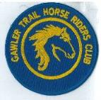
September 2020 Newsletter

athra.com.au Email: Gawler.THRC@gmail.com
President Julie Jackson 0419850793 Vice President Tamara Godfrey 0417869695
Treasurer Lisa Rothe 0478014828 Secretary Kath McCullagh 08 82807046
Publicity Officer/Newsletter Maria Pearce 0412195531

GENERAL MEETING 8pm Tuesday 8th September 2020

All members are welcome to join in - Southern Hotel - Gawler (next to Cafe Nova)
Come early for tea – 7pm

MEMBERS FOR 2020

The Club currently has 28 members and there have been a constant number of people enquiring to possibly join.

Welcome to New Members
Geraldine Dohnt from Monteith and Lorry Marchioro from Houghton.

We hope you both, and all members continue to enjoy many days of riding
(& socialising) with the club.

AUGUST MEETING

Meeting discussion included:
- Ride Calendar (ongoing)
- Trail Boss Renewal Accreditation completed for Sandy J, Sandra S, Sandra E & Richard G.
- Incident Report noted and filed.
2021 AGM
ANNUAL GENERAL MEETING
8PM Tuesday 13th OCTOBER 2020
Dining Room, Southern Hotel
We are seeking nominations (by nominee or other) for all executive positions for the Club.
We are also seeking nominations (by nominee or other) for ordinary committee members – those who would like to be more involved in the club.
- Nominations to be forwarded to the club Secretary at least 1 week prior to the AGM.
- If no quality nominations for positions come forward nominations are to be sought from the floor on the night of the AGM.
- In both cases if more than one nomination comes forward the members will vote on who is to be elected to the position.
- Each member personally present at any meeting shall have one vote (N.B. - Our constitution does not allow proxy voting).
Please contact any of the current executive committee if you are interested but unsure or email gawler.thrc@gmail.com. Hope to see you at the 2021 AGM – (even if you do not wish to be a current active committee member).

Kath McCullagh
Secretary – Gawler Trail Horse Riders Club

COMING EVENTS

August Camp : MT BELVIDERE - Saturday 29th Sunday 30th Aug 2020
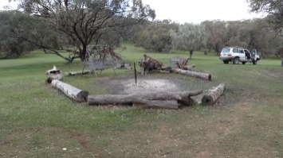
Host – Richard Grimson
Trail Boss – Richard Grimson
Saturday – Arrive after 10am for a 1pm ride out. (Pre ride meeting 12.45pm without horses)
RSVP by 26th August to: gawler.thrc@gmail.com (if you have any queries please email.)
This ride is open to Day Member Riders. (see below for costs and details)

Upon arrival (any time after 10am Saturday.) Pick a spot and set up your camp and have lunch. Saturday Ride out at 1:00pm for approximately 2 -3 hour ride. It can be rocky in places and then onto dirt and gravel roads.
Pre ride talk unmounted at 12:45pm.
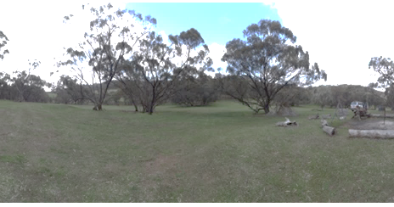
Sunday Ride out at 10:00am (pre ride meeting 9.45 no horse) – ride approximately 2 -3 hour ride.

Firewood is available, just need to collect and cut.
You will need to bring all food for yourself; water/feed for your horse.
No stock yards are available so you need to provide your own portable yards or electric fenced yard.
Drop toilet only on site.
We are permitted to ride anywhere on the property.
Depart mid-afternoon on Sunday.

September Ride - Auburn/Leasingham - Sunday 20th September 2020

Host – Sandy Jones
Trail Boss – TBA
Sunday – Arrive 9am for a 10am ride out. (Pre ride meeting 9.45pm without horses)
RSVP by 16th September to: gawler.thrc@gmail.com (if you have any queries please email.)
This ride is open to Day Member Riders. (see below for costs and details)

This ride has been planned within the Auburn region and is approximately 15k in length and travelling mostly along dirt roads - the last kilometre or two we will ride past some of the historic buildings of Auburn.
The ride will consist mostly walking with a bit of trotting and it is suitable for carts.
As a lunch break is not planned, consider taking along some nibbles or something in your saddlebag to eat in case you get hungry before we get back.
There is the option of going a bit further if the weather is with us and the majority of riders agree to extend the ride at the time.

NOTE Riders are encouraged to bring their lunch & camp chair so that we can sit back and socialise after the ride.

Cost- ATHRA member $2 Ride fee. Non ATHRA member riding visitor fee $25/day (please be advised that if you are not a member of ATHRA you will need to be sponsored by an ATHRA member to ride & pre-register as a day member 3 days prior with ATHRA online - $15 direct to ATHRA & $10 to club on the day).
Please bring the correct change & place in tin at sign on book

RIDE CALENDAR FOR 2020-
- If you are able to host a ride or think of one that you would like to go on (we will arrange for the particular ride to take place) please let the committee know so that we can include the ride.
- Camp weekend dates are negotiable

The following is a work in progress – dates, location & hosts to be continually confirmed

Ride Date  2020 | Location | Host | Club Meeting Dates for 2020
Aug 29-30 | Camp - Mt Belvidere | Richard Grimson
Sept 20 | Auburn / Leasingham | Sandy Jones | 8 Sept
Sept 26-28 | Camp – Southern Flinders TBC | Kath McCullagh
Oct 18 | Moppa | Michelle Day | 13 Oct
Oct 31-1 Nov | Camp (area TBC) | Maria Pearce
Nov 21 | Yaldara | Lisa Bates | 3 Nov
Dec 12 | Rosedale | Lisa Crinion | 1 Dec

NEWSLETTER DEADLINE

The deadline for any items that members want printed in the October 2020 newsletter will be Tuesday 22 September so please ensure that your emails reach Maria Pearce on gawler.thrc@gmail.com before that date to avoid disappointment.

HORSE HEALTH / CARE

Extract from evidencebasedworming.com.au
A Best Practice in Environmental Strongyle Worm Management
Seasonal Guide for Horse Managers
Relevant for healthy, adult horses from the age of 3 years
Gear up for SPRING
With an increase in temperature and good moisture, pasture grass will grow quickly. These are the best conditions for
Strongyles to begin laying eggs. So, about a month into Spring…
• Undertake a faecal egg count (FEC) for each horse and record these measurements for your future reference
O LOW (0 – 100 EPG) – No treatment necessary.
O MODERATE (> 100 <200 EPG) – No treatment, FEC monitor in 4-6 weeks or after warm, moist weather.
O MODERATE-HIGH (>200 <500 EPG) – treatment advisable, monitor with additional FEC at end of efficacy
period (according to manufacturer’s statement).
o HIGH (>500 EPG) – High-egg shedder. Treatment necessary. Continue to monitor these horses.
• Always treat HIGH egg-shedding horses with a targeted treatment (read the label) and monitor with FECs.
Become a Worm Weather Tragic:
• When the grass is growing, the worms will be laying eggs so, after warm, moist conditions (yes, these can even occur in
winter) be FEC-vigilant!
AND, MOST IMPORTANTLY: always integrate FECs with good pasture hygiene/horse husbandry strategies.

When does my horse need to see the dentist?
from Aquiculture – Responsible Horse Care
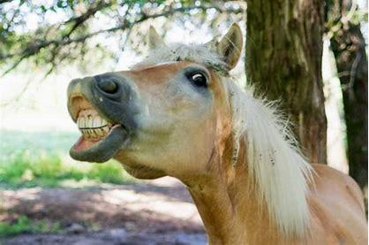
A vet or qualified equine dentist should be called in regularly to thoroughly examine and carry out any necessary work on your horse’s teeth. Horses aged 2-5 years should have their teeth checked prior to commencing work or at six monthly intervals. After the age of five years (when the horse has a full set of permanent teeth) all horses should have at least one annual dental check, more often if the horse is being fed significant amounts of concentrates as chew patterns and therefore tooth wear is different when eating concentrates. Remember that horses need a very highly fibrous diet for many reasons; correct tooth wear is only one of them.
The horse’s diet, mainly tough fibrous and often abrasive material, requires a lot of chewing and grinding. In normal situations the teeth of the horse are well equipped to cope with this diet. The top surface area of the teeth contains folds that help the horse to chew fibrous material. The teeth continuously erupt throughout the life of the horse in order to cope with what they evolved to eat. By five years old the horse has a full set of very large teeth. The roots of the molars (back) teeth are so large that they are often seen as bumps in the jaw line of the horse (usually the bottom jaw line and sometimes the upper jaw line with certain breeds). These bumps disappear as the teeth begin to wear inside the mouth and the teeth begin erupting on a continual basis.
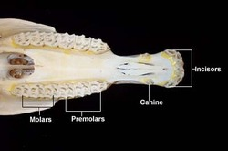
Well-cared for domestic horses generally live for a lot longer than free living (wild and feral) horses. This means that their teeth have to last them for a lot longer too.
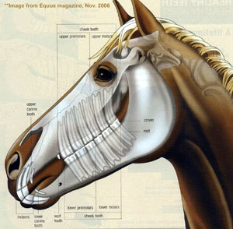
The teeth can develop sharp edges and uneven wear. If the horse’s ability to grind down food sufficiently is compromised for any reason, the enzymes and microbes of the gastrointestinal tract have a hard time continuing the digestive process and one of the results is a drop in condition. Often it is poor condition of the teeth that leads to starvation and premature death in free living horses.
Teeth problems can also cause behavioural problems as the horse attempts to alleviate any pain. Horses need regular dental care if they are to get the maximum benefit from their feed and perform well.

Potential problems include:
- Sharp cheek teeth (molars). This occurs to some extent in all horses but its occurrence is accelerated when horses have a high grain diet because the horse chews grain differently to grasses and hay. This causes the teeth to wear shaper edges.
- Imperfect meeting of the teeth such as parrot mouth – overbite – (where the top row of incisors are further forward than the bottom row) and sow mouth – under bite – (where the bottom row of incisors are further forward than the top row) causes problems with grazing (as the horse cannot ‘clip’ the grass properly) and the horse usually develops sharp ‘hooks’ on the last molars at the back of the mouth due to them also being out of alignment.
- Wolf teeth which are a much-reduced vestige of a tooth that was well developed in the ancestor of the horse. They sit in front of the first molar and because they usually have shallow roots they can be loose. A loose wolf tooth may cause a horse to head toss or be reluctant to respond to the bit.
- Teething problems, as with human babies, the eruption of teeth in young horses may cause transitory trouble. Also the horse may have ‘caps’ which are temporary (milk) teeth that have not fallen out but form a cap on top of a newer permanent tooth. These caps can create decay as food gets trapped under them.
- Decayed teeth, this can lead to the destruction of the tooth, which may lead to infection of the surrounding bone.

Some of the signs of dental problems include:
- Behavioural problems
- Weight loss
- Loss of coat shine
- Irregular chewing patterns
- Quidding (dropping partially chewed food out of the mouth)
- Unresponsiveness to the bit or head tossing
- Excessive salivation
- Bad breath
- Swelling of the face or jaw
- Lack of desire to eat hard food
- Reluctance to drink cold water.

However some horses show hardly any if no outward signs even though they are experiencing extreme discomfort, so don’t wait for signs before doing anything. Schedule regular visits from your vet or qualified equine dentist.
For more information please see: https://www.equiculture.net/responsiblehorsecare
Updated on May 2, 2019

POLICIES
A reminder to all members that our club has some policies that we endorse. These include a NON SMOKING, SAFETY & HOT WEATHER policy. These can all be viewed on the ATHRA web site, via the state page - www.athra.com.au.

Previous Newsletters, photos & club information can also be viewed at any time on the ATHRA web site.
WEATHER
The ride host/leader for the day will have the final say regarding weather (including inclement weather).
The hot weather policy states, if the weather forecast in ELIZABETH for the next day is to be over 32 deg (as per the news the night before) the club rally/ride will be cancelled (unless the ride is scheduled to commence prior to 9am or after 6pm). This is for the safety of all riders and horses. Also, any club rides in FOREST areas on TOTAL FIRE BAN days will be cancelled.
Please check with the Trail Boss if in any doubt. They have the final word!
CLUB UNIFORM
Our club uniform currently comprises of a lime yellow high-vis shirt (long or short sleeve), club badges available for $12. Gawler Club Members & their visitors are required to wear Safety Helmets whilst mounted - helmet must be no more than five years old from Date of Manufacture.

RIDE FEE & DAY MEMBERS
ATHRA members - a ride fee of $2 per ride is applicable.
Non ATHRA Members (Day Members) – a ride fee of $25/person/day is applicable ($10 to club on the day & $15 to ATHRA with pre-registration) (Non-refundable fee, maximum 2 days as a day member).
The important things to note:
1. Day Members must be sponsored and accompanied at all times by an ATHRA member during the ride or event.
2. The Sponsoring member must make the Day Member aware of ATHRA rules and requirements of the Code of Conduct.
3. They may only sponsor 1 Day Member per ride.
4. By participating as a sponsor, the sponsoring member acknowledges responsibility for the conduct and behaviour of the Day Member
5. Day Members must contact the trail boss to discuss attendance & then pre-register with ATHRA Online at least 3 days prior to ride.

RIDE HOST CHECKLIST
A ride host’s checklist is in the green bag, in which is kept the sign in book, ride fee tin, saddle bags, first aid kits, safety vests, etc. Trail Bosses are to check the list to make sure all is in order prior to your ride. It is also t
+he Hosts responsibility to ensure a ride report is arranged to be submitted to Newsletter Editor prior to next publication date.
DISCLAIMER
The material in this newsletter is for the benefit and information of our members. The items are in the nature of general comments only and are not to be used, relied or acted upon without written permission of GTHRC. The club accepts no responsibility for any errors or omissions or for any damage suffered as a result of any person acting without written advice. All opinions and views in the newsletter are not necessarily the view of the club, but are personal opinions only.

