August 2019 Newsletter
Club Postal Address
P.O. Box 55
Gawler SA 5118
athra.com.au Email: Gawler.THRC@gmail.com
President - Julie Jackson 0419850793 Vice President -Tamara Godfrey 0417869695 Treasurer - Sandra East 0400884402 Secretary - Kath McCullagh 08 82807046
General Committee Maria Pearce & Lisa Rothe

GENERAL MEETING (1st Thursday of the month) 8pm Thursday 1st August 2019

All welcome Southern Hotel (next to Cafe Nova)
Come early for tea – 7pm

July Meeting
- Ride Calendar.
- ATHRA accreditation training: 5 members to attend training Michelle Day & Maria Pearce for the first time & Julie Jackson, Tamara Godfrey and Kath McCullagh to go for a refresher. (15 & 16 June Waikerie).
- Club Can Coolers: to be available soon.
- .
- Opening our Reservoir Reserves: Club put in a submission to SA Water. Members are encouraged to also have a voice.

Members for 2019 Welcome
Penny Keen
& hope you enjoy many days of riding (& socialising) with the club

Coming Events
August Ride – TRURO GORGE Day ride/ Camp – Sat 17th & Sun 18th August 2019

Host Natalie Bennison
Trail Boss - TBA
Arrive 11am Saturday 17th Aug
Depart Sunday 18th afternoon
RSVP by 14th Aug to: gawler.thrc@gmail.com

Details for the Truro ride are as follows:
(Invitation has been extended to the Riverland Trail Club)
This is a ride for Gawler and Riverland Trail Horse Riders Club members only – NO DAY MEMBERS.

This ride can be a camp or just riding on either day. If any riders wish, they can arrive on Saturday after 11am to set up camp for yourself and horse and then go for a ride after lunch ~1pm. The main ride will be on Sunday departing at 9.30am. Trail Bosses will be designated on both days.

The ride/camp is situated on a private property and directions will be advised to riders who register and RSVP prior to the date. The ride will be a ‘tough ride’ – up and down the steep hillsides with mainly walking and a bit of trotting due to the terrain which has sand stone shale. We hope to make our way to a magnificent gorge with plenty of water. Seasoned barefoot horses should be fine.
Hazards would include wildlife and sheep.

There are six sheep yard pens that are available to us for use, but depending on numbers you may need to bring your own yarding equipment. We will advise after the RSVP date regarding the number of horses and yarding situation. You will be required to bring your own water/food for yourself and horse.
As it will most likely be very cold in these hills, be sure to bring warm clothing and wet weather gear if necessary.

The Riverland Trail Club has been invited to join our club ride for this weekend. All riders who wish to come on this ride need to RSVP to the gawler.thrc@gmail.com (Riverland club riders can you please RSVP as well, and state that you are from the Riverland).

Directions to this property will be emailed to you after the 14th August 2019.
Any enquiries to Julie Jackson on 0419 850 793

Directions: Further information & directions will be supplied to those who RSVP nearer the ride date.

Cost:- ATHRA member $2 Ride fee. Only limited Non ATHRA member riding visitors: fee $25/day (please be advised that if you are not a member of ATHRA you will need to be sponsored by an ATHRA member to ride & pre-register as a day member 3 days prior with ATHRA online - $15 direct to ATHRA & $10 to club on the day). Please bring the correct change & place in tin at sign on book.

RIDE CALENDAR FOR 2019

Rides are usually held on the 3rd weekend (Sunday calculated) & 5th Sunday of the month (if there is one).
Camps held ~1st or 5th weekend of the month (negotiable) Meeting dates are held on the 1st Thursday of the month

The following is a work in progress – dates, location & hosts to be continually confirmed
Please nominate a date if you have nominated to host rides

Ride Date | Location | Host | Club Meeting Dates for 2019
Aug 17/18 | Truro Gorge | Natalie Bennison/Julie Jackson | 1 Aug
Sept 14-15 | Leasingham (camp if wish) | Sandy Jones | 5 Sept
Sept 28-29 | Benson Park (TBC) | Julie Jackson
Oct 19 & 20 | Owen Camp & obstacle day | Julie Jackson | 3 Oct
Nov | Forest Ride/Camp – Kuitpo (not 16-17/11) | Lainie Ray | 7 Nov
Dec 7 (Sat) | Christmas Dinner (TBC) |  | 5 December
Dec 14/15 | Christmas ride (TBC)

Past Events
June Ride (was to be !!!) MT BELVIDERE CAMP - 29/30th June 2019- Summary from Richard Grimson

Camp time was approaching and weather forecast was not looking promising. As I had business in Gawler I took the opportunity to meet Darren, the property owner. We discussed his wet weather policy as to access to the campsite. He suggested we do not use normal 2 wheel drive vehicles but 4 wheel drives should be able to access the area. His thoughts were if we could get in he would be happy for us to use the area.

With this in mind the camp was still being held. My Landcruiser was in for repair and a new windscreen and was due for return on Friday, but unfortunately was not ready. It might be ready by Monday. I had already loaded the horse float and as I had a second Landcruiser and decided to use it. Unfortunately the tow hitch for the horse float did not fit so I will be unable to take my horse to the camp. Saturday morning listening to the weather report on ABC radio at 7:00am there was talk of 17mm rain on West Coast and 15mm in the Hills. My rain gauge recorded only 5mm of rain.

Well, the ride is still on so off in the light rain to Mt Belvidere. A couple of phone calls on the way delayed my progress but eventually reached Almond Corner Road where I put up the first direction sign, followed by two more signs, open the gate and into the property. That is where the fun began. Sliding along and off the access track, I eventually arrived at the campsite. If I was having so much trouble in a 4 Wheel Drive without a horse float on behind, those with one would have more trouble.

Decision to be made, also considering the horse might be slipping walking along the roads, “the camp is cancelled”. Also contacted the owner and he was disappointed we had to cancel. I contacted Tamara who then sent out the message to everyone. Thankyou Tamara for doing this important link in the communication chain.

Now to get out of the property. This was an even more slippery drive with only the ruts in the track preventing me from sliding into the adjacent creek. Eventually made it home and witness more heavy rain including 4 hailstorms.
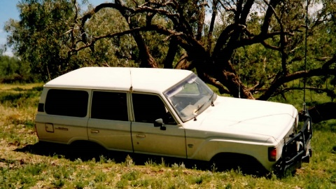
Sorry I had to call this as a cancelled ride but safety is important and we also need to consider the welfare of our favourite companions, our horses. Hopefully we can hold this camp again, but in more favourable weather conditions, or even as a day ride with a campfire BBQ after.

Thankyou Darren for allowing us to camp at Mt Belvidere.

It happened after all 😊 MT BELVIDERE – Sat 6th July 2019 Summary from Kath McCullagh
After several false starts we finally made it to ride at Mt Belvedere – yippee !!

Numbers were down & the camp over was abandoned due to the predicted bad weather (including hail) coming in later in the afternoon.

We still had 8 riders come for the day including, Sandra S, Maria, Natalie Pearce (day member), Margot & Rob,
Sandy J, Ruth & Kath.

The main ride set off in the sunshine to head out for pleasant ride around the district. Ruth & Kath stayed back to explore the property to see where they could take the returning riders. The property was steep and rocky and every hill was explored and a short ride mapped out by the “reci riders”.

They then set off to find the group out in the district to head them in the right direction. They were met by Natalie advising that Maria had retired from the ride with horse issues and the remaining riders had continued on around the locale to meet us back by the gate to the property. From what was told the ride had a nice trot and canter before the retirement of Maria, and a pleasant meander and chat before getting back to the gate.

As the wind had picked up and time was running out before the weather was to hit, riders opted to go back to the campfire for lunch and a drink before heading home. Richard and Chris had the fire burning nicely for us when we returned – thanks boys! A pleasant way to finish a ride 😊

P.S. Maria is on the mend & will be back out with us soon.

July Ride – ROSEDALE TO SEPPELTSFIELD – Sat 20th July 2019 Summary from Julie Jackson

Riders who attended this ride were Kathy, Tamara, Lisa C, Kylie, Sandy, Sandra S, Gayle and me
WOW what a ride, Maria, Lisa and Adrian (Lisa’s dad) planned this ride weeks ago and it was magnificent both terrain and riding wise.

We were lucky with the weather although it was a bit windy, but nothing we could not handle; we crossed through private roads and what a treat it was. We continued over gently sloping tracks winding through the back of Rosedale where we could trot a fair bit, canter and even get a buck or two in. A creek crossing was also involved but with no water over the culvert - just under.

Maria did not ride but waved us off on our journey from Adrian’s farm and met us at the Pindarie Winery, our first port of call. She was constantly on the phone to Lisa our lead rider saying speed up and we of course did Yippee!! I even had a canter on Flash. We were supposed to be at the winery at 10 and we left Adrian’s at 9 but then we got another call saying slow down as the bus which had booked for 10.30 was already there and they did not want extra people at the same time. We strolled the last few kms to the winery and were met by Maria, Natalie, Maria’s daughter, William and Club Member Mar whose car in the previous week was damaged by a flying roof in Robe in the S.E. and could not tow.

After a beautifully hosted wine tasting by Tammy and some nibbles and purchases we were on our way again. We decided to walk on foot 100 metres and cross the busy main road where William our traffic warden used our newly purchased slow / stop sign and the traffic obeyed him, well done cars! we walked across the road safely, remounted and we were off on our way again.

Sandra decided to not proceed for the rest of the ride after the winery and her float was brought to collect Ruby.
Again after some trotting and cantering we arrived at Chris and Maria’s at 2pm. We spent about 1 hour at the winery - we were told it was a long ride and it was but we all made it and had a ball. Upon arrival at our destination riders were ferried back to get their floats while a few lucky ones got to have a pre tasting of hot potato and leek soup and crusty bread made by Nat and Chris and suet bread made again by Chris, very tasty and filling. We did leave some for the others on their return.

A great after get together over wine, soup, suet bread, cake, coffee and slice was enjoyed by all.
Many thanks for contributing to this once again great club ride by Adrian, Chris, William, Maria, Lisa, Nat and last but not least the land owners. It was fantastic and look forward to doing it again next year????

***********************

Wanted
LOOKING TO BUY – from Sallyanne Burton

Hello everyone …..
I am presently looking to buy another horse.
I would ideally like to find a coloured horse (piebald, skewbald, palomino dun etc), age to be between 5 & 8 years old and 15 to 16hh. The horse has to have a good temperament and it needs to float well.
I am seeking a good trail riding horse and one that can do some show jumping as well.

I can pay up to $2000 for the right horse. If anyone knows of a horse available could you please contact me.
With thanks…..Sallyanne (phone on 04289 158 52).

***********************
Horse Humor
Barry ! 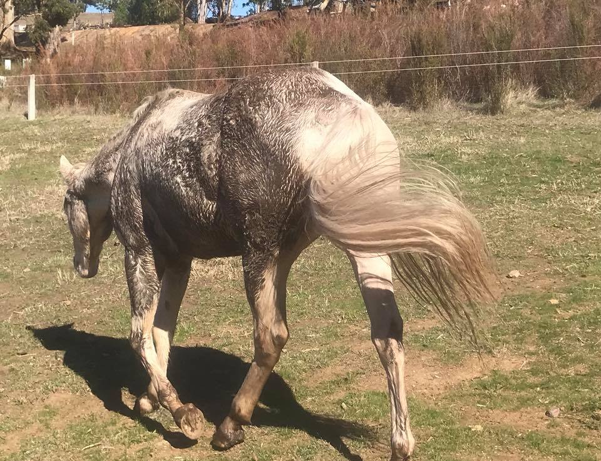

General
NEWSLETTER DEADLINE
The deadline for any items that members want printed in the September 2019 newsletter will be Tuesday 27 August so please ensure that your emails reach Maria Pearce gawler.THRC@gmail.com before that date to avoid disappointment.

Policies
A reminder to all members that our club has some policies that we endorse. These include a NON SMOKING, SAFETY & HOT WEATHER policy. These can all be viewed on the ATHRA web site, via the state page - www.athra.com.au.
Previous Newsletters, photos & club information can also be viewed at any time on the ATHRA web site.
WEATHER
The ride host/leader for the day will have the final say regarding weather (including inclement weather).
The hot weather policy states, if the weather forecast in ELIZABETH for the next day is to be over 32 deg (as per the news the night before) the club rally/ride will be cancelled (unless the ride is scheduled to commence prior to 9am or after 6pm). This is for the safety of all riders and horses. Also, any club rides in FOREST areas on TOTAL FIRE BAN days will be cancelled.
Please check with the Trail Boss if in any doubt. They have the final word!
CLUB UNIFORM
Our club uniform currently comprises of a lime yellow high-vis shirt (long or short sleeve), club badges available for $12. Gawler Club Members & their visitors are required to wear Safety Helmets whilst mounted - helmet must be no more than five years old from Date of Manufacture.
RIDE FEE & DAY MEMBERS
ATHRA members - a ride fee of $2 per ride is applicable.
Non ATHRA Members (Day Members) – a ride fee of $25/person/day is applicable ($10 to club on the day & $15 to ATHRA with pre-registration) (Non-refundable fee, maximum 2 days as a day member).
The important things to note: 1. Day Members must be sponsored and accompanied at all times by an ATHRA member during the ride or event.
2. The Sponsoring member must make the Day Member aware of ATHRA rules and requirements of the Code of Conduct.
3. They may only sponsor 1 Day Member per ride.
4. By participating as a sponsor, the sponsoring member acknowledges responsibility for the conduct and behaviour of the Day Member
5. Day Members must contact the trail boss to discuss attendance & then pre-register with ATHRA Online at least 3 days prior to ride.
RIDE HOST CHECKLIST
A ride host’s checklist is in the green bag, in which is kept the sign in book, ride fee tin, saddle bags, first aid kits, safety vests, etc. Trail Bosses are to check the list to make sure all is in order prior to your ride. It is also the Hosts responsibility to ensure a ride report is arranged to be submitted to Newsletter Editor prior to next publication date.

DISCLAIMER
The material in this newsletter is for the benefit and information of our members. The items are in the nature of general comments only and are not to be used, relied or acted upon without written permission of GTHRC. The club accepts no responsibility for any errors or omissions or for any damage suffered as a result of any person acting without written advice. All opinions and views in the newsletter are not necessarily the view of the club, but are personal opinions only.

