TAMWORTH BUSHRANGERS TRAIL RIDING CLUB
Newsletter – SEPTEMBER 2018
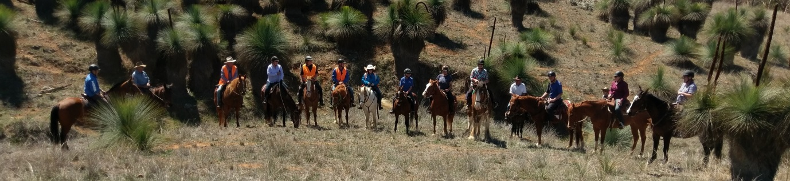
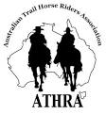 | President: Angela Witherdin  0418234854  awitherd@bigpond.net.au  Vice President: Bev Fletcher  Secretary: Francie MacLean  0407660334  Treasurer: Anthony Read  0409362434  Newsletter: barlowpark2@gmail.com
SEPTEMBER RIDE REPORT
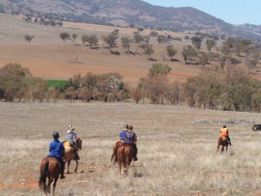
Duri – Dungowan Road, Timbumburi
Whoa! What a fantastic ride!. 16 fellow horse loving, life loving riders and one Black Betty loving chuck wagon Mike, gathered together on this glorious spring day last Sunday to shake off the winter cob webs and to feel alive.
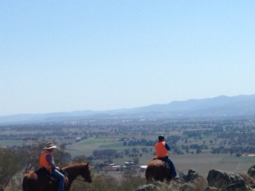
While meandering across the first paddock, jealous neighboring horses raced around, wishing they could join us. We then moved on to the climb where our group divided and conquered, some choosing to take the gentle slope while others took the breathtaking ascent to the plateau and were rewarded with a 360 view of Tamworth and it’s majestic surrounds. Of course, a photo shoot was too tempting, and as the chuck wagon also made the climb, Mike offered to do the deed.
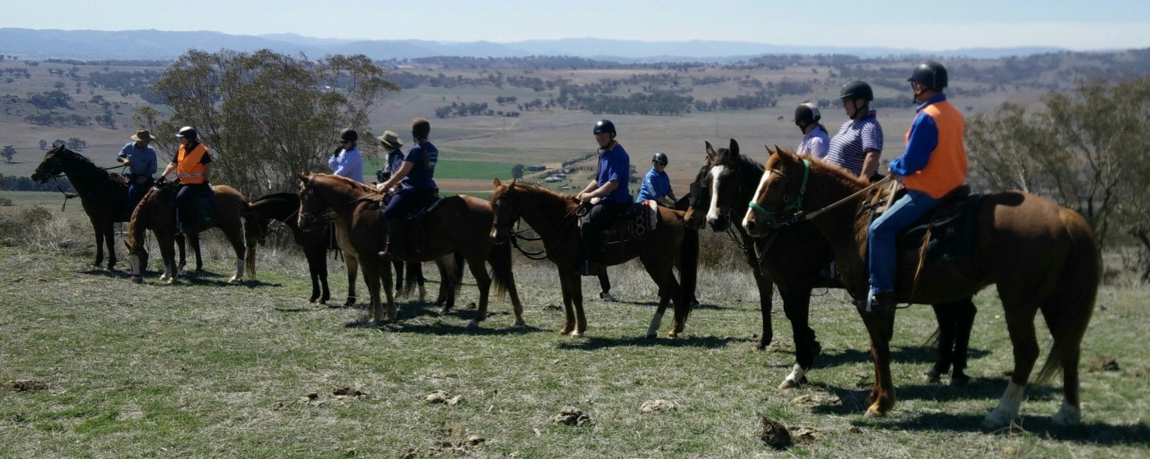
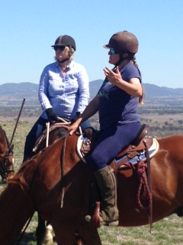
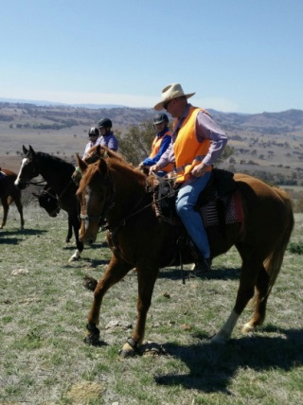
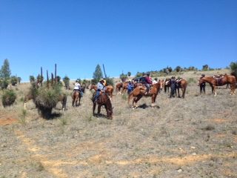
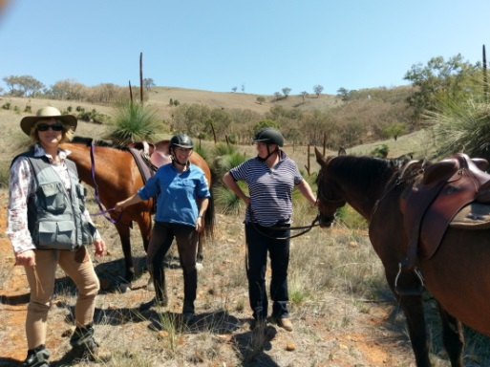
We then regrouped below at a water trough and continued on our way across paddocks, through gullies and down ridges until we came to our rest stop…. a magnificent stand of grass trees tucked in behind a ridge. Listening to the soft whisperings through their ancient fronds, one couldn’t help but be taken back in time to an era when all a man could need was within his sight. After more photos, much gossiping and one long five minute leg straddling mount, we were off again.
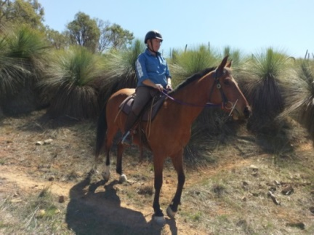 | 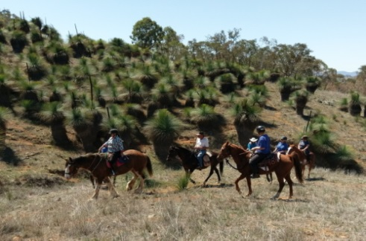 | 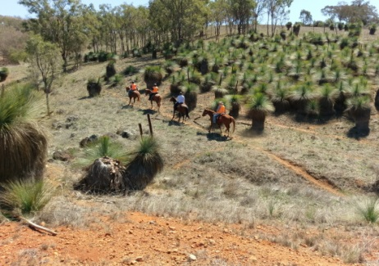
Although the day had warmed up, we were blessed by a glorious breeze every few strides and eventually, but not before our host Ken had a zapping experience with his gate, our refreshing spring ride came to an end and we were back at the yards. However, the comradery didn’t end there and after the horses were washed, fed and tethered, we enjoyed another breathtaking view of our surrounds while lunching and chatting on Lynda and Ken’s verandah.
We would like to thank Lynda, Ken and their neighbours for opening their homes and property to the club and allowing us the opportunity to once again get together and enjoy this beautiful country we are privileged to live in while bonding with our four legged besties.
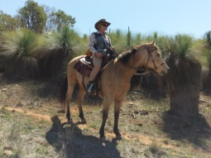Thanks to Donna for the Ride Report

Hear Ye! Hear Ye!
We are pleased to announce preparations for this year’s Bushranger Christmas party have begun.
News just in…we WILL be getting the old "The Bushrangers Have No Talent Choir and band” back together again.
So, in preparation of this momentous occasion would you please give some thought on what "talent" you can bring to the party on this our special night. Please, dig deep to locate school recorders, clarinets and trombones, brush up on your Keats, dust off those tap-dancing shoes.
Any queries please contact,
Helen Woods
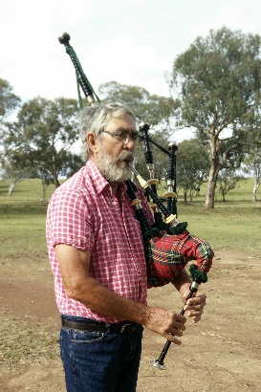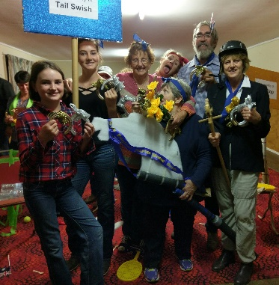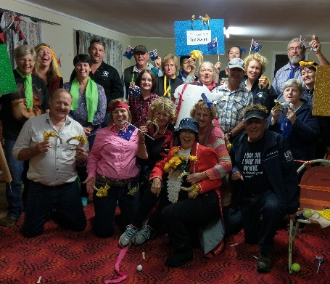

Date: 24th – 25th November 2018
[ride is on the Saturday, party Saturday night, camp or cabin]
Time: 0900 ride 6:30pm Xmas party
Venue: Nundle Pony Club Grounds
Similar plans to last couple of years – more details to follow closer to the date
## This month’s ride info to follow in next couple of days

