MT OVENS ANZAC BIKKIE BAKE OFF RIDE – APRIL 24TH
The day started out looking bleak with misty rain. Nine riders ventured out onwards and upwards so to speak, a steady climb of approximately 200 metres to the campsite for Morning Tea which included the Anzac Bikkie Bake Off tasting and judging. First place went to Mick followed by second place to Rob (Lesley’s bikkies) and third place to Dagmar.
We then had a short stroll to the Mt Oven Lookout with spectacular viewing out to Bathurst.
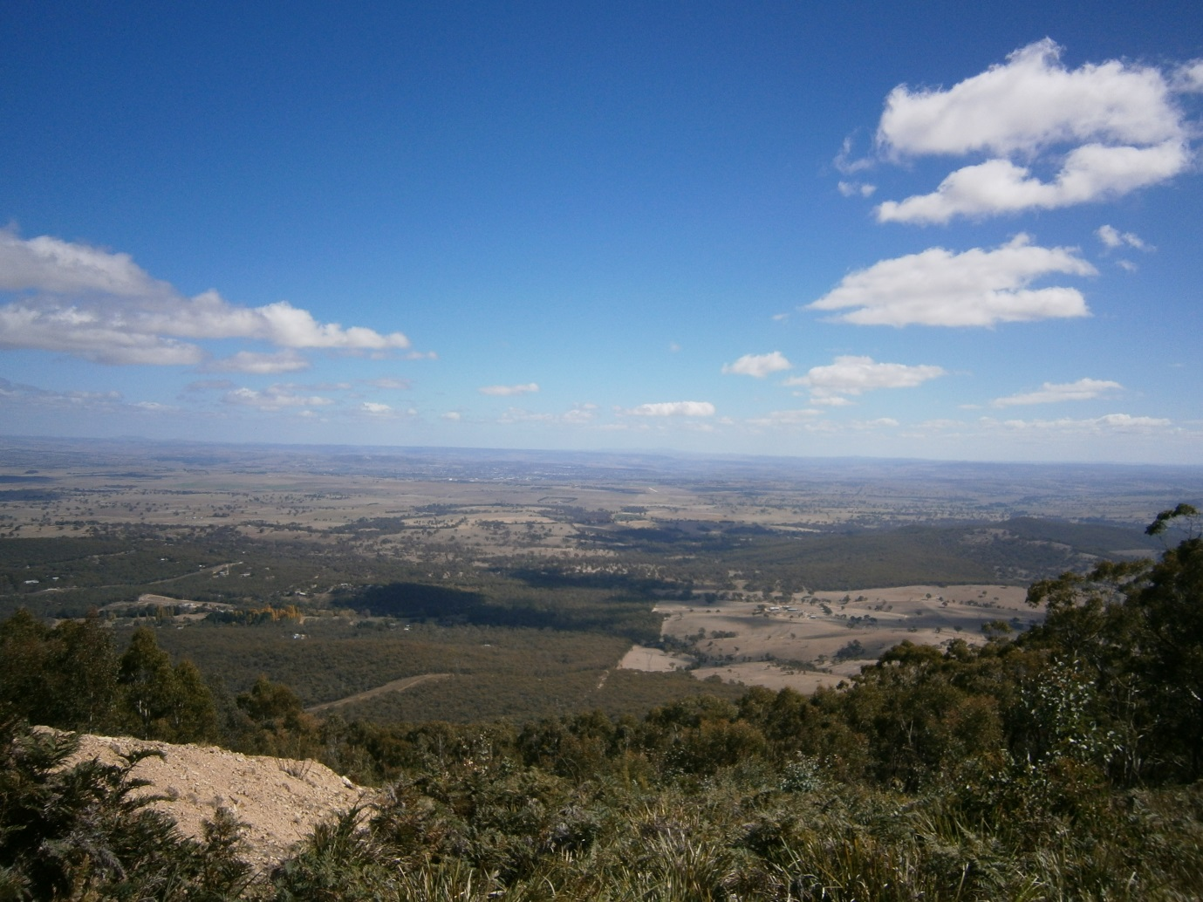

Then back for lunch of snags and rolls, coffee and lots of chit chat. We then saddled up for the descent back to the floats and home. Great day out and weather was kind.

