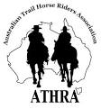
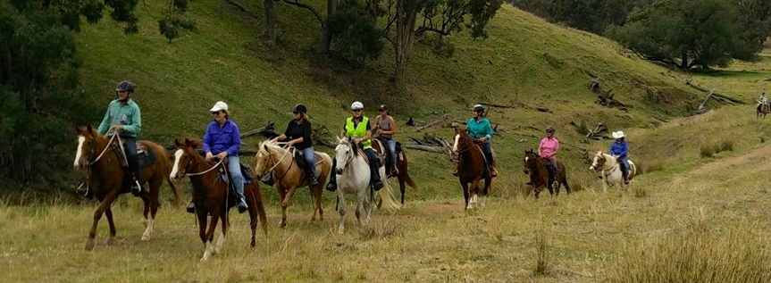
Tamworth Bushrangers Trail Riding Club – Newsletter October 2017

A SPIN IN THE ROUNDYARD
with
Clayton Bryant

Where were you born? NZ

What star sign are you? Tauras

As a child who was your favorite cartoon character and why? Donald Duck

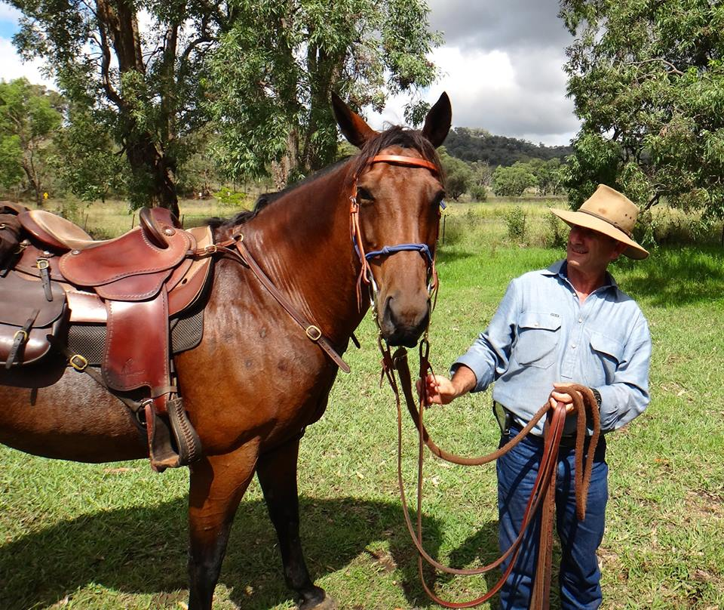
Where did you go to Senior/Secondary/High School? Melville High

What was your favorite subject at school and why? Metal work, I like to work with my hands

How did you come to own your first horse and want was its name? The trail riding company I was riding and working for gave me the opportunity to purchase a horse named Whiskey nice looking Palomino gelding

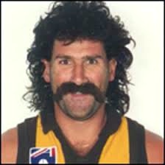
Who is the most famous person you have met, were did you meet? Robert DiPierdomenico ex AFL player for Hawthorn, I worked with him

What book are you reading? A training manual for work

What is on your computers screen saver? A picture of Kruise

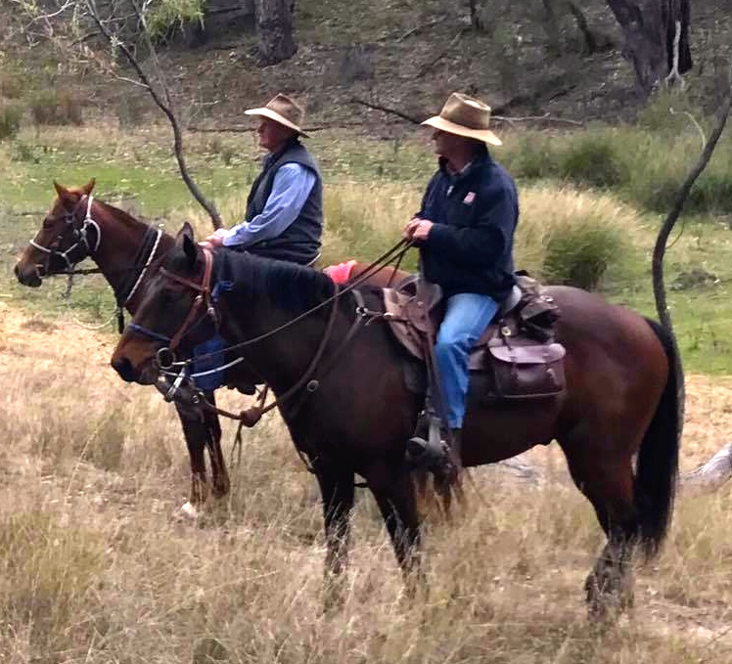

What is your nickname? Clinger

What was your first job? working in a furniture factory making chairs

What is the funniest thing that has ever happened to you? The reason for my nick name falling of a horse and would not let go the horse just kept walking and I kept clinging onto the horses neck

Were where you on New Years Eve 1999 into 2000? I was at a New Years Eve party at a volunteer fire station south east of Melbourne

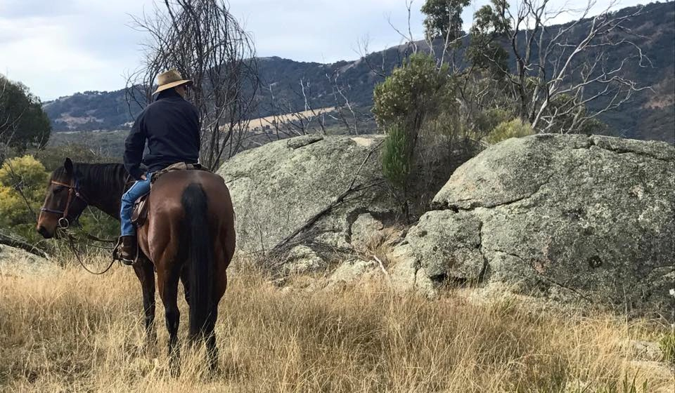

“Oakview”
Mulla Creek
Sunday 24 September 2017 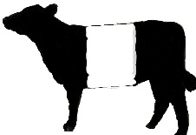
With some concern and trepidation due to ominous weather predictions from our weatherman that the day would be hot, hot, hot… Sunday dawned and all was good. What a pleasant surprise it was to arrive at Oakview to find comfortable temperatures assisted by a gentle wind...nothing too scary for the horses or too annoying for the riders.
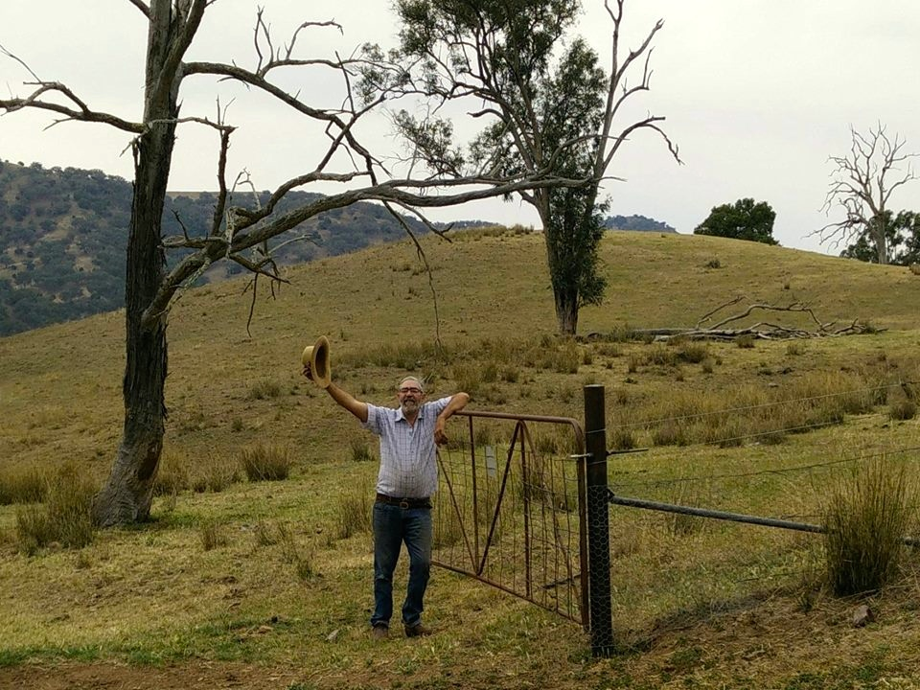

Oakview, for those who have not been there is home for club members Francie and Duncan Maclean. Here Francie and Duncan run stud Belted Galloway cattle as well of other mooing creatures … which Francie tells me are commercial Beltie Galloway, Angus and Black Baldy cows. It is just the prettiest property with club members most appreciated to be allowed access.

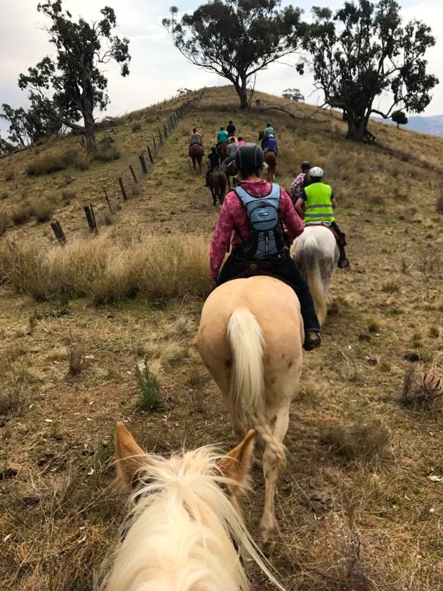
With horses and riders arriving in good time it was decided we should set out at the earlier time of 9.45 instead of the intended 10.00 … so following our usual pre-ride brief this is what we did. Along for the ride there were fourteen riders supported by two non-riders in 4WD.
Riders and horses on the day were Anthony on Gas err’ Play Station, Jenny Lee, Carolyn Hood, Robyn on Scooter, Francie on her 24-year-old, palamino, mare plus me on my Princess Matilda. Visiting members were Merryl, Carmel and Ken with Lynda riding her part Clydesdale gelding Mojo. New members were Michelle Smith-O'Grady and Kevin O'Grady. With us also came Francie’s son Lachlan on Pursuit and friend Nicole on Pippa. The non-riders were the charismatic Duncan Maclean and 4WD driver extraordinaire Mickey Mike Woods.

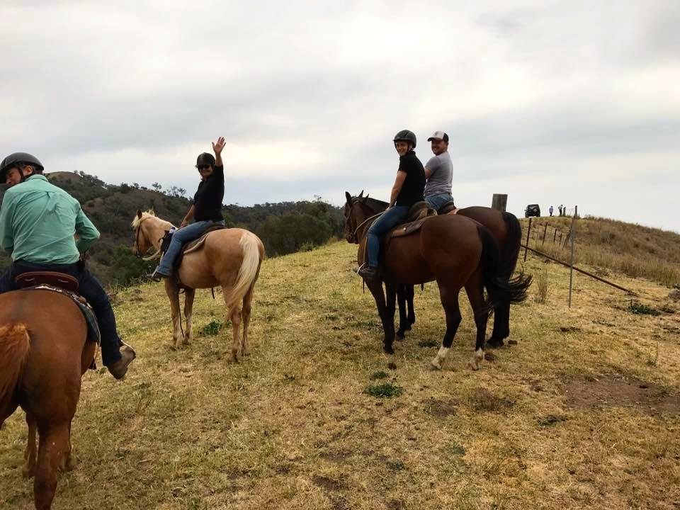
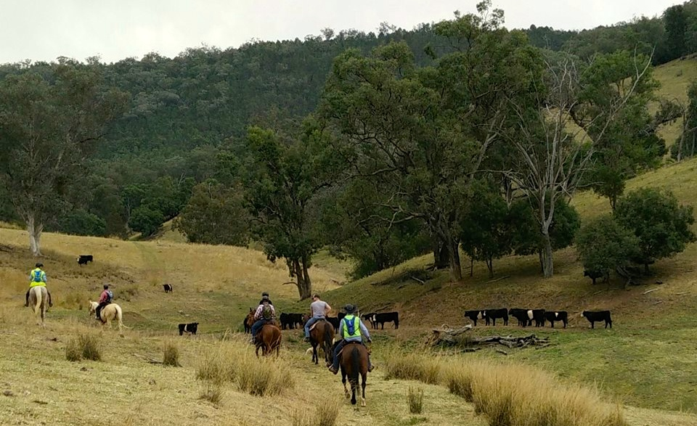
From the homestead, riders rode down and along Mulla Creek, which we crossed once or twice until it was time to ride up and across Mulla Creek road. From here we entered Middle Paddock where some of Francie’s prize Belted Galloway cows were either due to give birth or had recently given birth. Following a quick cattle roll call, riders then began their climb stopping now and then to give horses a breather. Views on the way overlooked Limbri and Moonbi with Echo Hills in the background…breath taking.
On reaching one of the higher points along the back-ridge boundary … I think, we dismounted and gave the horses a rest before remount and down, down, down.
There were happenings on the way back down with one rider taking on tiger pear and another practicing circ soleil somewhere in the Back Paddock but you know what they say … what happens on the ride stays on the ride.

Back at Oakview we ate a leisurely lunch by the creek...the end to a very pleasant day.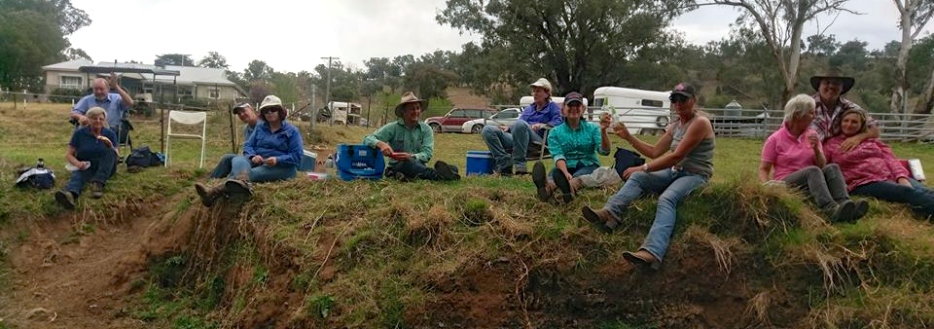
A big thank you goes out to Lynda who was kind enough to take on position of First Aid officer for the day…it was appreciated.
And a big welcome also to new members Michelle and Kevin plus horses Red and Lenny. This ride was Michelle and Kevin’s first ride with our club and Lenny and Red’s first trail ride in company. Together horses and riders did an excellent job and we look forward to seeing you all again.
And once again a ginormous, huge thank you goes out to Francie and Duncan for kindly making their property available for a Bushrangers ride…thank you thank you thank you.

Ride Repot by Helen Woods

The winning Caption was…………………………………………………..,
You are still in with a chance You gotta walk the plank ride the hook,
Gonna let them ride and keep it nice and tight.
Now the time is growing near your movin down the wall,
A steady as she goes you got your toes upon the nose.
And now you hang five, hang five,
Hangin five toes upon the malibu
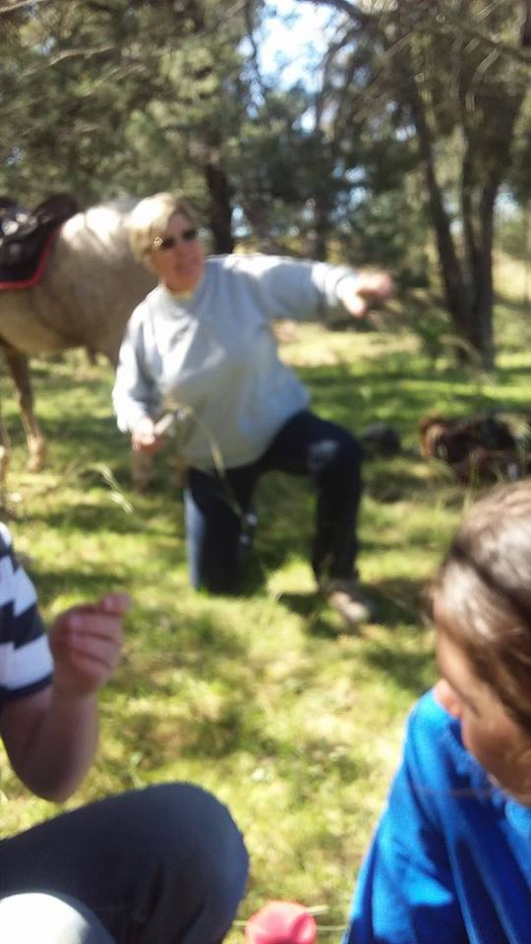
Thanks to Helen Woods for her creative caption

Fire Season

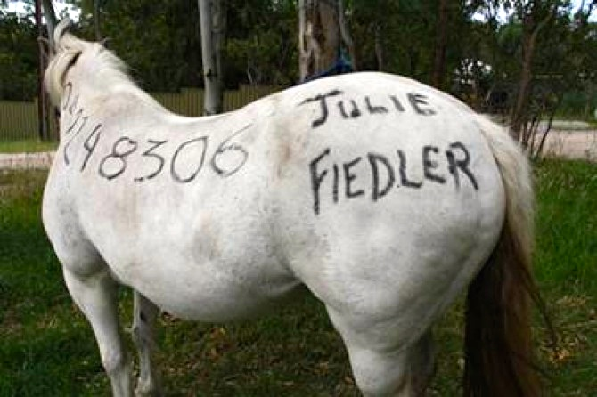
Prepare your horse for bush fire?

When preparing your Bush Fire Survival Plan this year ensure you include your horse(s)

The NSW Rural Fire Services has some great tips on planning and preparing which includes a great document dedicated to horses on the below link

NSW_2012_Prepare_your_horse_for_bushfire

Shout Out’s!

Special thanks to

Clayton Bryant for his member profile

Helen Woods for the Oakview Mulla Creek ride report

Tamworth Bushrangers Trail Riding Club

ATHRA

This is a club newsletter; so if you have any information you would like to contribute to the monthly newsletter please forward your contribution to buddsie@bigpond.com.au before the 4th Sunday of each month for consideration.

If you have photographs you would like to submit to the newsletter you could load them on to the Tamworth Bushrangers Trail Riding Club Facebook page. If you choose to email photos from the monthly ride for the newsletter please do so before the cut off date of the 2nd of each month for consideration.

Happy Trails Kaz

