TAMWORTH BUSHRANGERS TRAIL RIDING CLUB
Newsletter – OCTOBER 2018
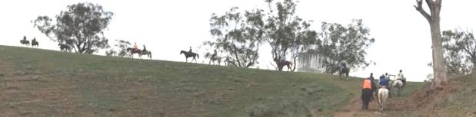
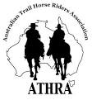 | President: Angela Witherdin  0418234854  awitherd@bigpond.net.au  Vice President: Bev Fletcher  Secretary: Francie MacLean  0407660334  Treasurer: Anthony Reid  0409362434/67665448  Newsletter: barlowpark2@gmail.com

OCTOBER RIDE REPORT
“Attunga Park” Garthowen Road ATTUNGA
We had 16 riders show up for what was lovely ride up some hills and down some dales. Lyn our host did a great job showing off her lovely property and we provided a bit of a treat for her Air B&B guests. We ambled around her property with a bit of a climb with views and more grass trees.
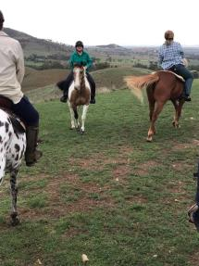 | 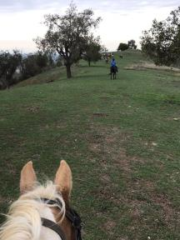 | 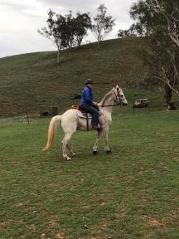
We passed a few Dorpers and had a view over Tamworth and surrounds. We had visitors from Gunnedah Blue Bums, Armidale NETRA and the rest of the riders were Bushrangers.
The weather was terrific only warming up as we were returning to the cars. Thanks to Ken for doing the book work and to everyone else for their cheerful company and lovely photos. | 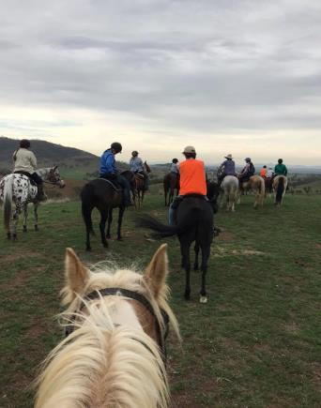  Thanks to Kevin (Paddison) for this Ride Report
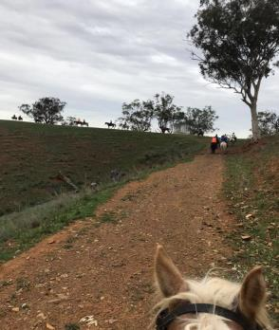

Reprinted here for those members who may not have seen this announcement from the Athra Board and wish to renew their membership under the definition of “Family Membership” or know of potential members who would be eligible for this new membership category:

ATHRA Announces Family Membership Incentive for 2019
To All ATHRA Members,
ATHRA always aims to provide the best support to our members, the ATHRA Board is excited to announce that a new “Family Membership” is now available ON –LINE for the 2019 membership year and beyond.
A Family in this regard is one adult riding member who is the Parent or Legal Guardian and one riding child/junior. ATHRA has waived the child/junior member fee to lower the overall cost for families.
The ATHRA cost component of this membership is $100.00 in total. Clubs still have the ability to add their club fee to this figure, so accordingly the total amount payable will vary from club to club as they add on their individual club fees.
Kind regards
ATHRA Board

Bushrangers Ride & Christmas Party
This is final ride for what was an extremely dry and dusty 2018. It is also the weekend we celebrate the end of the year with our Christmas Party. # Ride Information to follow shortly.

Date: 24th/25th November 2018 - ride is on the Saturday, Party Saturday night
Time: 10:00 ride out - to allow those travelling more time 6:30pm Party
Venue: Nundle Pony Club Grounds - Taylors Lane, Nundle
See previous email for all details
RSVP on the clubs Facebook post or email to Angela awitherd@bigpond.net.au by 6pm Thursday 15th November.
NOTE- Due to catering, RSVPs for Xmas party after this time will not be accepted.
When replying please indicate what option you or your family require as per the table below
Name: | Number of people |  | Number of cabins/floats
Member Rider & attending the Christmas Party
Visitor Rider & attending the Christmas Party
Ride ONLY
Attending the Christmas Party ONLY
Staying overnight in cabin
Staying overnight in float

Note: Cabins are filling up so don’t leave it too long to RSVP if you want one

Hear Ye! Hear Ye!
We are pleased to announce preparations for this year’s Bushranger Christmas party are underway.
Hopefully you have decided on what "talent" you can bring to the party on this our special night. Please, dig deep to locate school recorders, clarinets and trombones, brush up on your Keats, dust off those tap-dancing shoes.
Any queries please contact Helen Woods

