President Garry Fischer 53681439 – 0400 640 433  Vice President Julian Gross 57270440 – 0427 270 400  Secretary Amy G 0408 342 990  Treasurer Julie Samson 54248545 – 0427 859 586  Publicity Officer Amy on above details | 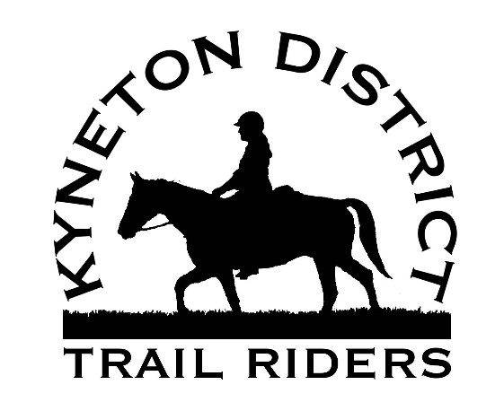

January 2018 NEWSLETTER

Update from the Secretary:
Hi all, Happy New Year! We have some fantastic rides organised for you already for 2018, as well as the addition of the ‘Green Beans & Nervous Nellies’ rides. Please keep your eyes on the ride calendar as it does change from time to time, however most of these rides are pretty much locked in. Thank you to all of those that have put their hands up to host a ride this year! It’s wonderful to see some new ride locations and fresh trails having been marked out. I’m excited! Don’t forget to always RSVP/Nominate for each ride with the ride leader. Look forward to seeing you on a ride with us soon. Yours on trails, Amy.

Next KDTRC Committee Meeting:
The next KDTRC Committee Meeting will be held at our Bullarto Ride on Sunday 28th January.

KDTRC 2018 MEMBERSHIPS

All memberships are now processed online through ATHRA. Go to their website www.athra.com.au then click on Memberships. It will give you three options, click the most appropriate for you and follow the prompts. Once you get to the end, it will tell you that you can pay the ATHRA amount $100 online, but the KDTRC $25 is to be paid directly to us. Complete the ATHRA online process, and then either do a bank transfer into our account for the $25 with your online banking (log on through your banks internet banking website), or just give us the $25 on your first ride with us. So membership is:ATHRA $100.00, KDTRC $25.00 = TOTAL $125.00

To ride with us if you are NOT a KDTRC member, fees are;ATHRA members are $5 and non-ATHRA Day Members pay $35. If you are already an ATHRA member with another club but think you might end up riding with us frequently also, you may want to join our club as well for just $25.

Bank details for KDTRCare:
Kyneton District Trail Riders
WESTPAC BANK
BSB: 033234
ACCOUNT NO: 561506

Make sure you put your name and ‘membership’ in the details section e.g. ‘AmyGMship’.

KDTRC Ride Calendar for 2018

Ride calendar is subject to change. Please look for updates in the newsletter.

DATE |  | LEADER/PHONE | WHERE | TYPE OF RIDE
28th January |  | AMY G  0408 342 990 | BULLARTO | Let’s cruise into the new year riding through the cool Bullarto area of Wombat Forest. You may even see a wombat! Hills, bush tracks, single trail, saddle bag lunch.
25th February |  | JULIE SAMSON  5424 8545 - 0427 859586 | Spring hill | Bush tracks, walk and trot. TBC lunch
10th, 11th, 12th March  Labour Day Long Weekend |  | Leanne Romaszko  0415 760 058 | High Country - Tolmie | High Country Riding! Your horse will need to be FIT and conditioned ready to ride two to three days in a row. Camping and fun funfun.
24th& 25th March |  | DEAN MIGHELL  0418 354 362 | TRENTHAM – The Path of the Horse | TBC – may be camp and rides at The Path of the Horse. Details to come.
29th April |  | ROB FEATONBY  0413 529 696 | Aireys Inlet | Bush and Beach riding!
27th MAY |  | GARRY FISCHER  0400 640 433 | GREENDALE | Hilly bush tracks, beautiful gullies and saddle bag lunch at old mine.  Intermediate Ride.
24th JUNE |  | ALISON STONE  0427 169 791 | TARADALE | Bush tracks and single trail. Hills, gullies, saddle bag lunch.
29th JULY |  | AMY G  0408 342 990 | HepBURN SPRINGS – Pub ride | New ride from Daylesford to the Old Hepburn Hotel for pub lunch! Mostly bush single trail, hills.
26th AUGUST |  | Garry Fischer  0400 640 433 | Mt edgeton/Ballan | TBC
29th& 30th SEPTEMBER |  | ARNOLD VAN orsouw  0425 885 201 | Enfield | Two day camp at Enfield. Bush riding both days.
28th OCTOBER |  | Di symonds  0407 486 121 | korweinguboora | Bush tracks, saddle bag lunch.
25th& 26th NOVEMBER |  | GARRY FISCHER  0400 640 433 | NEWBURY | Two day camp and rides. BBQ celebrations, lots of fun.

NEXT RIDE: KDTRC Bullarto Ride, January Ride hosted by Amy G.
Where – Meeting at Bullarto Hall, South Bullarto Road Bullarto 3461. Turn into South Bullarto Road from the Daylesford Trentham Rd, cross the railway line, and the Hall is on your left. Plenty of parking, no known water available.

When –9.45 horseless muster for 10am ride out.

Come and sign in with AMY

Ride – We will cross the Daylesford Trentham Rd enter the Wombat State Forest, weaving our way through single trails and overgrown logging tracks. There will be a long hill climb up Babbington Hill, with a chance for a breather at the top before descending to the east down the hill to Lyonville Springs for lunch. Lunch will be provided (picnic lunch of build your own roll, cold drink, and slice). We will then ride around the base of Babbington Hill, taking the opportunity to have a long trot and canter. We’ll ride a short distance along Baddington Rd (back road) before reentering the bush for some single trail to Bullarto Reservoir and then back to the floats.
Conditions – A mixture of smooth tracks, with some sections where it’s rocky underfoot. Make sure your horse is shod (on all hooves), or booted as my barefooted fellow found the rocky sections a bit ouchy. This is 20kms with an epic hill climb, and some trotting later in the ride. So make sure your horse is well conditioned. Bullarto is always a number of degrees cooler than everywhere else in the district so it’s a nice location for a summer ride even if it’s really hot. If it’s a Code Red fire day the ride will be cancelled. There’s no mobile reception at the Bullarto Hall, so please let me know if you can’t make it the night before the ride. There is mobile reception on the ride though.

Bring –Bring a drink bottle, a halter and lead to tie up with at lunch, some hay band to tie up to as the trees are quite big, and $5 for lunch.

Nominations/RSVP –. Amy via text message on 0408 342 990 for click that you are attending the event on Facebook.Any non-ATHRA members must do the on-line Day Membership before they turn up to the ride.... see the ATHRA website for details.

KDTRC extra‘Green Beans & Nervous Nellies’
Ride Calendar for 2018

Okay gang! Here’s the rules/guidelines for these extra ‘Green Beans & Nervous Nellies’ rides.

There are limited numbers on these rides of around 6 riders not including the ride leader. Riders must be KDTRC members or prospective members. Priority will go first to those that are not yet able to go on our regular rides due to confidence issues, horse green etc. Then it will be those that go to our regular rides, but have a new or green horse that they are working that they have not bought on our regular KDTRC rides yet. Then it will go to those that have been on our regular rides, with this particular horse, but they have been having trouble. This will only be an issue if more than 6 people nominate to ride, and I will have to prioritise based on the above.

What the ride leader says – goes. Be prepared to be told to stop, slow down, get back behind the ride leader, give another horse some distance etc. I’m not being bossy, this is a learning experience for people and it needs to be respected.

Be prepared to be patient with other riders. We will ride to the ability of the most inexperienced horse/rider. We may have to stop, we may have to wait, and we may have to change our plans.

Think of these rides as a ‘schooling’ exercise for your horse. We may be changing locations amongst the group, doing a creek crossing, trying out taking horses past an obstacle like a scary bin, or a burnt out tree stump. We might spend some time at these things.

We may try different passes such as trot and canter in short controlled distances. We will only do this if everyone agrees to it and there will be no ‘peer pressure’.

Expect that other people’s horses may not behave, especially the Green Beans. You are all in the same boat be patient and forgiving, everyone will be doing their best.

DATE |  | LEADER/PHONE | WHERE | TYPE OF RIDE
14th January |  | AMY G  0408 342 990 | GLENLYON | Leaving from the Glenlyon Recreation Reserve, riding up a back road for 1.5kms, then bush tracks. Up to 10kms.
4thMarch |  | AMY G | DAYLESFORD | Leaving from Ajax Rd, Daylesford. Riding bush tracks and single trail loop back to floats.
13th May |  | Di SYMONS or Amy | Trentham | TBA details
10th June |  | AMY G | GLENLYON | Leaving from the Glenlyon Recreation Reserve, riding up a back road for 1.5kms, then bush tracks. Up to 10kms.
12th August |  | TBA | TBA | TBA
14th October |  | TBA | TBA | TBA

KDTRC Ride report Newbury Weekend –Xmas Break up Rides

Prepared by Julie Samson

We had a lovely break up weekend at Newbury, blessed by very pleasant weather, plenty of yards for the horses and good company both old and new.

On Saturday Julie lead the afternoon ride through the bush west of the Garlicks Lead Schoolhouse following fence lines, bush tracks, Lyonville Track and along the Rail Trail before becoming disoriented quite near our destination. Fortunately Wendy and Di knew the challenging bush track to The Path of the Horse, so we arrived almost on time to be greeted by our host Dean Mighell and some of our friends and family who had come to find out more about it.

After doling our refreshments, Dean spoke about how he was putting the Equine Psychotherapy course into practice on his beautiful property, working with people in need of some de-stressing; several of our riders could relate to how their relationships with their own horses helped them psychologically. Dean has been helped a lot by a local Rotary club and the horses and property are looking great. He said we were welcome to use it as a base in the future for a ride. (At our subsequent KDTRC Committee Meeting, the proposal to donate $300 to The Path of the Horse was unanimously endorsed). The 18 riders only took half an hour to return to our camp, in total we did 16kms. Thanks to Matt for being First Aider and Jo Garner for riding drag.
It was great to see Kerryn Douglas, Doug Stone, Jake & Leanne, plus all the new members at the BBQ that evening. Thanks to James and Julian for cooking, although it was very mild weather, it wouldn’t be the same without the camp fire. Thanks to Jo and Di for bringing the wood and John and Bruce for setting up. Amy’s Kris Kringle seemed to leave ever one very satisfied, thank you.

On Sunday morning 13 riders covered 17 kms on the eastern side of Newbury towards the Blackwood forest. The group was led by our president Garry, and he led the group down some beautiful 4WD tracks and some interesting stories were told about mines in the area. Then there was some single file through some challenging tracks that crossed the creek, and as we were heading back, some elves had left out treats for the riders (candy canes), and the horses (carrots). It turned out to be Amy & Meredith who then treated us to a drink and delicious slice and cup cake concoctions! Yum yum, and what a surprise. We arrived back for a BBQ lunch at the grounds at around 2pm.

I was pleasantly surprised at how easy it was to get our rubbish down to half of what it was last year by doing away with plastic plates and cutlery. It was really easy to do the dishes. Packing up at the end of Sunday’s ride went smoothing with many hands making it lighter work. Thanks to all those people who hopped in and did what needed to be done very quickly and efficiently.

Julie Samson
KDTRC

KDTRC donated $300 to The Path of the Horse

After discussions at our November committee meeting at our Christmas break up, on the 16th of December, Julie Samson our Treasurer happily handed Dean Mighell from The Path of the Horse a cheque for $300 on behalf of KDTRC! Thanks for having us visit and sharing with us your vision Dean.

We hope our contribution will help you improve the lives of many more people in 2018.

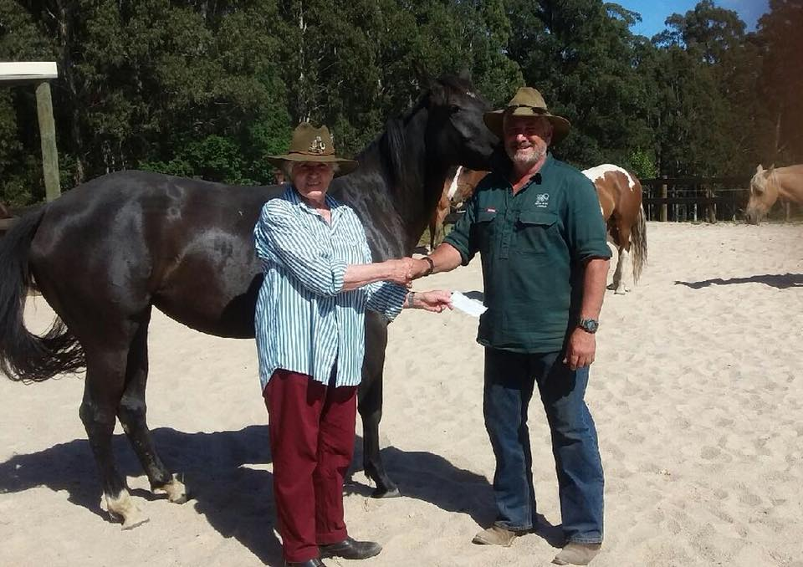

Xmas Break up pictures

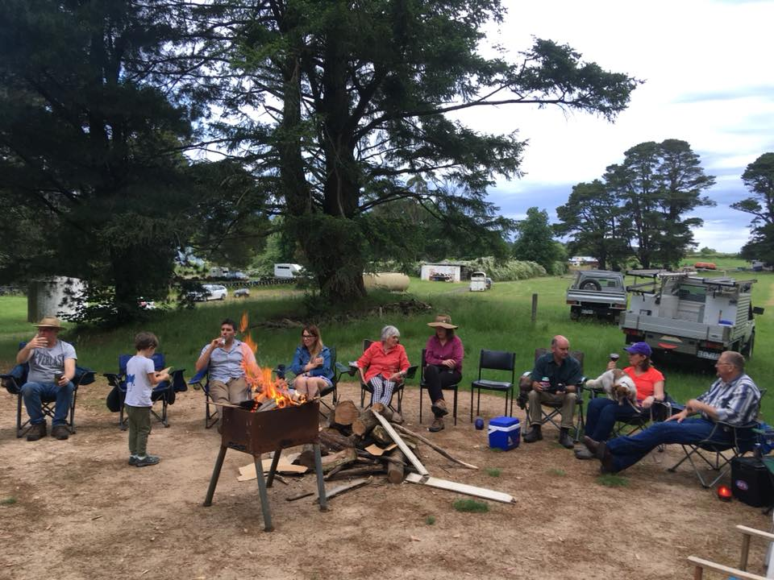 | 