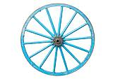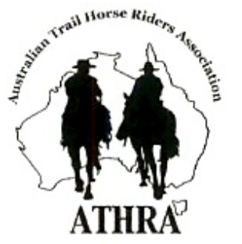

**OTHRADA**

2014

President; Donna Crameri

Secretary; Talena McKenna

Treasurer; Veronica Ford

C:\Users\Veronica\AppData\Local\Microsoft\Windows\Temporary Internet Files\Content.IE5\2BBFJ31F\MC900235201[1].wmfC:\Users\Veronica\AppData\Local\Microsoft\Windows\Temporary Internet Files\Content.IE5\2BBFJ31F\MC900235201[1].wmfC:\Users\Veronica\AppData\Local\Microsoft\Windows\Temporary Internet Files\Content.IE5\2BBFJ31F\MC900235201[1].wmfC:\Users\Veronica\AppData\Local\Microsoft\Windows\Temporary Internet Files\Content.IE5\2BBFJ31F\MC900235201[1].wmfC:\Users\Veronica\AppData\Local\Microsoft\Windows\Temporary Internet Files\Content.IE5\2BBFJ31F\MC900235201[1].wmfCowboy on the horse vector illustration from Wild West series - stock vectorCowboy on the horse vector illustration from Wild West series - stock vector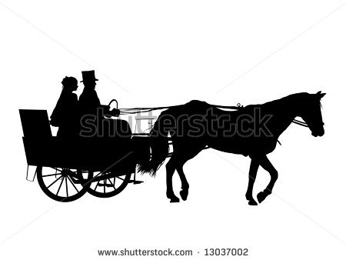Cowboy on the horse vector illustration from Wild West series - stock vectorCowboy on the horse vector illustration from Wild West series - stock vector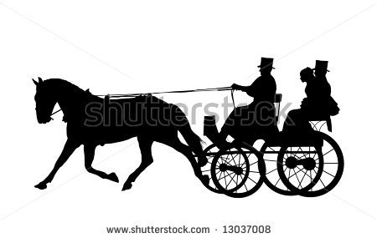Orange Trail Horse Riders And Drivers Association.

I have copied 22 of the 55 most common Q & A, from the" FAQ Insurance fact sheet" and retained the numbers that identify the Q & A for easy reference. You can find the entire fact sheet IMS-FAQ-002 on the Athra Website - www.athra.com.au

1. ( 2. **Are we covered for social functions?**

Yes, if limited to less than 50 participants, you do not need prior written approval. If a function is going to have more than 50 participants, more planning is probably required. One element of the planning will be to notify ATHRA’s Insurance Coordinator in writing through your Regional Manager so that it can be approved.

2. (3. **Does Public Liability Insurance cover Social members at club functions even though they will not have paid full ATHRA membership?**

ATHRA has Adult, Junior and Social membership categories, all of which are covered by insurance at sanctioned club functions, provided the member is financial. Day members (Ride Visitors) who have paid the appropriate fee to participate are also covered.

3. (4. **Are our committee members covered?**

Yes. Official position holders and committees of all affiliated clubs as well as ATHRA administration position holders are covered for Association Liability which insures liability arising against the committee in respect of acts, errors or omissions arising out of the operation of the committee.

4. (5. **Does ATHRA’s public liability policy cover property owners?**

Yes. Property owner’s interests are covered for that component of their property that is being utilised by an ATHRA club. The property can also be endorsed on our policy as an “Interested Party” if required.

**5. (8. Are non-riders, who are not ATHRA members, covered at club events such as campouts?**

If the non-rider is not an ATHRA member they are not covered by insurance. If however the non-rider is carrying out official support activities for the club they are covered by insurance provided their name and delegated duties are documented in the Ride Attendance Register for the event.

**6. (9. Can a rider who has previously been an ATHRA member attend a club ride as a prospective member/visitor?**

Yes, provided: they are listed in the Ride Attendance Register; have signed a current Risk Warning and Waiver form, provided a signed Parental Consent and Indemnity form if under 18 years; have provided personal details as required; and have paid the applicable fee.

A past member is considered to be the same as a “prospective member”.

**7. (44. If a new rider is having their third ride with us and becomes a member, is it OK to join on the day of the ride or does it have to be done beforehand and the paperwork of to ATHRA before the ride?**

There is no problem for the person to join up on the day of the ride. Once someone pays their fees to the club representative (usually the Secretary or Treasurer) and receives a receipt in return, they are considered to be covered by ATHRA’s insurance policies. The person should hold onto this receipt if attending rides with other clubs until they receive their ATHRA membership card.

**8. (46. Are people who ride on the two trial rides before joining the club, covered by insurance (ie, before they have paid ATHRA membership)?**

Yes. Non member riders, riding as either guests or as prospective ATHRA members on official ATHRA organised events are fully covered by ATHRA’s current insurance policies, provided they are listed in the Ride Attendance Register; have signed a current Risk Warning and Waiver form, provided a signed Parental Consent and Indemnity form if under 18 years; provided personal details as required; and paid the applicable fee.

**9. (16. Can we get insurance cover through ATHRA to cover ourselves for general riding - not official club rides?**

Yes, ATHRA’s insurance partner Affinity Insurance Brokers has structured a number of insurance components specifically for ATHRA members. These include Horse, Public Liability, Personal Accident, Float, Tack and Vet fees. The individual ATHRA member decides which components and to what value they want covered. You can contact Affinity on 03 8587 7777 to discuss your needs and obtain a quote.

**10. (18. Are members over 80 years or under 5 years covered by ATHRA’s personal insurance policy?**

No. Members under five years or over 80 years are not covered by the Personal Accident Policy. However, they are covered for public liability. (Note the 80 years of age is already an extension to what is generally available elsewhere.)

**11. (20. When does coverage start and end at a Ride?**

Your “Personal Accident” policy covers you travelling to and from and whilst participating and/or attending sanctioned events and activities of ATHRA affiliated clubs.

Your “Public Liability” policy starts when you arrive at the event and ends when you depart the ride. This does not include loading/unloading your horse or driving to or from the event.

The “Association Liability” policy covers position holders when conducting and acting on behalf of the ATHRA organisation either at a National, Regional or Club level.

**12. (21. Can our club hold a ‘last minute’ ride, and still be covered by insurance?**

Yes, provided the ride has been approved by the club’s committee in writing and all members are advised of the ride details.

**13. (25. If a junior member and his/her guardian chooses to let the junior rider ride in a non compliant helmet and has been told specifically that it doesn't comply, are the other riders still covered?**

All members are always covered for personal injury. All members are also covered by our Public Liability policy. An exception to this may occur in the event that a court of law determines that the parent/guardian is negligent by not ensuring the junior’s compliance with relevant road laws and/or the ATHRA Code of Conduct. In such a case this may negate any compensation payable to the injured person from the ATHRA Personal Liability Insurer. Further, those who gave the permission to ride in the non-compliant helmet may be held liable.

**14. (30. Are hackamores allowed to be used on club rides?**

Allowable tack and other horse riding equipment used by members is not an issue as far as insurance is concerned. There is no mention of conditions relating to riding tack in the current insurance policy. However, ATHRA’s Code of Conduct Rule 3.15 states: “riding with a halter is only permitted where a rider has demonstrated effective control”.

**15. (31. Do junior riders have to wear helmets?**

ATHRA’s Code of Conduct rules 3.23 and 3.24 state that riders under 18 must wear an approved helmet and that a parent or guardian must also accompany juniors under 16.

**16. (33. If a car injures a horse, is it covered by ATHRA’s insurance?**

No. Horses are not directly covered at all under any of the current ATHRA policies.

**17. (35. Can riders ride bareback?**

No. ATHRA’s Code of Conduct Rule 3.15 states: “The minimum equipment required is a saddle with stirrups and girth, and appropriate head gear”. In appropriate circumstances, and in a controlled environment such as a camp, the Trail Boss may allow bare back riding when swimming horses if safety precautions are in place.

**18. (38. What if my horse kicks?**

ATHRA recommends that members riding horses they suspect have a propensity to kick use a red ribbon in their tail or alternatively use the “Horse May Kick” stickers provided by ATHRA.

Riders should note the following Code of Conduct Rules:

Rule 3.12 - At all times horses remain the responsibility of their riders, and as such, riders should always be aware of riders/horses in their vicinity, to avoid potential danger.

Rule 3.13 - It is the responsibility of all riders to maintain appropriate control of their horse and to keep them out of kicking distance of other horses at all times.

It is every rider’s responsibility to control their horse, and to be aware of other horses in their vicinity.

**19. (40. When does insurance cover start and finish for Ride Visitors?**

Ride Visitors are covered under the Personal Accident insurance policy and the Combined General Liability insurance policy during their participation in an ATHRA sanctioned event.

The insurance coverage commences at the time the Ride Visitor registers at the event location, and applies during the event and for the period required to travel home from the event at its conclusion. This travel period is capped at 12 hours for a single day event and 24 hours for an event held over two consecutive days.

**20. (42. So what happens when riders attend a ride more than twice and they are not members?**

If your club permits prospective members/visitors to ride more than twice, then that club is in breach of the Code of Conduct and is liable. Clubs that do not conform to the Code of Conduct may have their ATHRA affiliation withdrawn, thus leaving them open for personal liability claims.

**21. (53. What is Duty of Care?**

In the context of horses and trail horse riding, it would mean taking reasonable care to protect member/riders and others/general public from foreseeable harm or loss.

**22. (55. Caveat:** All answers are provided subject to the terms and conditions of the relevant insurance policy. ATHRA reserves the right to amend or revise these FAQs without notice.