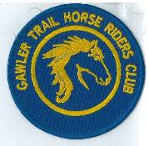
April 2019 Newsletter
Club Postal Address
P.O. Box 55
Gawler SA 5118
athra.com.au Email: Gawler.THRC@gmail.com
President - Julie Jackson 0419850793 Vice President -Tamara Godfrey 0417869695 Treasurer - Sandra East 0400884402 Secretary - Kath McCullagh 08 82807046
General Committee Maria Pearce & Lisa Rothe

GENERAL MEETING (1st Thursday of the month) 8pm Thursday 4 April 2019

All welcome Southern Hotel (next to Cafe Nova)
Come early for tea – 7pm

March Meeting
Accreditation progressing
Ride calendar almost complete.
ATHRA AGM to be held 30/3/19

Members for 2019 Welcome
Welcome Back to Re-joining Members
Alison Turner of Gould Creek, Sandra Sampson of Birdwood, Lisa James of Kersbrook,
Veronica Kenny of Mannum, Nat Bennison of Truro, Deb Smith of Williamstown,
Codii Hughes of Kersbrook & Kay Boon of Two Wells,

& hope you continue to enjoy may days of riding (& socialising) with the club

Coming Events
March RIDE OUT – Birdwood – Sunday 31 March 2018 - RSVP by 27/3/19
Host & Boss – Sandra Sampson phone 0417001158 Ride time – 9am > for an 10am start
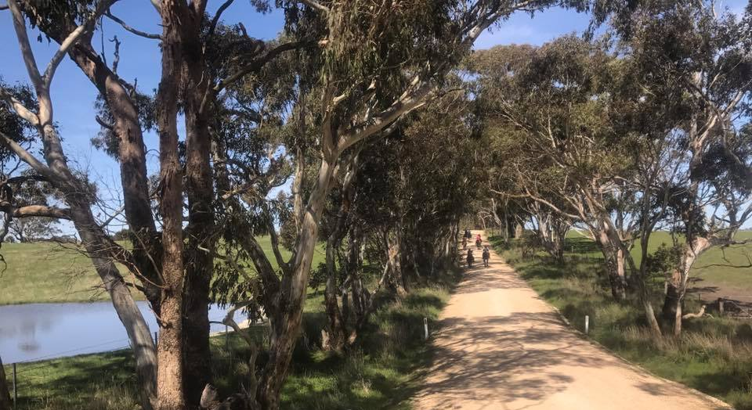
Ride Description: The ride will be along shady roads and probably 2 - 3 hours long. Mostly walk with some trot.

Please stay for a BBQ after, meat supplied, BYO your chair, drinks & a salad or desert to share.

Directions: provided to those that RSVP

Hazards: There will be a four crossings over main roads, stock in paddocks & the odd kangaroo.

Cost- ATHRA member $2 Ride fee. Non ATHRA member riding visitor fee $25/day (please be advised that if you are not a member of ATHRA you will need to be sponsored by an ATHRA member to ride & pre-register as a day member 3 days prior with ATHRA online - $15 direct to ATHRA & $10 to club on the day). Please bring the correct change & place in tin at sign on book.

APRIL - TRAIL RIDE CHALLENGE/OBSTACLE DAY– Cockatoo Valley - Sunday 14 April 2019
Coordinator: Sandra E Mobile 0400884402 Arrive 9am for 9:30am start
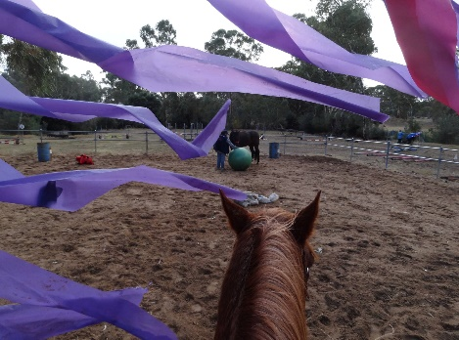
Once again a few new ideas have be thought of for the training/obstacle day for horse & riders. Once again we should have an interesting & fun day. The idea is to expose you & your mount to items & experiences that will help you (& your horse) to remain calm & in control when you come across those unexpected situations on the trail.
A few of the ideas are as follow & of course, more ideas are always welcome.
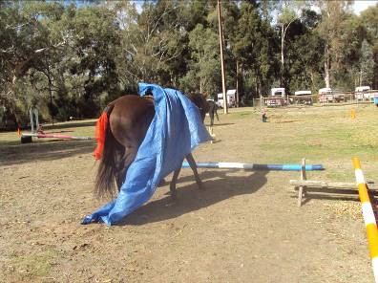
- *NEW* complimentary Motor Bike & Hoon to chase
- Flag, ball, umbrella & cones
- Cavaletties, jumps & bending poles
- Bridge & gates
- Bag down/Ride with a bag of bottles
- Pick up clothing/tarps/ chaff bags - un/mounted
- Dressage Test – choice of 2 tests (pre learnt) with feedback from the Judge.
- Cross country & show jump course

We will also be holding the “ATHRA Trail Ride Challenge” - see ATHRAs challenge via the link. http://www.athra.com.au/forms/trail-ride-challenge-1/399-ims-gu-001-trail-ride-challenge-v20151010.html - may even be a prize for the best performance
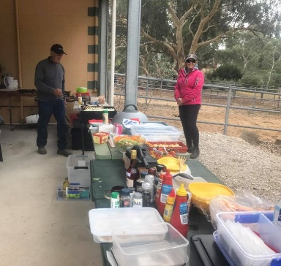
These are ideas only & we may get to do some or all of these on the day. Some are done on the ground & mounted also. Also if you have items you can bring to help in these tasks also let Sandra know.

We are going to have a fun filled day and lots of learning, new experiences & hearty laughter & of course don’t forget an excellent sausage sizzle lunch supplied by the club (Yum!!), BYO drinks, & a salad or desert to share. (May be a lunch break or a late lunch depending on how the day runs)

Please let Sandra know ASAP if
- you are able to help set up Friday 12/4 & Saturday 13/4
- if you’re not riding or have a happy helper that is willing cook the BBQ on the day

Directions: Provided to those that RSVP (need numbers for catering also) – RSVP ASAP but no later than 11/4

Cost- ATHRA members only - $2 Ride/food fee. Please bring the correct change & place in tin at sign on book

RIDE CALENDAR FOR 2019 host MEETING DATES 2019
Rides are usually held on the 3rd weekend (Sunday calculated) & 5th Sunday of the month (if there is one).
Camps held ~1st or 5th weekend of the month (negotiable) Meeting dates are held on the 1st Thursday of the month

The following is a work in progress – dates, location & hosts to be continually confirmed
Please nominate a date if you have nominated to host rides
& MANY More rides needed to complete the calendar

March 31 | Birdwood | Sandra S
April 14 | Trail Challenge Day Cockatoo Valley | Di S | 4 April
April 27 | Winery Ride | Lisa B
May 18/19 | Kapunda | Sandy | 2 May
June 16 | Mt Crawford - Cromer | Sandra S | 6 June
June 29 & 30 | Belvidere Camp | Richard
July 21 | Rosedale to Seppeltsfield (TBC) | Lisa C | 4 July
Aug 18 | Truro Gorge | Julie J | 1 Aug
Sept 14/15 | Leasingham | Sandy | 5 Sept
Sept 27-30 | Camp – Southern Flinders? | Kath
Oct 19 & 20 | Owen Camp & obstacle day | Julie J | 3 Oct
Nov | Forest Ride/Camp – Kuitpo (not 16-17/11) | Laine | 7 Nov
Dec 7 (Sat) | Christmas Dinner (TBC)
Dec 14/15 | Christmas ride (TBC)
? | Camp – Point Pass – (TBC) | Maria P

Past Events
BEACH RIDE – Osborne Beach – Sunday 17 March 2019 - by Di Scheafer
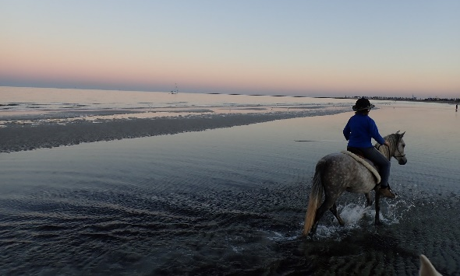
On the Saturday before the Sunday Beach Rally, Sandra East and I were saddling up at the Mt. Crawford Forest ready to go for a quiet trail ride, and we had noticed a few floats parked a little further down the road, where three of the riders were just about to ride off.

From that distance we weren’t sure who they were, but then Kath and Melissa rode over, followed shortly after by Tamara. They were all very happy and relaxed, riding their lovely horses and they joked about the proposed early start for the next morning beach ride. They threw out the challenge….and we (Sandra and I) boldly committed to see them at Osborne Beach, in the morning….with a picnic hamper containing breakfast and a (home grown..) zucchini!

As previously stated, (and well known to a few) I am no early rider (riser…), but, I arrived at Sandra’s at 5 .35 a.m., Sunday morning, with my gear, and Sandra was already at the stables with the lights on. I transferred my picnic hamper and basic necessities into her car, then we caught the two horses, Ace and Diamond and loaded them into the float. We drove off in the dark, and fortunately Sandra was confident where we had to go, as I had never been to Osborne Beach.

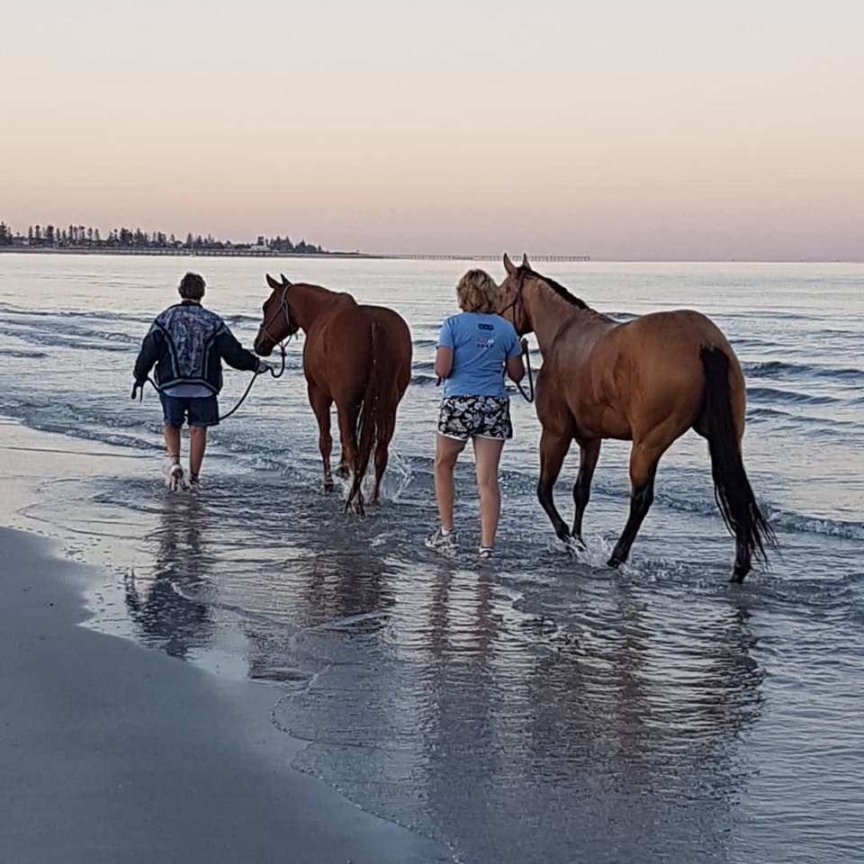
We arrived to see Kath and Tamara already saddled up, and after a cheery ‘Good Morning’, they set off for the water. John, Kath’s wonderfully helpful husband, was left in control of walking the two dogs, and was on breakfast B.B.Q. duties. Kerry, Tamara’s vibrant sister was also a kind assistant and also a very capable photographer.

Sandra and I intended to just lead the two horses in the sea water on this occasion, so we unloaded and then proceeded down the sand track to the water’s edge. Diamond was her usual sensible self, while Ace turned into horse -giraffe, as he saw all sorts of unusual spectacles out there in the water….He obviously saw things we didn’t! Maybe sharks…or was that dark figure in the distance only Kerry?????

Kath and Tamara had headed off down the beach, along the sand and into the water, while Sandra and I simply waded out into the sea leading the obliging horses. We were keeping an eye out for other Club Members, when we saw a rider coming towards us. Neither Sandra or I recognised the horse and rider from that distance, but we were convinced it must have been a Club Member, however, as the rider got closer, we realized it was not the person we thought it may have been…( Julie J….????).
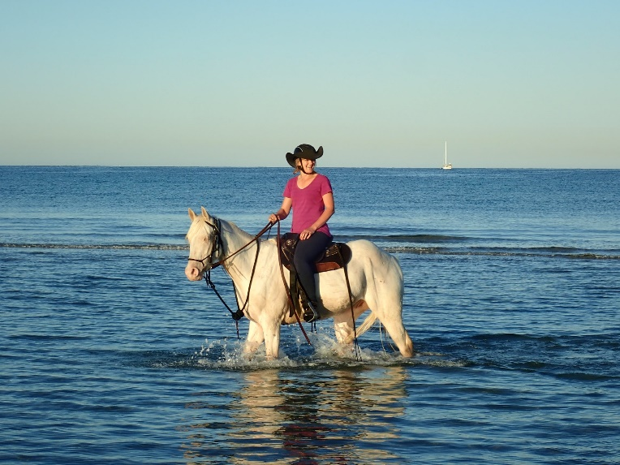
‘Hello Dianne’ the rider called out! What an amazing coincidence to see my long time neighbor of 30 + years confidently riding along in the water on Hank, her now superb looking 24 y.o. Q.H. gelding. Rosie moved to Large Bay some years ago, and to meet up again so completely unexpected at 7.15a.m. in the surf was truly unbelievable!
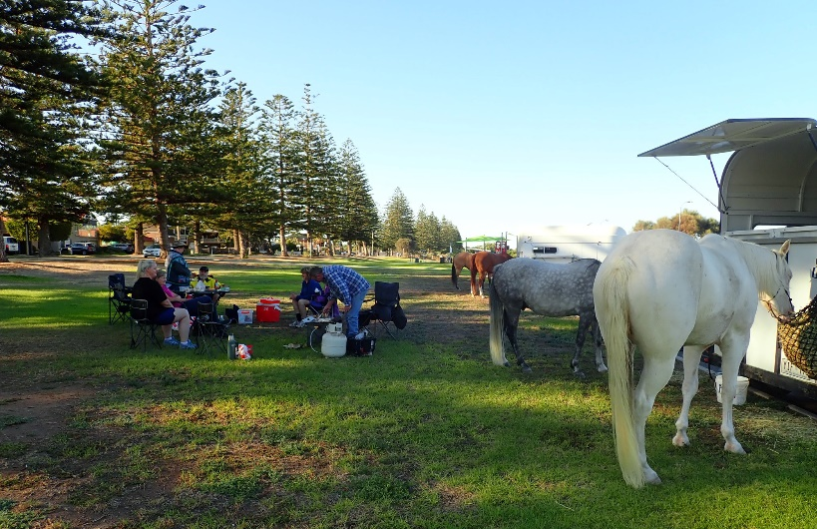
Rosie, her husband Gary and one of her twin daughters came back and sat with us during our B.B.Q. breakfast. Rosie, Gary and the twins were active members of the Riding Club many years ago, so it was quite wonderful to have them join us to enjoy a morning Riding Club activity, once again.

Thank you to John for being a great chef, to Kerry for being a good fun gal and imaginative photographer, and to Kath and Tamara for organizing another superb morning for a beach Rally.

Horse Health & Wellbeing

Supplement Could Help Control Horse Pasture Parasite Burdens – extract from “thehorse.com”

Adding a supplement to your horses’ feed to reduce the worm burden on your pasture sounds like a rich claim, but researchers recently tested an Australian product designed to do just that—and with positive results.
In recent field trials a feed supplement (commercially available in Australia as BioWorma) effectively reduced the “gastrointestinal nematode (GIN) infectivity of pasture surrounding the feces of treated horses,” the researchers said.
The supplement contains spores of the fungus Duddingtonia flagrans IAH 1297. The fungal spores pass through the horse’s gastrointestinal tract unharmed and are deposited in manure. There, they germinate and grow a mass of fungal hyphae—fine rootlike structures—and sticky traps that inhibit worm larvae, ultimately trapping and killing them.
Kevin Healey, MAppSc, MSc, lead author of the study and research and development manager of International Animal Health Products (IAHP) Pty Ltd, Australia, said the study results suggest D. flagrans could lower the incidence of parasite infection of animals grazing the pasture.
The horses the team studied had naturally acquired parasite infections, consisting principally of cyathostomes, plus some Strongylus spp. and Trichostrongylus axei. After eight weeks of supplement administration, the researchers found that the overall average number of worm larvae in the feces was reduced by 84%.

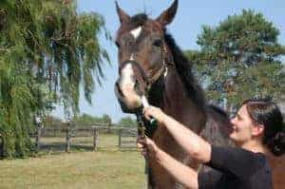
Healey and fellow study author Chris Lawlor declared an interest in the research through their links to IAHP. The study’s other authors—Dr. Malcolm R. Knox, of the Commonwealth Scientific and Industrial Research Organisation Livestock Industries F.D. McMaster Laboratory, in New South Wales, Australia; Michael Chambers, BVSc Hons, MVSt, MANZCVSc, GCAS, director of research services, and Jane Lamb, BS, a PhD student, from Invetus, in New South Wales; and Peter Groves, BVSc (Hons), MACVSc (Epidemiology), PhD, of Zootechny, in New South Wales—had no such links and were responsible for conducting the field trials.
Healey said the study showed that administering the supplement to horses and other livestock, including cattle and goats, could “lead to decreased levels of GIN infection in animals grazing pasture where this product is used and would provide an alternative means of controlling parasitic nematodes. Importantly, BioWorma is equally effective against worms that have developed resistance to chemical wormers.”
The study, “Field evaluation of Duddingtonia flagrans IAH 1297 for the reduction of worm burden in grazing animals: Pasture larval studies in horses, cattle and goats,” was published in Veterinary Parasitology.

NEWSLETTER DEADLINE
The deadline for any items that members want printed in the May 2019 newsletter will be Wednesday 17 April so please ensure that your emails reach Kath kathryn.mccullagh@hotmail.com before that date to avoid disappointment.

Policies
A reminder to all members that our club has some policies that we endorse. These include a NON SMOKING, SAFETY & HOT WEATHER policy. These can all be viewed on the ATHRA web site, via the state page - www.athra.com.au.
Previous Newsletters, photos & club information can also be viewed at any time on the ATHRA web site.
WEATHER
The ride host/leader for the day will have the final say regarding weather (including inclement weather).
The hot weather policy states, if the weather forecast in ELIZABETH for the next day is to be over 32 deg (as per the news the night before) the club rally/ride will be cancelled (unless the ride is scheduled to commence prior to 9am or after 6pm). This is for the safety of all riders and horses. Also, any club rides in FOREST areas on TOTAL FIRE BAN days will be cancelled.
Please check with the Trail Boss if in any doubt. They have the final word!
CLUB UNIFORM
Our club uniform currently comprises of a lime yellow high-vis shirt (long or short sleeve), club badges available for $12. Gawler Club Members & their visitors are required to wear Safety Helmets whilst mounted - helmet must be no more than five years old from Date of Manufacture.
RIDE FEE & DAY MEMBERS
ATHRA members - a ride fee of $2 per ride is applicable.
Non ATHRA Members (Day Members) – a ride fee of $25/person/day is applicable ($10 to club on the day & $15 to ATHRA with pre-registration) (Non-refundable fee, maximum 2 days as a day member).
The important things to note: 1. Day Members must be sponsored and accompanied at all times by an ATHRA member during the ride or event.
2. The Sponsoring member must make the Day Member aware of ATHRA rules and requirements of the Code of Conduct.
3. They may only sponsor 1 Day Member per ride.
4. By participating as a sponsor, the sponsoring member acknowledges responsibility for the conduct and behaviour of the Day Member
5. Day Members must contact the trail boss to discuss attendance & then pre-register with ATHRA Online at least 3 days prior to ride.
RIDE HOST CHECKLIST
A ride host’s checklist is in the green bag, in which is kept the sign in book, ride fee tin, saddle bags, first aid kits, safety vests, etc. Trail Bosses are to check the list to make sure all is in order prior to your ride. It is also the Hosts responsibility to ensure a ride report is arranged to be submitted to Newsletter Editor prior to next publication date.

DISCLAIMER
The material in this newsletter is for the benefit and information of our members. The items are in the nature of general comments only and are not to be used, relied or acted upon without written permission of GTHRC. The club accepts no responsibility for any errors or omissions or for any damage suffered as a result of any person acting without written advice. All opinions and views in the newsletter are not necessarily the view of the club, but are personal opinions only.

