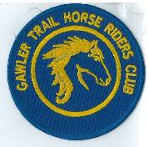
November 2018 Newsletter
Club Postal Address
P.O. Box 55
Gawler SA 5118
athra.com.au Email: Gawler.THRC@gmail.com
President - Julie Jackson 0419850793 Vice President -Tamara Godfrey 0417869695 Treasurer - Sandra East 0400884402 Secretary - Kath McCullagh 08 82807046
General Committee Maria Pearce & Lisa Rothe

GENERAL MEETING (1st Thursday of the month) 8pm Thursday 1 November 2018

All welcome Southern Hotel (next to Cafe Nova)
Come early for tea – 7pm

October AGM
- No Changes to the Executive Committee
- Welcome to New General Committee members – Maria Pearce & Lisa Rothe - thank you for volunteering to help the club succeed & we look forward to your input in the future.
October Meeting
- 2019 Ride Calendar – more info below
- Christmas Dinner 2018 – planning – more info below.

Members for 2019 Welcome
Welcome to NEW Members
Virginia Adare of Rosedale & Lisa Laughton of Mt Pleasant
& Re-joining Member
Kath McCullagh of Humbug Scrub
& hope you enjoy many days of riding (& socialising) with the club
Coming Events
November Camp: Burbrook – Saturday 17 & Sunday 18 November 2018
RSVP to Gawler.THRC@gmail.com by 13 November
Host – Lainie Ray 0438846741 Boss – Tamara Godfrey

Camp description: We will be camping on private property, BIG thanks to Carol and Denis Manning, the owners of BURBROOK who are allowing the club to use their land. The camp area consists of a paddock with trees. It will be BYO everything including water for HORSES! NO DOGS ALLOWED.

Rides - There will be a ride on Saturday arvo, after setting up and lunch, commencing at around 2pm and we be about 2-3 hrs ~ 12k
Sundays ride will incorporate a lunch stop along the way if the weather is favourable. Please carry your saddlebag lunch. ~5 hrs & ~25k

Ride Grades – Easy/Moderate. The terrain consists of flat country, undulating hills, gravel roads and some wide verges, creek crossings and maybe a snake or two! There are dams the horses can drink out of on the ride both days. There will be trotting and maybe even a chance to canter depending on where we end up on both Saturday & Sunday rides. This ride will be quite suitable to barefoot horses.

FORESTRY PERMITS: You do require a permit to ride in the Forest. If you do not have one you will pass the Ranger Headquarters (Corner Brookman & Harvey Road) on the way to Burbrook so you can pick one up and pay for it there!

EACH DAY THE RIDE WILL BE CANCELLED IF TOTAL FIRE BANS APPLY.

Horses – You will need to be self-sufficient with camping for horses Horses cannot escape from the property itself however horse yards will need to be erected in the form of electric fencing or some other suitable arrangement set up as there are no permanent yards. Nightlines are not permitted. No water for horses available so please come prepared (suggest ~ 20l/day). Cars and floats will need to be parked away from the communal area – see Lainie when you arrive.

People – You will need to be self-sufficient camping (including water) as no facilities provided. The Fire restrictions will be in place and the Manning’s have requested we don't have a fire so you will have to cook on BBQ/Cookers for your dinner - alternatively there is an awesome Pizza Shop in Meadows if you feel the need! Remember come prepared for any weather, especially the cold evenings!

Directions: Meadows area – full directions to all that RSVP.

As usual, it’s clean up all manure and hay before you depart.

If you are not able to make it for the whole weekend, or even to ride, please feel free to come for the weekend, day or the evening. Spouses are welcome too, especially if they are good at making a campfire!

Lainie - 0438846741 if you need any more info or contact her on Facebook

Cost- ATHRA member $2 Ride fee. Non ATHRA member riding visitor fee $25/day (please be advised that if you are not a member of ATHRA you will need to be sponsored by an ATHRA member to ride & pre-register as a day member 3 days prior with ATHRA online - $15 direct to ATHRA & $10 to club on the day). Please bring the correct change & place in tin at sign on book.

RIDE CALENDAR FOR 2018 HOST MEETING DATES 2018
Rides are usually held on the 3rd weekend (Sunday calculated) & 5th Sunday of the month (if there is one).
Camps held ~1st or 5th weekend of the month. Meeting dates are held on the 1st Thursday of the month
Nov 17 & 18 | Camp - Burbrook | Lainie R | 1 Nov
Dec 1 (Sat) | Christmas Dinner - Seppeltsfield | Maria & Chris
Dec 8 | Christmas ride - Rosedale | Lisa C
RIDE CALENDAR FOR 2019
Time to get those thinking caps on – Planning starts NOW! - all suggestions happily received.

We will be continually discussing our monthly ride calendar for the next couple of months so get those ideas & dates to the committee …Please make suggestions of rides that you would like the club to do & maybe some new rides, pretty rides, bush, forest, country or just a favourite ride you would like to share. Remember it does not need to be from your home, but the start of the ride need to have parking of floats. So give it some thought & let us know. Or even just let us know which of the rides the club has done that you would like to do again. (Email Kath kathryn.mccullagh@hotmail.com)

Remember it’s your club, so vote for a ride you want to do & we will find a volunteer to host….

Ride Nominations (Saturday or Sunday) – Moonlight, Beach (Pt Parham & Osborne), Leisingham, Obstacle/Trail Challenge Day (Sandra E), Truro Gorge, Seppeltsfield Winery Tour, Tungkillo (Sallyanne), Birdwood (Sandra S), Mt Crawford Forest (Lainie R),
we also try to schedule road rides in winter (forest rides have to be when ground not too wet or fire bans in place)
Camp Nominations – Robe, St Kits (Maria), Bellvadeer (Richard), Southern Flinders (Kath), Owen & tail course (Julie), Waterloo (Sandy?)
As not all members can travel/camp the camp nominations for 2019 will be mostly been scheduled as additional weekends (~5th weekend of the month or 1st if we have nominations) - camp weekend dates are negotiable

Woo Hoo – Looking forward to another great year of riding in our great state

DRAFT - RIDE CALENDAR FOR 2019 host MEETING DATES 2019
Rides are usually held on the 3rd weekend (Sunday calculated) & 5th Sunday of the month (if there is one).
Camps held ~1st or 5th weekend of the month. Meeting dates are held on the 1st Thursday of the month

The following is a work in progress – dates, location & hosts to be continually confirmed
Please nominate a date if you have nominated to host rides
& MANY More rides needed to complete the calendar

Jan 19 | Moonlight Ride (TBC) |  | 3 Jan
Feb 10 | Pt Parham (TBC) | Sandra E | 7 Feb
March 17 | Beach Ride - Osborne | Tamara | 7 Mar
March 30/31 | Camp?
April 14 | TBC Trail Challenge Day Cockatoo Valley | Di S | 4 April
May 18/19 |  |  | 2 May
June 16/17 |  |  | 6 June
June 29/30 | Camp?
July 20/21 | Camp? |  | 4 July
Aug 17/18 |  |  | 1 Aug
Sept 14/15 |  |  | 5 Sept
Sept 27-30 | Camp? | Kath
Oct 19/20 |  |  | 3 Oct
Nov 16/17 | Forest Ride – Kuitpo | Laine R | 7 Nov
Dec 7 (Sat) | Christmas Dinner (TBC)
Dec 14/15 | Christmas ride (TBC)

Past Events
September CAMP: Bendleby Ranges (via Orroroo) – Friday 21 – Sunday 23 September 2018 – by Lisa James
Day 1- The sun was out as Kylie and I set off at 8am with Dad following in his vehicle with Camper in tow. We decided to head in the direction of Burra from Gawler and the trip was very easy going. 2 hours took us nearly to Burra where we stopped for the horses to pee and a thermos coffee was had. At Orroroo we topped up with fuel and then the road turned to dirt. Very dusty drive as when we stopped for fuel Sandy drove past (who we hadn’t expected to see, but happy that another rider would be joining us) and we followed her all the way into Bendleby to arrive by 1pm. Perfect timing considering I really hadn’t know what time to leave to arrive by 1pm.
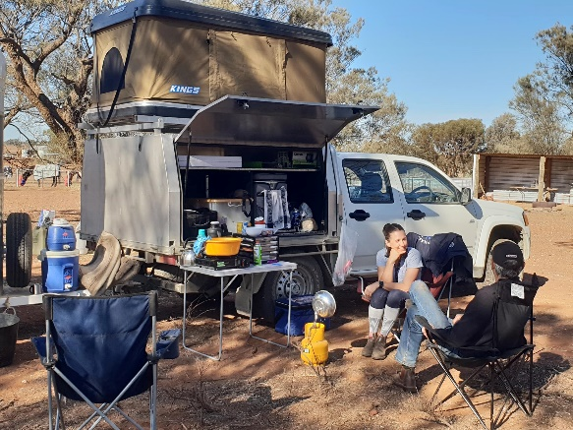
The campsite was a welcoming site and first thing was to get the horses off and settled with some feed into their yards. My two were lucky enough to have a very spacious yard together. Ride was due for a 2pm start and I don’t think we were to far off starting then. Expecting a 2 hour ride, Kath alerted us we were heading out and expected back in 3 hours!!! I thought oh gosh wasn’t expecting that, better pack an arvo snack. It was t-shirt weather when we left and I was thankful for the sunscreen I put on.

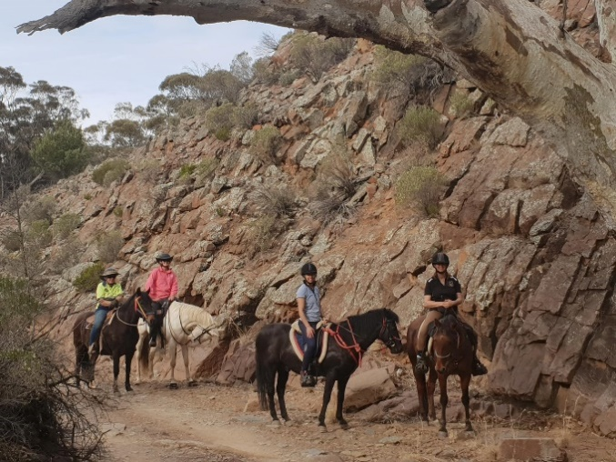
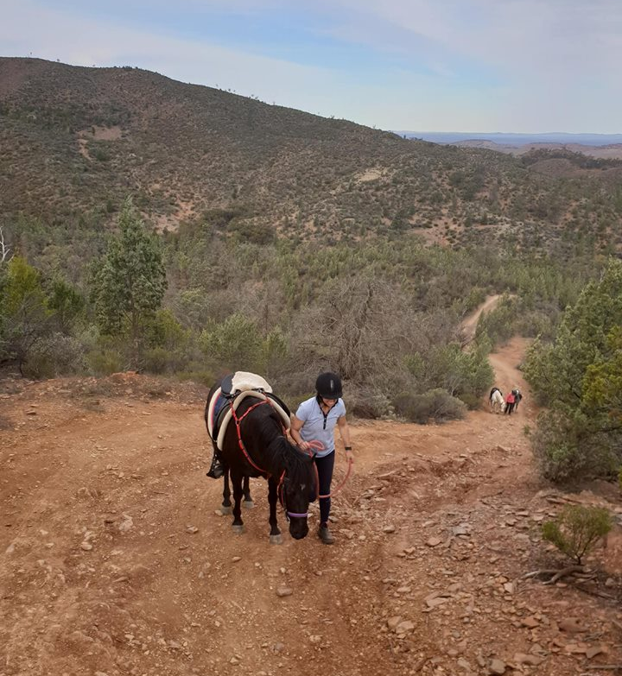
We headed off on an open track with views across flat land to the ranges. I think maybe we rode an hour and then we reached the rocky tracks at the base of the ranges and ambled along a creek bed. We had photos at the base of a beautiful rocky cliff and then from there we headed uphill (pretty much straight up!!!) Kylie on my pony Armani lead the group up the very steep track followed by me on Macca, Sandy on Roo and drag riders Kath & Tamara on Joey and Barry. Armani had a trip on a slippery rock and went down onto his knees and nose, thankfully Kylie stayed in the saddle. We all made it to the top and the views were spectacular for the rest of the ride as we made away across the top of the ranges and then the gradual decline down. The horses were very happy when we reached the windmill and trough as it had been a warm ride. We rode back into camp 3 hours later to a lovely fire that had been started for us by my Dad, Neville who had come along just for the camping experience.

Drinks and nibbles were had by the fire and later on Kylie and I enjoyed tea being cooked for us by Dad.
I forget what time we all headed to bed but I think it was around 10pm

Day2 -Woke to beautiful warm sunshine. Perfect day for a 6 hour day out in the ranges.

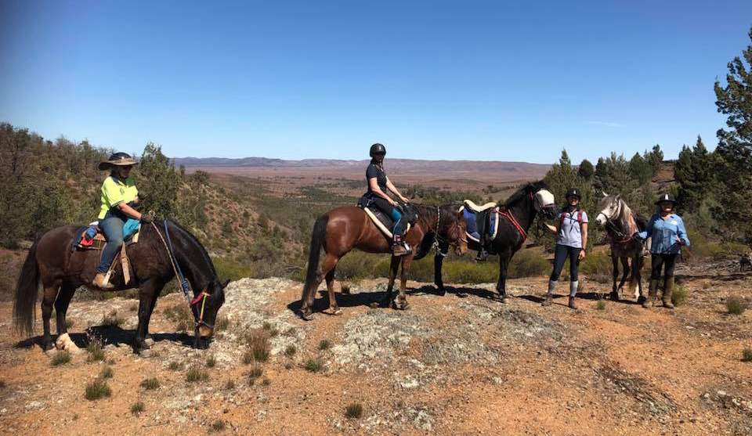
We headed out across the flat, drink stop at the trough, thankfully they all drank because it was going to be a long ride before we made it back to that trough. We headed out behind the ranges and made a gradual uphill climb through rocky pine studded hills to head to the kokoda track. It was magnificent and I loved every minute. Once again Armani powered along in front for Kylie and the rest of us followed. My little Brumby outdid all my expectations for her. His first long float trip.

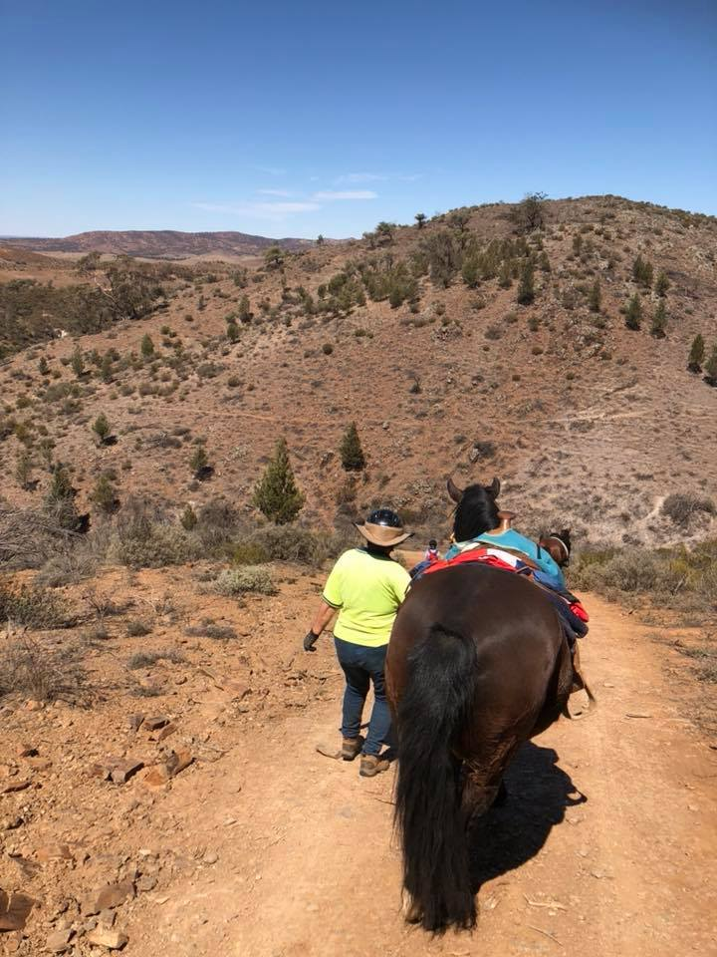
About midday we reached the exciting part of the track. The anticipated steep downhill section and yes it was pretty “straight down” steep. We all dismounted to make it easier for the horses and to avoid falling straight over the front ahaha. Lunch was had along the way at a camp spot in a river bed where we unsaddled and let the horses rest with a few carrots and apples to eat. We stopped for at least half an hour and then in the warmest part of the day was able to follow a shady valley and creek bed back to the water trough. Both Macca and Armani realised the trough was someone close over the hill. There pace quickened and they started licking their lips.

We rode back into camp at 4? I think. Drinks, nibbles and a few laughs and then a night by the fire that Dad had gotten ready for us again after his day of driving around sight seeing.

Day3 -we were all up early, packed up camp and in the saddle by 9am. Another sunny morning, bit of a breeze. Had a lovely 2 hour 20min ride across the flats of Bendelby ranges.
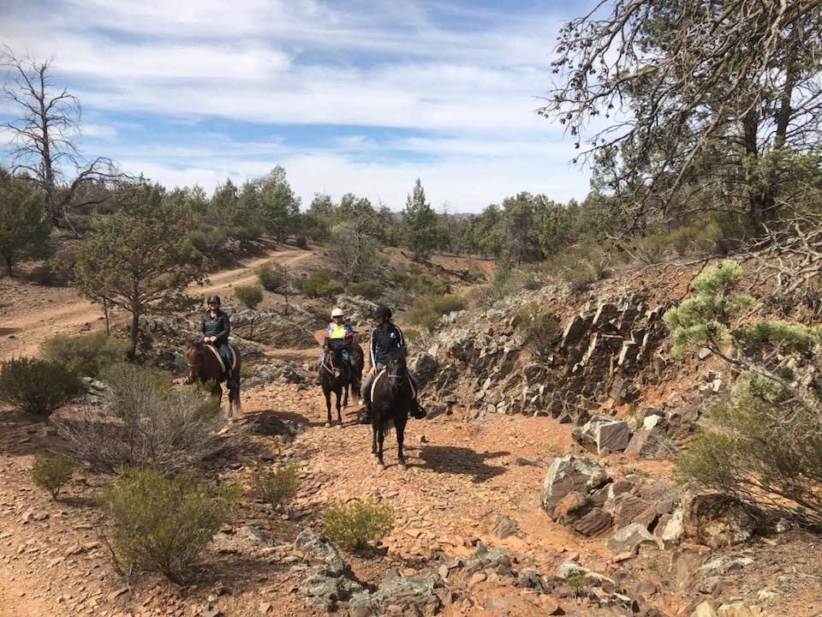
Horses were let go to roll and drink while that last of things were packed up. I had a bit of a fright
when I picked up the last of the haynets to go into the float to find a golden bronze tiger striped snake sitting underneath it!!! While Dad tried to shoosh it away from camp I followed videoing it!!! It was a bit stubborn and much preferred to hang around us and the floats. It made its way around my vehicle and back to where I originally found it and then decided to go and hide under Sandys float where Roo was tied. Dad kept a watchful eye on it, I ducked into Sandys float and leaned out and untied Roo with the snake just underfoot. Eventually it slid off out to the paddock and we all safely got our ponies into their floats and headed on our way home.

Amazing weekend!! Forever memories!! Beautiful quiet horses!! And great company.

Bendleby Ranges Camp – by Sandy
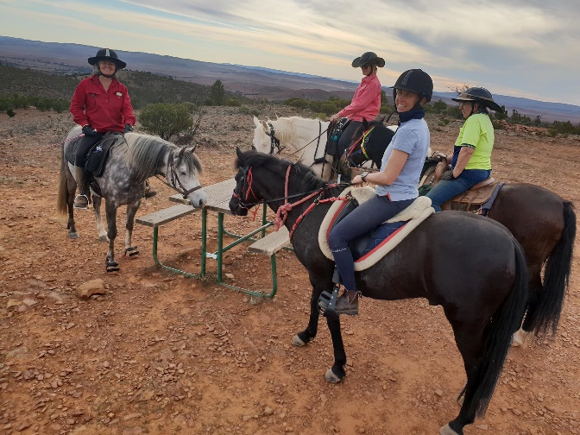
After keeping everyone behind me guessing as to what speed I was doing due to being distracted by the dead carcasses on the road, live emus and kangaroos, camels, loose ponies and pretty parakeets I arrived at Bendleby. Oh how dry it is up there but at least it was warmish.
Friday's ride was a 2.30 start along a reasonably flat but rocky road. Passed a bush camp, then along a creek bed then up a hill, steep enough to make mine and Ru's eyes pop out. Unfortunately none set the picnic table we came across or else the kangas ate it all before we got there. Neville had a lovely fire going by the time we got back.
Saturday we were under way by 10. This time we went down a steep hill. Even I dismounted for this one although I probably would have been off staying on as I had more trouble going down than Ru did. A break for lunch and then back to the water trough with Ru telling me Kath was going the wrong way home but home she got us without any worries.
Sunday was a short ride just to get the kinks out before we headed for home. Makes one wonder just what anything eats up there as its so dry but its still lovely country. The big brown snake under Lisa's hay bag certainly finished the weekend off with a bit of excitement. Just didn't want to go away.
Thanks Kath and Tamara for organising a great weekend.
Bendleby Camp – by Kath

After leaving much later than anticipated & then having to wait for forgotten documents & then turn around beacuase we forgot the BOOZE (whath the !!!!) the most important thing after the pretty ponies, we finally got to Bendleby before 1pm. Horses & beds sorted it was time to Ride – YEE HAA

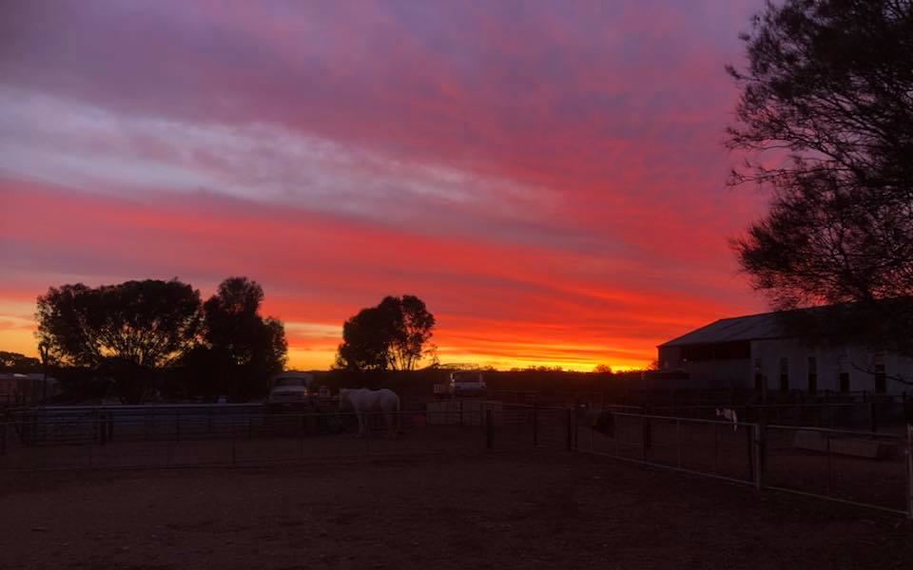
Off on the first ride of the weekend to explore the hills & creek beds in the glorious sunshine. Fist along the creek – easy then up a STEEEEP hill with all stopping for many breathers up the trail not so easy on the lungs & legs as most of us walked up there was a lot of riding ahead for the weekend. Along the ride top for great views of the southern flinders. Back to camp after ~3 ¼ hours to a nice fire started by Neville, THANKS, great to have a camp host for us all to return too. Talking, eating, laughing, drinking & comparing notes till bedtime. Great start to the weekend.

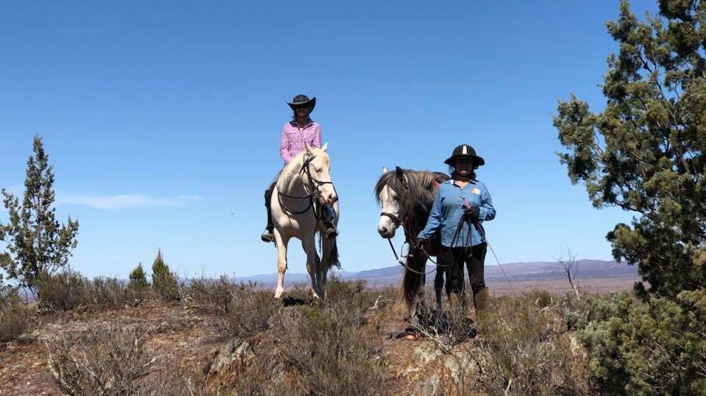
A very cold night followed by a great morning to prepare for the long day riding ahead. A bit late heading out again but well worth the effort. Over the flats, then up the range, for beautiful panaramas once again. Not many flowers about due to the prolonged lack of rain but the hop bush put on a great array of warm colours for us to view. Then time to go DOWN. Kokoda track once again putting the brejebuz up you when you look over the edge & think “who on earth would choose to ride down that”. But once over the precipice its not that bad, even though we all chose to walk down to save the horses backs . Lunch stop in the creek bed & then heading home via the creek for afternoon shade. A bit of an extension over a pretty track to head home a different way for a chance of a trot or two across not so rocky ground. Again a camp fire waiting for us after a ~7 hour ride. A warmer night around the fire & to bed for a great nights sleep.
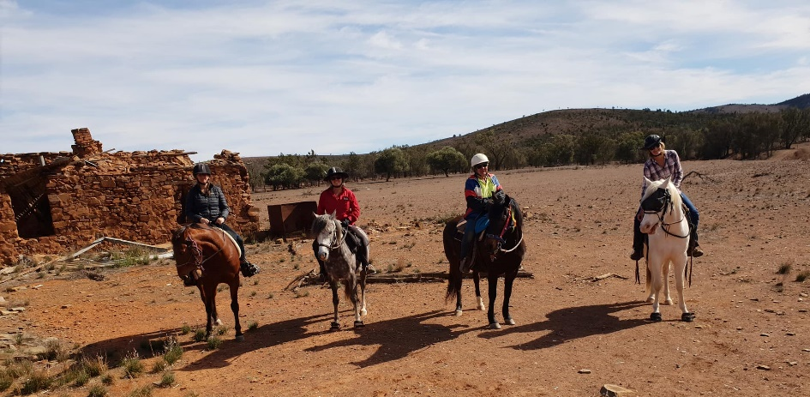
Sunday we were all up & eager for a 9am start so we could head home by midday. Out to some ruins & a different view of the picturesque Bendleby Range from afar & below. Along some lovely tracks, a bit of a trot, photo shoot then back to camp after ~ 2 1/4hrs. Sandy, Lisa & Kylie were full steam ahead after we got back from our last ride to get underway with Neville warning off the beautiful snake that claimed his place in camp. Tamara & I did a slow pack up after lunch & headed home with our ponies, Joey & Barry, who were glad to get back in the paddocks to rest & eat…..

There was only 5 of us who ventured up for the weekend, pity that not many others chose to join us, but good for us as it was great number to ride with. A great weekend once again. You sure missed out if you weren’t there – maybe next time

October Moonlight Ride: Gawler River – Saturday 20 October 2018 – by Julie Jackson
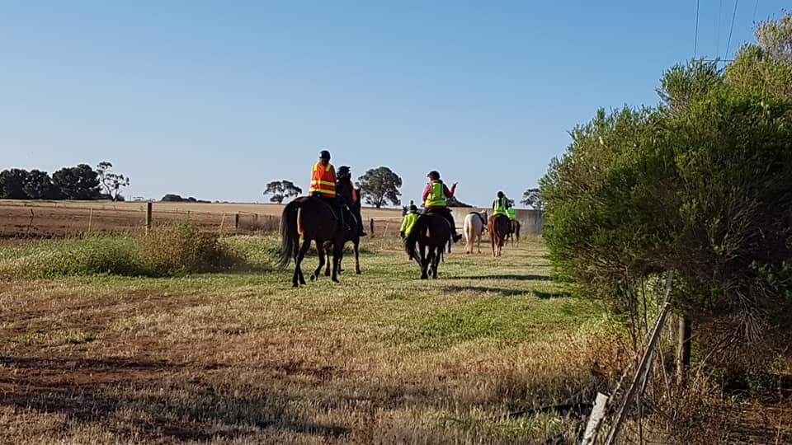
It was perfect weather for a day / evening / twilight ride. No wind and the temperature just right. People started arriving just before 4pm and once parking was sorted and horses settled they headed up to the house for a bbq cooked by William. Members contributed with salads, home made bread – magnificent Kathy and desserts by Sandra, the illusive rhubarb cake, Mae with a scrumptious pavlova and Maria with her famous Anzac biscuits. It was lovely to see Val a past member and Kay Boon who lives just up the road join us for tea thanks girls for doing the dishes.

Contented riders headed back to their floats and saddled up for the ride. We had Kathy, Tamara, Sandra S, Maria, Lisa C and dad Adrian, Yvonne, Mae, Lisa Z and new member Lisa Laughton and myself we headed out at 6.15 and got back at 9.15pm. Grant [Lisa L’s husband], Chris P and William were our traffic wardens which we needed in the first 20 minutes of our ride and the last 20 mins of our 3 hour ride on mainly back roads of Kangaroo Flat and I only saw 2 roos. We had a little hiccup with Maria’s horse taking 5 kms to decide that a grass seed missed in her saddle blanket was finally annoying her so she started to play up. I rang her husband back at the house who came and got them. Kathy and Tamara stayed back with her as required by club rules and we rode on. They finally caught us up about 4 kms from home and I lost them again. Another rule always stop at a road junction to allow all riders to catch up (especially in the dark). Luckily Tamara and I had the 2 way radios.

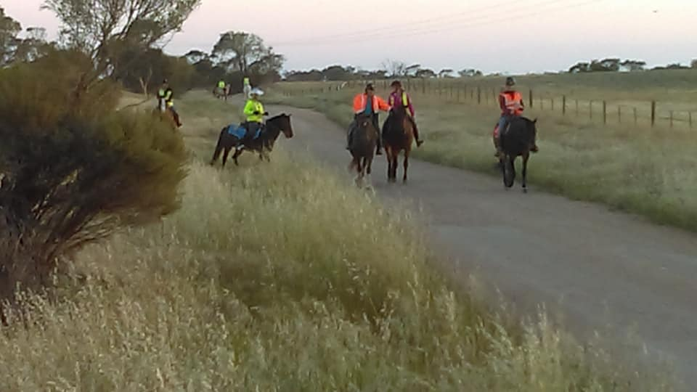
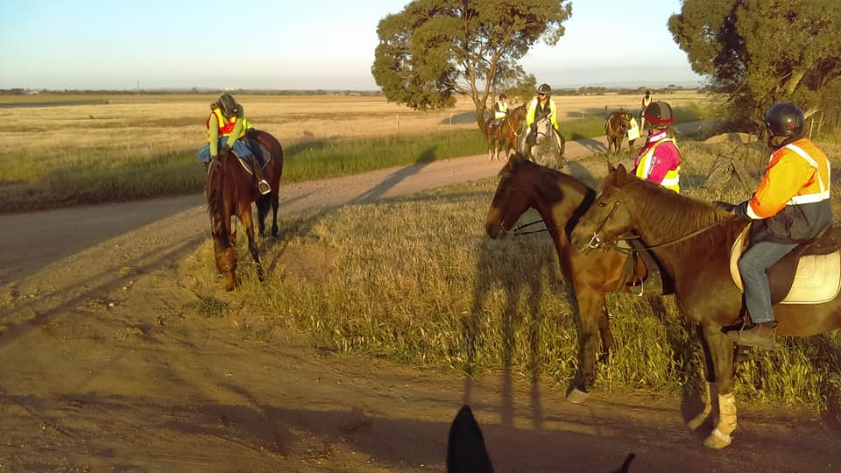
We did all get back safely in the moonlight and most stayed back for a cuppa and yoyo biscuits. The rhubarb cake was eaten by the boys while they waited for us, “beautiful and tasty “ were the words I heard. Many thanks to all who contributed to a great night. It was a shame that the best part of the ride was in the dark and a few members would love to do the ride in daylight so we will have to plan this.

Horse Health & Wellbeing

Things You Should and Should Not Put on a Horse's Wound – from “thehorse.com”

Horse owners and veterinarians have been treating equine wounds for centuries. After all, horses are unabashedly practiced at the art of sustaining wounds. Over the years we’ve tried many different wound ointments and salves, cleansers and dressings, but not all of them are backed by evidence of safety and/or efficacy.
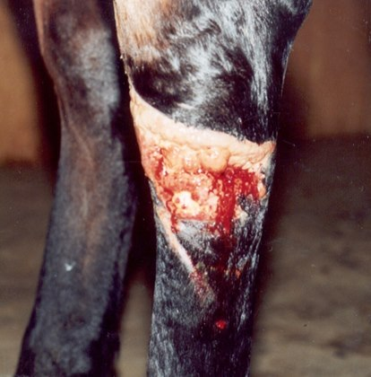
So Dean Hendrickson, DVM, MS, Dipl. ACVS, professor of equine surgery at Colorado State University, in Fort Collins, went back to basics, describing effective and ineffective wound-cleaning agents to an audience of veterinarians at the 2015 Annual American Association of Equine Practitioners Convention, held Dec. 5-9, in Las Vegas.
Although our intentions are good, “most wound-cleaning agents and techniques will cause chemical or mechanical trauma to the wound bed,” he said. “Weigh the benefits of cleaning the wound against the trauma that agent will cause.” In other words, ask yourself: Is that cleaning agent ultimately going to speed up or retard wound-healing?
Before applying anything, however, clip the hair around the wound to prevent it from contaminating the area. Then, use sterile gauze to very gently scrub the wound. “If gentle scrubbing doesn’t work, use a different technique,” said Hendrickson. “Don’t scrub harder.”
One approach is saline lavage to remove surface debris—“One of the best things we do,” he said. Again, don’t use much pressure; a gentle showerhead-type sprayer works well.

Hendrickson then delved into the common topical treatments we apply to wounds and which ones are safe to use.

Saline
Hendrickson referenced saline again and again throughout his presentation as one of the most simple, yet effective, wound-cleaning agents. Hypertonic saline, in particular, is very effective for debriding (removing surrounding dead, damaged, or infected tissue) while lavaging and for reducing bacteria in the wound. It does have the ability to damage normal cells, as well, he cautioned, so use it only in infected wounds.

Povidone Iodine (PI)
While povidone iodine has been used extensively in equine wound care, Hendrickson cited several studies showing that it causes tissue necrosis, impairs healing, and leads to increased infection. “Consequently, PI should only be used around the wound over intact skin and never in the wound itself,” he said.

Chlorhexidine
Hendrickson explained that chlorhexidine has low systemic toxicity, but studies have shown little evidence of its safety and efficacy reducing bacterial numbers without causing wound trauma. It also causes tissue necrosis and bacteria regrowth, he said.
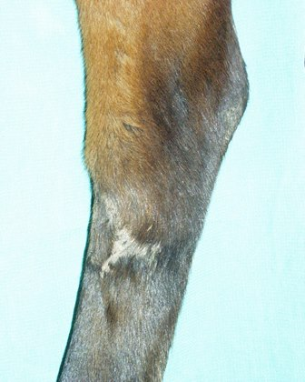
When treated with the proper products, many horse wounds heal well.
Photo: Dean Hendrickson, DVM, MS

Hydrogen Peroxide
Popular for its effervescent activity, which can convince the user it’s thoroughly working, hydrogen peroxide has few beneficial or negative effects. “Its antimicrobial properties are probably greatly overestimated,” said Hendrickson.

Acetic Acid (Vinegar)
“There is science behind using common distilled vinegar, even though most people don’t consider it,” he said. “Its low pH is not compatible with certain bacteria like Pseudomonas,” meaning it can be effective against this common disease-causing pathogen.
He suggested using this agent as a 15-minute gauze soak or compress per day and then rinsing with saline.

Surfactant-Based Cleansers
Hendrickson explained that these cleansers are minimally toxic and irritating, but not necessarily nontoxic. “They are very effective on minimally contaminated wounds and should be applied, allowed to sit for 1 to 2 minutes, rinsed off, and reapplied as necessary,” he said.

Topical Antibiotics
Drugs in this class are effective at reducing bacterial numbers, but their overuse contributes to antibiotic-resistant microbes. Thus, Hendrickson suggested using them for only one to two weeks and choosing one you have confirmed the infecting pathogen has sensitivity to. Common topical antibiotics for wound care include:
- Silver Several studies have shown the efficacy of this antimicrobial agent. It most commonly comes in the form of silver sulfadiazine cream, but it is also available in a dressing form. Hendrickson said silver also contributes to less exuberant granulation tissue than other ointment options.
- Nitrofurazone He emphasized that there’s not a single positive study about this common topical antibiotic and, in fact, it might even retard healing. “Don’t put it in open wounds,” he said bluntly.
- Triple Antibiotic Ointment This product, used since the 1950s, still has good bacterial susceptibility and many studies (although primarily in humans) have confirmed its efficacy. “Along with silver, it’s one of the best topical agents available to use in a wound,” he said.
- Honey Honey derived from plants like the Manuka bush have an antimicrobial effect. Just remember that not all honeys are created equal and to only apply ones that have antimicrobial benefits to wounds.

Dressings
Hendrickson described a variety of dressings that serve different purposes. Debridement dressings, for instance, are designed to remove bacteria and necrotic tissue from the wound. Gel dressings are designed to encourage moist wound healing in dry wounds. “We know moist wounds are healthy wounds,” he said. Granulation tissue dressings help encourage proper wound healing and contraction when the wound is lacking granulation tissue. And epithelialization dressings help finish off the wound healing process.

Take-Home Message
In summary, Hendrickson encouraged us to forget what we’ve heard about “magical cleansers” purported to heal wounds and, to take a line from human medicine, “Don’t do to a wound what you wouldn’t do to your own eye.”
Saline, surfactant-based wound cleansers, silver, and triple antibiotic ointment are the few things we should put in wounds, he said.

Horse Humour

Sheila walked into the stables to find Bruce stalking around with a fly swatter.
"What are you doing?" She asked.
"Hunting Flies" He responded.
"Oh. Killing any?" She asked.
"Yep, 3 males, 2 Females," he replied.
Intrigued, she asked. "How can you tell them apart?"
He responded, "3 were on a beer can, 2 were on the phone."

NEWSLETTER DEADLINE
The deadline for any items that members want printed in the November 2018 newsletter will be Thursday 22 November so please ensure that your emails reach Kath kathryn.mccullagh@hotmail.com before that date to avoid disappointment.

Policies
A reminder to all members that our club has some policies that we endorse. These include a NON SMOKING, SAFETY & HOT WEATHER policy. These can all be viewed on the ATHRA web site, via the state page - www.athra.com.au.
Previous Newsletters, photos & club information can also be viewed at any time on the ATHRA web site.
WEATHER
The ride host/leader for the day will have the final say regarding weather (including inclement weather).
The hot weather policy states, if the weather forecast in ELIZABETH for the next day is to be over 32 deg (as per the news the night before) the club rally/ride will be cancelled (unless the ride is scheduled to commence prior to 9am or after 6pm). This is for the safety of all riders and horses. Also, any club rides in FOREST areas on TOTAL FIRE BAN days will be cancelled.
Please check with the Trail Boss if in any doubt. They have the final word!
CLUB UNIFORM
Our club uniform currently comprises of a lime yellow high-vis shirt (long or short sleeve), club badges available for $12. Gawler Club Members & their visitors are required to wear Safety Helmets whilst mounted - helmet must be no more than five years old from Date of Manufacture.
RIDE FEE & DAY MEMBERS
ATHRA members - a ride fee of $2 per ride is applicable.
Non ATHRA Members (Day Members) – a ride fee of $25/person/day is applicable ($10 to club on the day & $15 to ATHRA with pre-registration) (Non-refundable fee, maximum 2 days as a day member).
The important things to note: 1. Day Members must be sponsored and accompanied at all times by an ATHRA member during the ride or event.
2. The Sponsoring member must make the Day Member aware of ATHRA rules and requirements of the Code of Conduct.
3. They may only sponsor 1 Day Member per ride.
4. By participating as a sponsor, the sponsoring member acknowledges responsibility for the conduct and behaviour of the Day Member
5. Day Members must contact the trail boss to discuss attendance & then pre-register with ATHRA Online at least 3 days prior to ride.
RIDE HOST CHECKLIST
A ride host’s checklist is in the green bag, in which is kept the sign in book, ride fee tin, saddle bags, first aid kits, safety vests, etc. Trail Bosses are to check the list to make sure all is in order prior to your ride. It is also the Hosts responsibility to ensure a ride report is arranged to be submitted to Newsletter Editor prior to next publication date.

DISCLAIMER
The material in this newsletter is for the benefit and information of our members. The items are in the nature of general comments only and are not to be used, relied or acted upon without written permission of GTHRC. The club accepts no responsibility for any errors or omissions or for any damage suffered as a result of any person acting without written advice. All opinions and views in the newsletter are not necessarily the view of the club, but are personal opinions only.

