TAMWORTH BUSHRANGERS TRAIL RIDING CLUB
Newsletter – JUNE 2018
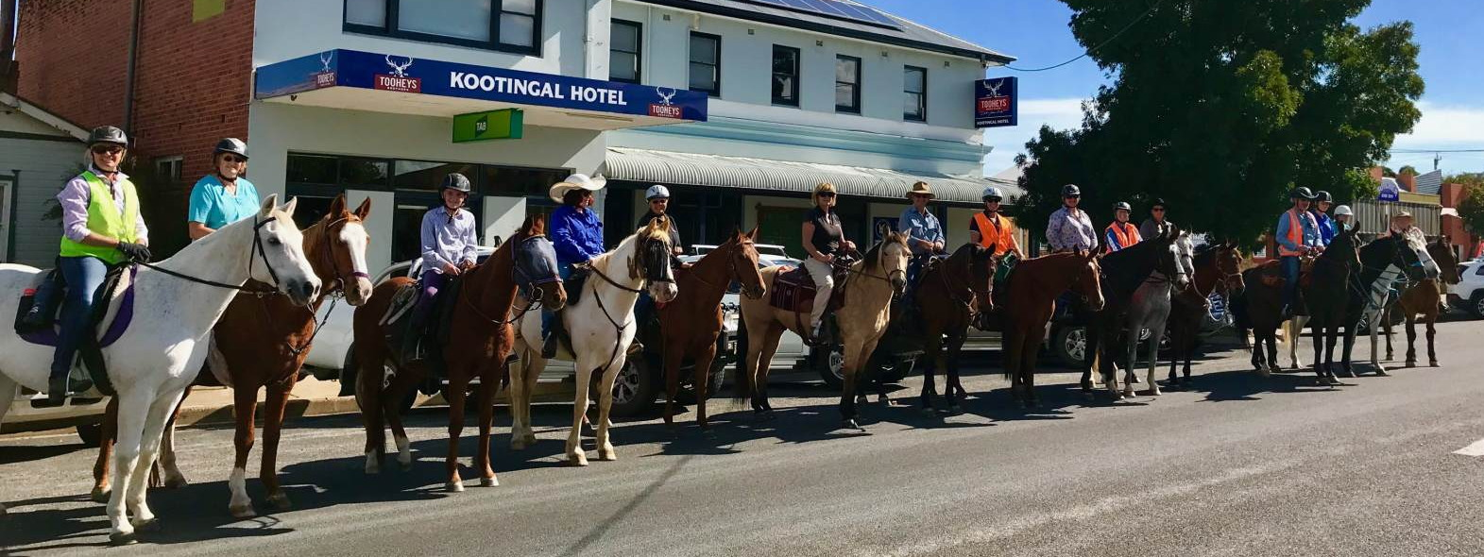
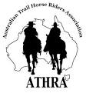 | President: Angela Witherdin  0418234854  awitherd@bigpond.net.au  Vice President: Bev Fletcher  Secretary: Francie MacLean  0407660334  Treasurer: Anthony Read  0409362434/67665448

BUSHRANGERS OUT AND ABOUT …..
If you see something interesting or are involved in other horsey events club send a note to …….. barlowpark2@gmail.com to be included in the Newsletter – and don’t forget your photos. Read an interesting article that you would like to share with other members (or a ‘funny’) send that to be included. After all the newsletter will only be interesting if members make the effort to contribute.

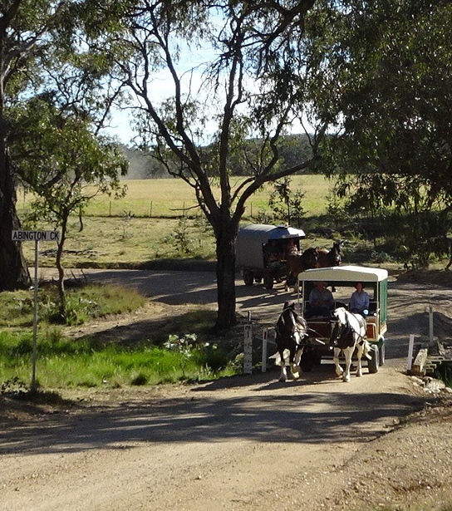 | HOLIDAY WITH A DIFFERENCE  In early January this year some friends of mine accompanied by another couple with a passion for heavy horses set out for a week’s holiday ‘with a difference’. They travel approximately 20km a day on quiet back roads on the western fall of the New England ranges in their ‘wagons’ powered by some gentle, truly magnificent horses. Setting up camp each afternoon at pre-selected locations on either TSR’s or private property by a stream or secluded dam to boil the billy and sit around the camp fire with nearby property owners and other friends who drop by for a yarn (or more than likely ‘a tall story’)

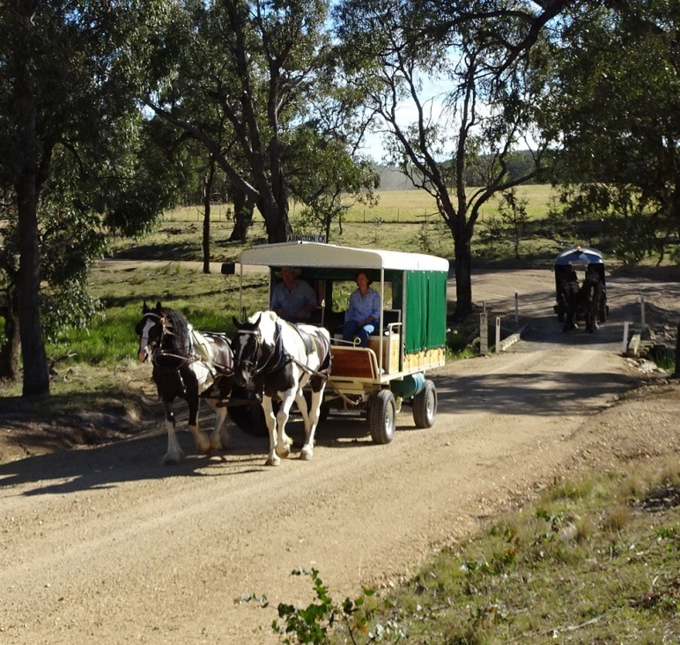 | 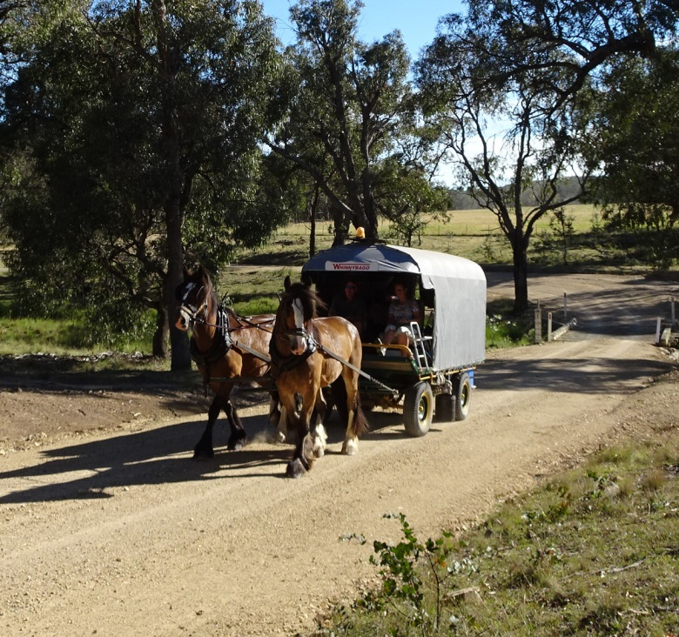
The Wagon on the right is called ……… |  | 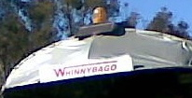
❃❃❃❃❃❃❃❃❃❃❃❃❃❃❃❃❃❃❃❃❃❃❃❃❃❃❃❃❃❃❃❃❃❃❃❃❃❃❃❃❃❃❃❃❃❃

JUNE RIDE REPORT

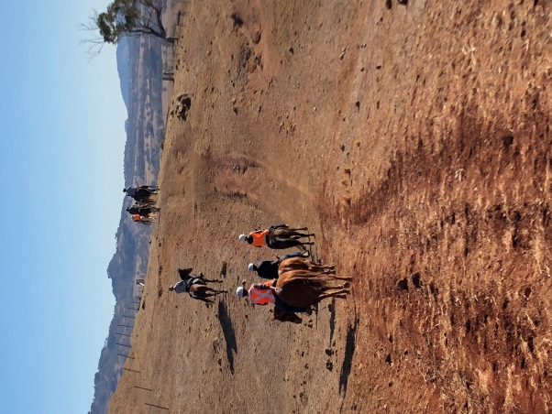

“Whyallia” via Nundle.

We gathered on a crisp bright clear morning at the magnificent property of Judy and Kevin Gill. Our club has ridden on this property previously and it is a stunning ride, although this time, sadly drier than we have ever seen.

I managed to find my way there without getting lost. It’s true!! (Thx to my young navigator). The same cannot be said for someone else who shall remain nameless. Despite passing me at a Maccas stop on the highway...still got there after me. 😂😂😂😃

We welcomed visiting riders and new friends Michelle and Kevin and set off at 10am. It was lovely to again ride with Judy. She is one of the many dear people I have had the pleasure to call a friend and a fine example of the lovely warm people this club attracts. It was also lovely to see Terry back in the saddle on his lovely gentle mare.

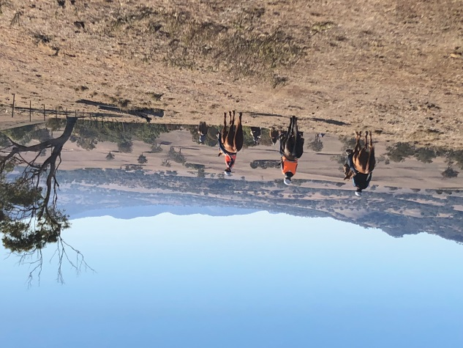 | 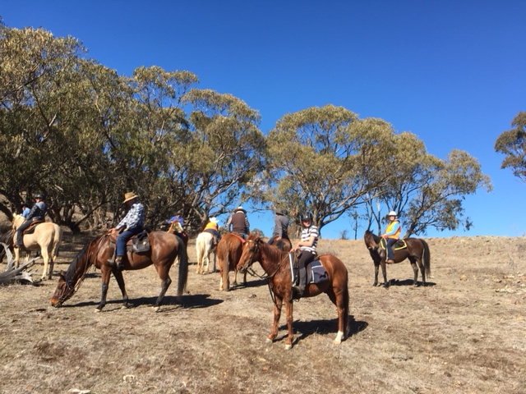

I had only one of my daughters in tow, Miss Eloise on her newish buddy Fleetwood, who again didn’t put a ‘foot’ wrong. Unlike my steed who despite a reasonably taxing ride, thought it should be done at a canter...gggrrrr.

We were able to get up fairly high on this property and were treated to lovely views. We are very grateful to Jude’s hubby Kevin who’s trusty Landcruiser acted as a chuckwagon and assistant guide. I felt like.....cattle following the hay filled ute.....no wonder Smokey was keen to keep up!
Lunch was at the cattle yards and we all enjoyed catching up. However I did note a quieter lunchtime than normal with the absence of Helen, Ange, Francie and Dot. Eloise especially missed her lunchtime story teller and general club entertainer Helen......  In all a lovely ride as always. Again thx to Kevin and Jude, and to Miss Donna for organising it.  Till next time  Toodle Pip  Megsy.  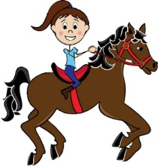 |  | 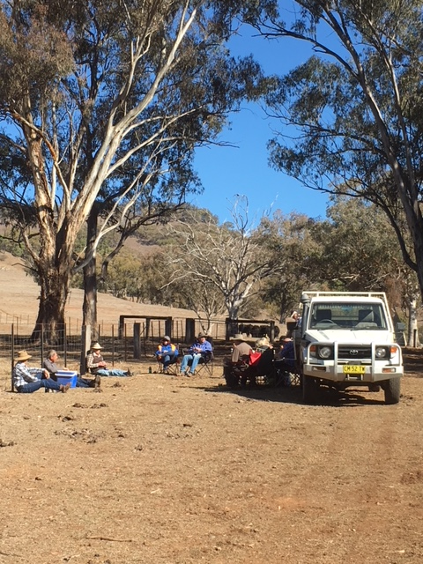
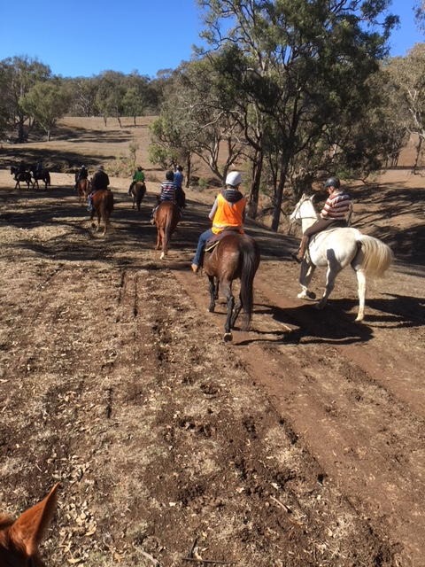 | 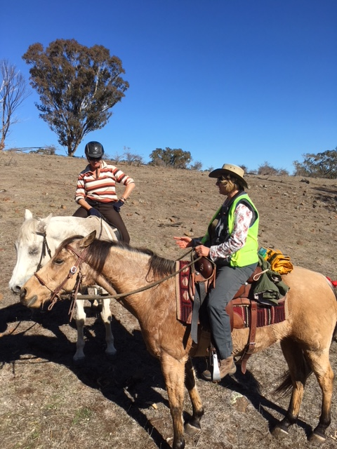 |  | 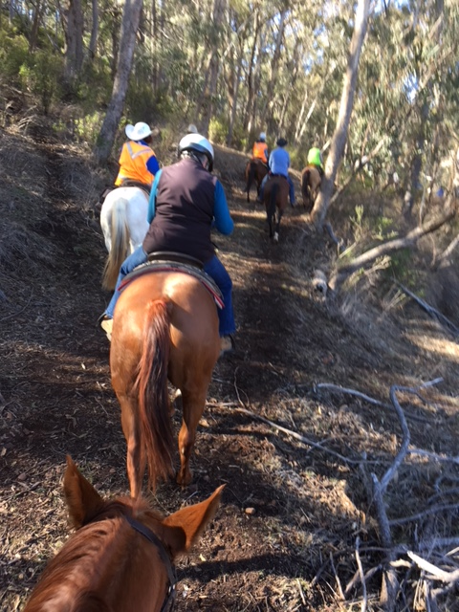
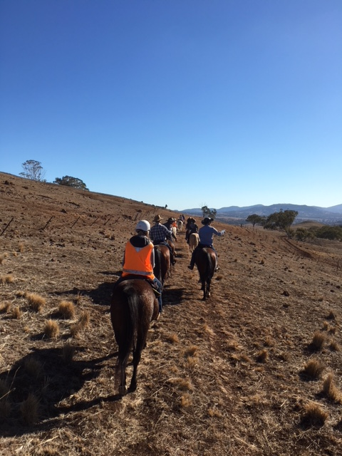 | 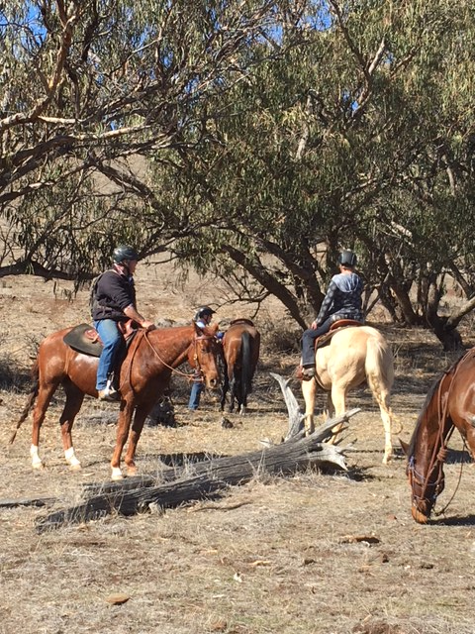 |  | 