South Coast Association of Trail Horse Riders SCATS
Hi everyone, Sorry for the late May Newsletter but we had to wait till Bendethera ride and chainsaw course to make a newsy letter. Lots have happened since our last meeting some of which is in the newsletter the rest will be discussed at our monthly meeting back to our usual 3rd Wednesday of the month at the Tomakin Club 6pm That’s 18th May .
I have set up a Face book site (using our official name) https://www.facebook.com/South-Coast-Association-of-Trail-Horse-Riders-SCATS and anyone can see all the photos Karen Scott took on the Bendethera ride. If you have some photos you can put them on the site i will also put our newsletters on the ATHRA web site.
Alisha has written her ride report for Shoebridge and it will be placed in the Ride Book with map and photos.
We are hoping to get more photos of old rides so if you could let me have a copy it would be much appreciated.
Future rides in 2016:
Sunday 15th May Benandarah State Forest. Through the bush on Bill’s tracks. Meet at Spoxton,s Farm home of Kath Grindrod. 293 Old Nelligen Road Nelligen . 0930 take off from Kaths. Any queries ring Sue 44781029 Smoko on the track.Bring late lunch to have when we get back.
SATURDAY 4th June day ride at Karen Ryan’s 57 Malabar Road Moruya. Bush and Beach ph 44742973 or Karen Scott 0428643133 for details.
June Long Weekend 11,12,13th, June Woila Creek this is a packing weekend. Names in by 5/6 Details Karen Scott 0428643133/John Davidge 0424788116
10thJuly Day ride at Neville Davies @ 468 Congo Road Congo. Beach and Bush 44745896. Stay tuned for times.
23,24th July Wadbilliga 2 daya with support crew Contact Karen Scott
2016 Committee
President:-Lawrie Smith 044713754/0414429802
Vice Pres:- Lesley Whale 0421331002
Secretary:-Sue Clifton 44781029
southcoasthorseriders@gmail.com
Ride Sec:- Karen Scott 0428643133
Trail Boss:- John Davidge0424788116
Treasurer:- Terry Love:-0408489536
Publicity :-Sylvia Sharpe:- 0427059236
Newsletter :- Karen Ryan:-0411740188

Anyone needs to put money into the SCATS account??
Westpac Batemans Bay
BSB.032681
Account.204143

What’s happening?

Lesley, John Davidge and Sue Clifton attended a Get To Know The Regional Manager and ask questions pertaining to his position. Cobargo and Wanderers had questions on insurance matters prepared and Tony answered and explained. We must have spent at least 11/2 hours just on this topic. Just shows you how confusing it can be and we were glad to have had this opportunity to listen.
Our questions related to role of ATHRA in National Parks meetings. Tony gave us ATHRA Director Pam O’Neil’s name as land manager and we will make every effort to compile a letter asking her to clarify her position and her thoughts on trails in our area offering any information she needs to assist her knowledge of the area. This will be presented to a meeting before being sent off. If anyone would like input please let me know. Cobargo news letter has a more detailed account of insurance matters.Have a read.
On 21/22 /4/16 Harold, Lawrie, Bill, John and Michael attended a chain saw accreditation sponsored by National Parks
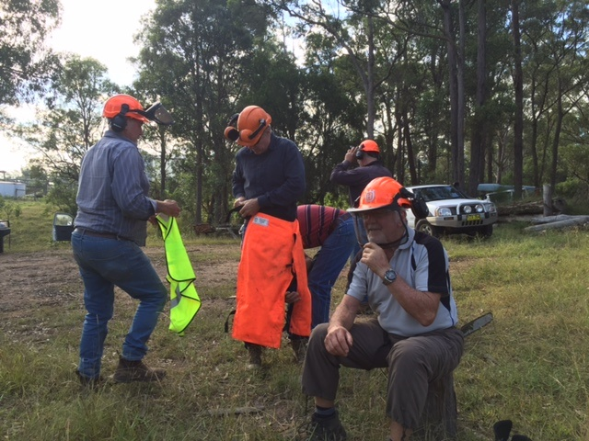s 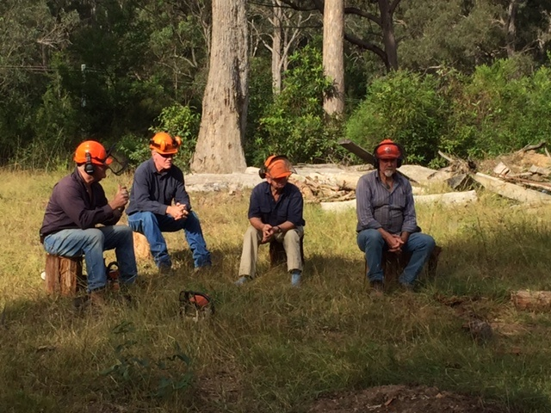
Chainsaw Course held at Moryua TAFE.21,22/05/16
If you want a laugh ask the boys who wore steel cap boots!
Thanks to National Parks our track clearers are all schooled up and ready to hit the tracks. Bill has mentioned that he would like to start with clearing the bracken near Bendethera.

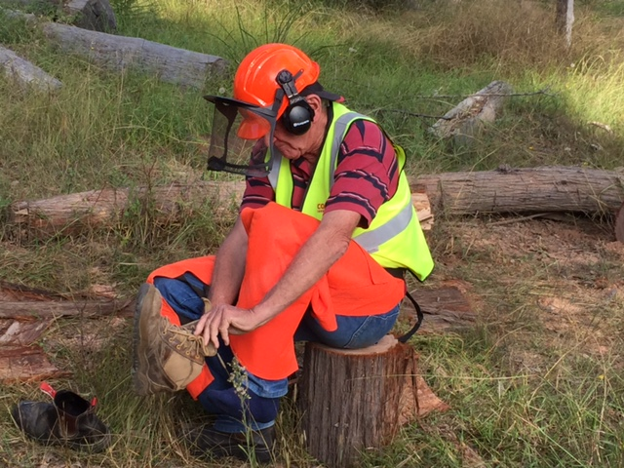

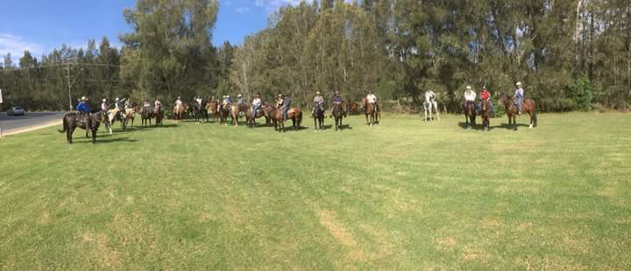
Termeil Ride with Cumberland as host club.
10 SCATS riders camped on Friday night on the property of Laurie Baxter, I personally was in awe of the caravans and floats, these Cumberland riders are seasoned at this type of camping. A camp fire encouraged everyone to share trail and life experiences and we were made to feel very welcome.
Three more riders came in the morning and ETD was 9:30 and after a briefing by David Club president we were on our way guided by Lawrie Baxter, first obstacle was the Princess Highway after listening to the traffic half the night I thought we would need a police escort. However over the road safely we were into the Meroo National Park where we followed some very long legged horses down a very old logging trail down to Termeil Lake. After the horses had settled we could enjoy the big spotted gums and different vegetation in the swampy areas. Thank goodness for a dry spell otherwise it would have been a very boggy ride.
The sound of the ocean excited our fellow riders from the highlands; they had come with a bucket list. Canter along the beach and ride in the waves, some will have to come back. Our group meandered between high and low tide marks and I hoped Bob didn’t want to join the cantering throng. Over the headlands and a few more beaches then a short diversion along the streets to where we had lunch at the Bawley Point shops on the grass a convenient spot.
Homewood bound via the main street and the residents could hear 100 hooves on the pavement, we were glad to leave the streets for the bush and beach again. Last chance for some on the beach at the edge of Meroo Lake, aren’t we lucky we have similar areas, so accessible to us.
On the way home three groups developed a faster, middle and those enjoying the scenery. Obstacles like branches and vines brought one rider down, nothing a good machete couldn’t handle. Luckily she was ok and continued the ride.
Crossing the highway again cautiously, then under the power lines back to where we started.
By the end of the day the horses and riders were happy for a rest two members stayed for the Sunday ride the others opted for the comforts of their beds and no traffic noise.
So with all the thankyous said we were on our way home planning for our next ride to Bendethera.
There are lots more clearer photos on Cumberland’s Trail Horse Riders - Facebook Site.

Anzac Weekend Bendethera Ride 2016.
After many texts and phone calls logistics were sorted by John Davidge. Bay Removals once again came to our assistance with transport for us and our trusty steeds to Coondella Trig. Our instructions were to be at Bay Removals for 0600 take off so with due diligence Sue Bill and Bob arrived the evening before in case of floating issues. Neville slept at the yards to avoid getting up very early. Headlights appeared at 0500, nobody was game to be late. Guess who turned up late, our Trail Boss and the only one game to have a crack was Genevieve and that’s what it was like for the whole trip.
All 10 riders were ready and on our way up to Coondella Trig headed for the Georges Pack track, one of our Wilderness Heritage Trails opened for a trial in 2014 by National Parks. The track we were taking made it possible for early settlers to move between properties and towns like Snowball and Moruya just like we were doing the only difference they did it out of necessity we were doing it for fun. And that’s what it was lots of fun and laughs and with an Irishman in the group “Fooken Hell” and “Hey Johnny” were regular phrases from the front of the pack. Kimberly did her best to keep the boys under control up the front.
Not long after we started our descent Karen R was riding on little Teddy’s neck .This was the first WOOW and after that every WOOW was noted by the Boss. Shane came back to put some muscle into tightening girths but another WOOW came as Genevieve and Karen S simultaneously rolled their saddles. Genevieve has a history of rolling down hills on narrow sections and didn’t disappoint. Karen said she was quite graceful. Both their horses new to the trail stood perfectly still while resaddled.
Coondella Creek was beautiful and clear. Karen R can testify to its coolness. At the end of the pack she didn’t notice how we hugged the outside of the creek and little Teddy decided to take a short cut. A log stopped his forward movement and water filled her saddlebags and jeans WOOW again. Sylvia’s Whisky thought it a bad idea to go into that creek at all, Alisha came to the rescue and led her through.
The track remains just wide enough for one horse and occasionally you can see the work of the old timers. Rocks strategically placed 150 years ago. The track itself is gentle on the bush until you meet the bulldozer fire trail .I am sure there is a ZIg Zag to be found around there, those old timers wouldn’t go straight up and down.
Lesley packed Guts at short notice and she did a great job carrying the chainsaw which was used a few times to clear the path. The ferns and prickly bush were in places impenetrable. The horses at the front did a great job pushing open a trail. Sylvia remembered the previous year the track being much clearer it proves that a couple of good seasons and we are back where we started.
With the daylight hours getting less John D was mindful of getting into camp without torches and no one was game to say WOOW except Genevieve.
The sounds of the camp ground made the horses walk faster, campers were surprised to see us come out of the bush and past their camps .We watered the horses in the Deua and made our way to the horse yards. Their home for two nights. The boys Terry Carl and Bill had set up camp and Bruce and Ann had driven up the track to see we were on our way.
Around the fire, a good night of stories, poems and the history of SCATS and its relationship with the track since the 1990,s In one conversation Bruce talked taking 6 months of weekends clearing the track. A mighty effort.
Sunday was a restful day some choose to walk to the caves ON FOOT; some took a short ride with JD. I took Bill back up the track to experience logs, ferns and prickly bush. Neville had a chat to young campers. I don’t know what he said but the music was a little more subdued Sunday night. We did get our own back, Anzac morning Terry and Bill turned on the car radio and we listened to the ANZAC Dawn Service. Laying in a nice warm swag, full moon heavy mist, peace and strains of the last post all made it perfect. Other campers also appreciated the effort.
Bacon eggs and official thanks to the ground crew we were off ahead of schedule .Up towards the caves and a left turn between Con and Little Con took us past Kurrajongs and Figs as the land marks. Through the grey blue wattles and onto the Zig Zag reaching 1000 metres at the Minuma Range after going through dense wattles all the way up the ridge.
The next section was so different with many Burrawangs and Snow gums and the headwaters of the Shoalhaven River where we had a short lunch, mindful that we had to be finished at 2pm. The track is much more navigate able towards this side of the range and more time to take in the scenery without dodging bushes and prickles. Avoiding Wamburugga Swamp and to the north side of the dam we were on the fire trail to Snowball.
The horses quickened their pace, knowing their job was nearly done when we heard Bay Removals semi. Bruce and Ann had given up their public holiday Monday to pick us up. Off with the saddles into the truck and down the Clyde. Next thing we were home thinking how lucky are we to have the opportunity to ride these tracks. Many thanks to everyone for a great weekend.
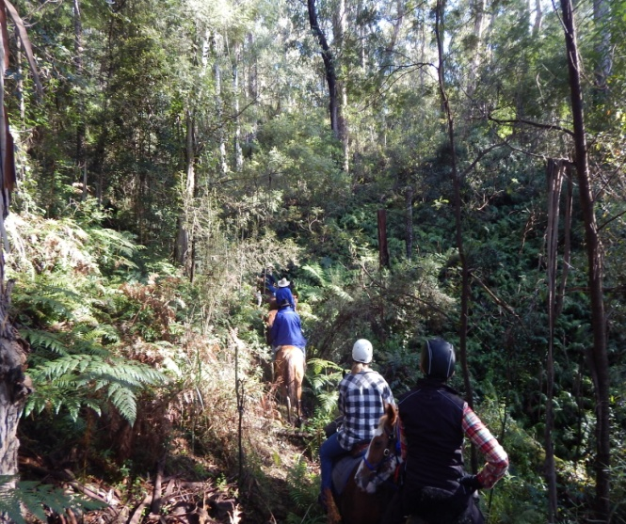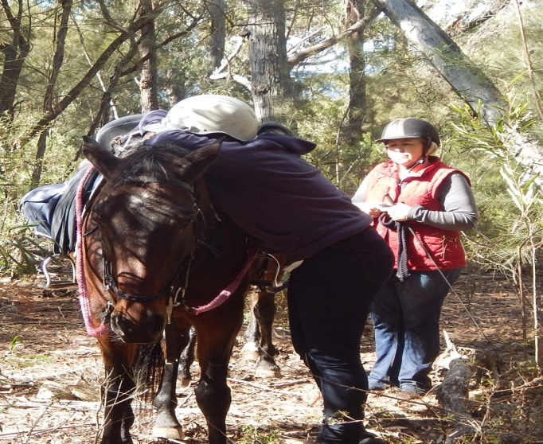
SEE MORE on South Association of Trail Horse Riders on Face Book.
Message from Karen Ryan..Lucerne Hay Large Bales $200.00 Ring Maxi Mulch 0414650582

