South Coast Association of Trail Horse Riders SCATS
Hi everyone, June newsletter early as I am going to be a Grandmar again this time flying to Doha, so see you in July leave you in the capable hands of the committee. Still send emails to Club address.
Most important notice is that Lawrie has resigned as President but he remains an active member of the Club, Thankyou Lawrie for all your efforts. As a consequence, a new president will be elected at the next meeting on 15th June 2016. If you have a desire to help out and do the job, please nominate or encourage someone else and get their permission to nominate them. If you cannot attend the meeting a letter will suffice.

Future Rides in 2016:
Sat 4th June
Karen Ryan’s @ 57 Malabar Road Moruya 0900 for 930 Karen doing lunch. Book in ring Ride secretary Karen Scott 0428643133

June Long Weekend 11,12,13th June Change from Woila Creek packing to Base Camp Rides @ Belowra with day rides at Myrtle Creek and surrounds. For directions and further information ring Karen Scott 0428643133 or John Davidge 0424788116

10th July Day Ride at Neville Davie’s @468 Congo Road Congo. Further info will be need as Neville might be away stay tuned as there may be changes.

23,24th July Wadbilliga with support crew this ride is dependent on weather conditions could be very cold or wet and will be discussed further at next meeting.

30-31st July TBA

Remember to contact Karen about weekday rides there is always something going down.
2016 Committee
President:- VACANT
Vice Pres:- Lesley Whale 0421331002
Secretary:-Sue Clifton 44781029
southcoasthorseriders@gmail.com
P.O. Box 697 Batemans Bay NSW.2536
Ride Sec:- Karen Scott 0428643133
Trail Boss:- John Davidge0424788116
Treasurer:- Terry Love:-0408489536
Publicity :-Sylvia Sharpe:- 0427059236
Newsletter :- Karen Ryan:-0411740188

Anyone needs to put money into the SCATS account??
Westpac Batemans Bay
BSB.032681
Account.204143

What’s happened?
Only short this newsletter as we have covered Bendethera in our late newsletter last month.
BENANDARAH STATE FOREST RIDE SUNDAY 15th May 2016
The day started off well weather wise and only got better. 9 riders and horses, met at Kath Grinrod’s property at Nelligen. Kath, Sylvia, Lesley, Sue, Karen S, Jane, plus J D, Harry, and I haven’t quite worked it out yet co's I can't understand him, but it is either Shaun or Shane, but Irish definitely suits. Great young bloke, first to fly off to open a gate or tighten up some bodies girth. Welcome on board Irish.
We hit the bush and followed trails, motor bike tracks forestry roads, power lines and cut tracks with every possible coloured ribbon you could imagine, courtesy of Bill the bush basher. He did a pretty fair job for a little bloke, very horse friendly. Everyone was looking forward to smoko as Bill had built it up big time and he didn't disappoint. The billies were boiling and all went well. A few of us were reluctant to get back on and ride off.
We headed back in the general direction of home, there were filtered views of the Bay and the coast line all very pleasant with good company, and plenty off repartee. All the horses were well behaved, pretty boring really, I don't mind a bit of a rodeo as long as it's not my horse preforming.
We arrived back at Sue and Bills for a late lunch, very pleasant spot, where the girls all had a beer and the boys a cuppa. ????
Some old photo albums of SCATS rides and riders were on view.
Back in the saddle and over the paddocks to the floats. Thanks Sue and Bill, great day.
Geez I slept well last night, Cheers H.

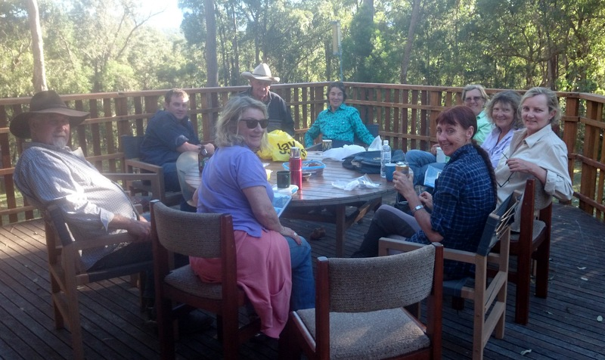
Late lunch at Sue and Bill’s.

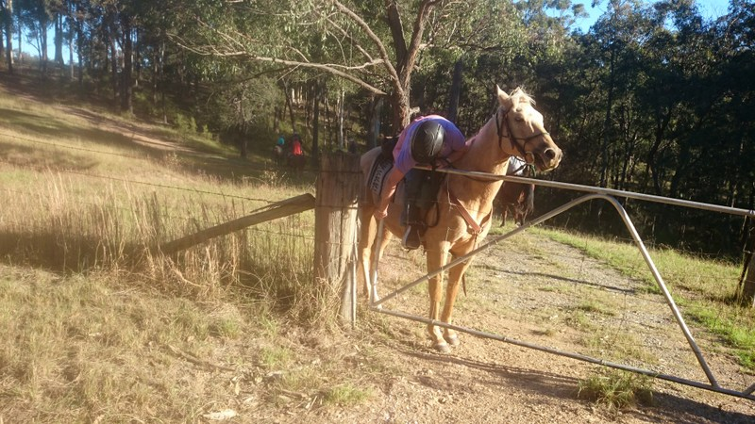
Jayne showing us one of the Accreditation Skills needed to be a Tail Boss.

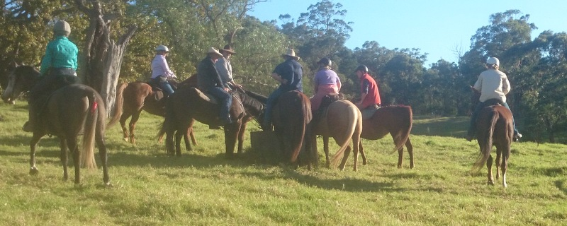
Thirsty work, watering at Sproxton’s Farm.
We are trying to update our photos of club rides if anyone has photos or articles from previous rides please let us know or put them on our Facebook site South Coast Association of Trail Horse Riders. Just google it. Kath Grindrod gave us some photos of rides from around 2006 have a look, we would like to see more if you have them.
John’s Tip
Always carry a sharp knife that can quicky cut leather or rope in an emergency..to carry on in this vane … split reins area good idea.
Hope that this newsletter reaches all iphones without any hassels…See you in July.

