|  |  |
| --- | --- |
| **KYNETON & DISTRICT TRAIL RIDERS CLUB** |  |

**President – Jo Garner – 54272257- 0419 935 402**

**Vice President – Garry Fischer – 53681439 – 0400 640 433**

**Secretary – Amy G – 0408 342 990**

**Treasurer – Julie Samson – 54248545 – 0427 859 586**

**Publicity Officer – Julie & Amy on above details**

**December 2015 NEWSLETTER & HAPPY NEW YEAR!**

**Update from the Secretary:**

Hi all! I hope you all had a fantastic Christmas, New Years Eve and Holiday session. We had a great year of riding in 2015 and I would like to send out a HUGE thank you to all of our members that led rides in 2015. Without you, we would not have a club. We have started drafting up a calendar of rides for 2016, but please stay tuned for more details. Further to that, please read the new membership costs in the newsletter below. And lastly, please contact me if you would like to add something to our newsletters. Articles, updates, interesting horsey information or clinics you’ve been to. All input greatly appreciated. ☺

**Next KDTRC Committee Meeting:**

The next KDTRC Committee Meeting will be held at Julie Samson’s house after the Spring Hill ride on January 31st at approximately 2.30 – 3pm. We will be having a late lunch BBQ so please come along and join us.

**Pre-nominations are required for all KDTRC rides** either by calling, texting the ride leader. This is to ensure that ride leaders are aware of the number of riders attending their ride and if these rides are catered for, then how much food is needed to be purchased.

In addition, if you are unsure of any of the KDTRC rides that you want to attend then you also need to contact the ride leader to discuss this with them so that you are certain you and your horse will manage the ride on the day.

**KDTRC Ride Calendar DRAFT for 2016**

|  |  |  |  |  |
| --- | --- | --- | --- | --- |
| **DATE** | | **LEADER/PHONE** | **WHERE** | **TYPE OF RIDE** |
| 31st Jan | | JULIE SAMSON  5424 8545 | SPRING HILL | Bushy tracks some road trails. BBQ lunch after ride. |
|  | | | |
| 28th February | | AMY G  0408342990 | Hepburn Springs | Bushy tracks with hills & steep gullies. BBQ lunch mid ride at springs. |
| 26th 27th March | | EASTER | NO KDTRC ride as clashes with Easter | Many riders may wish to join **Riddells Creek Trail Riders** for their Easter Camp at Glenlyon. 3 half-day and 1 full day ride to choose from. |
| 23rd 24th April | | CAMP TBC | TBC | Details to come |
| 29th MAY | | GARRY FISCHER | GREENDALE | Hilly bush track.  Saddle bag lunch. |
| 26th JUNE | | TBC | TBC | Details to come |
| 31st JULY | | TBC | TBC | Details to come |
| 28th AUGUST | | TBC | TBC | Details to come |
| 25th SEPTEMBER | | AMY G  0408 342 990 | GLENLYON | Bush tracks  Saddle bag lunch |
| 30th OCTOBER | | TBC | TBC | Details to come |
| 26th & 27th NOVEMBER | | TBC | NEWBURY | 2 day ride bushy tracks & lovely trails creek crossings, hills & gullies. bbq tea & breaky. |

**ARE YOU INTERESTED IN HOSTING A RIDE??? We would love to hear from you!!! We will be discussing the ride calendar at our next meeting but you can also text one of us or send a messenger owl!**

**Getting ready for the Fire Season – looking after your horses**



Last year I went to a community meeting run by the CFA in Franklinford. Apart from catching up with all the neighbours, it was great opportunity to find out information about how to protect our properties and animals. There are a few key things to know about how horses behave in fires and some dos and don’ts. I have attached some links to the CFA website below for specific information about horses in fires.

Good luck, and may the rains be with you!

<http://www.cfa.vic.gov.au/plan-prepare/prepare-and-maintain-your-property/>

<http://www.cfa.vic.gov.au/plan-prepare/farms/>

<http://www.cfa.vic.gov.au/plan-prepare/horses-and-bushfires/>

**CODE RED Fire Danger Days and KDTRC Rides**

Just a reminder now we are in fire session that on CODE RED Fire danger days, KDTRC are automatically cancelled. On Extreme risk days and/or Total Fire Ban, it is up to the ride leaders discretion so please have a look at the ride notice details, on our facebook page or contact the ride leader on these days to ensure the ride is still on. We will do our best to contact you if we cancel a ride and will always put a notice on our facebook page.

**Memberships for 2016**

The new year is here and not only does that mean a new calendar of fantastic rides is coming your way, but it also means it’s time to renew your club memberships. As you know, ATHRA (Australian Trail Horse Riding Association) has had to put their membership cost up to cover us all for our insurance. This means your **ATHRA insurance is now $100** per year which means you are covered by insurance if you have a fall, cause property damage, from when you leave your house on the day of the ride until you get home on any ATHRA affiliated rides (see full details of insurance on their website).

However!.... your **KDTRC membership is still the same at only $25 a year!** That means for only $25 a year, we provide you with at least 12 rides in all parts of Central Victoria, information and photos through our lovely newsletters, organise fun camps, BBQs and dinners, and most of all.... the pleasure and company of other horsey people to ride with. As an ATHRA affiliated club you need to pay both your ATHRA membership and your KDTRC membership to ride with us, which **totals $125 a year**.

With our first ride of the year coming up on 31st January, we would like to encourage everyone to please try and renew their memberships via the information below before the ride day if you can. If not, and you would like to join on the ride day, please come with your membership form and your risk waver already filled out to give to Julie Samson on the day.

Thanks all, and we look forward to another terrific year of riding!

**KDTRC Ride report – November Rides**

## *Prepared by Julie Samson*

We had a lovely break-up weekend at Newbury, blessed by very pleasant weather, plenty of yards for the horses and good company both old and new.

On Saturday Julie lead the ride to the Lyonville pub for a drink and snack; there were 15 of us and we went via a fairly direct route parallel to the rail-trail and came back on a meandering route with some bush-bashing and a chance for a trot. It was great to see Wayne O’Farrell out with us again, also Tony Cottle, Donna Kelly and Marieke. New riders were Catelin Kelly, Sandra Vin and Jake Samson who all handled the 12 km very well.

Thanks James and Amy for cooking the BBQ that night; it wouldn’t be the same without the camp-fire... thanks to Rob Stephens for bringing the wood and setting that up; we had quite a few non-riders join us, including Greg and Pat Falkiner and it was good to see Greg looking so well, given his recent medical treatment.

Sunday was another lovely day. Rob Featonby led 14 of us out at 10 for a more adventurous ride towards Blackwood. He found some amazing tracks and some challenging obstacles for us to overcome and the 4 ½ hours passed very quickly with only a short break for morning-tea. I don’t know how far we rode... felt like 20 km to me. Thanks to Jo for riding drag.

Back at Newbury, Julie cooked the BBQ and we had our usual raffle (where everyone wins a prize!) and we were all packed up and out of there by 5, thanks to all those people who hopped in and did what needed to be done very quickly and efficiently.

Julie Samson

Treasurer

KDTRC

|  |  |
| --- | --- |
|  |  |
|  |  |

**NEXT RIDE: KDTRC Spring Hill Ride, led by Julie Samson**  
  
**Where -** 525 Springhill Rd, Spring Hill.  
  
**When -** 10am sharp ride out time.   
  
**Directions –** The address is 525 Springhill Rd, Spring Hill. As soon as you turn in the drive, turn left into paddock to park. Please come up to the house to sign in, pay your membership etc. At least half an hour before ride-out time, which is 10 a.m. Tea/coffee available at sign-in table.  
  
**Sign in –** COME & SEE JULIE TO SIGN IN.  
  
**Ride –** Meander down a quiet road into the Spring Hill bush, fairly undulating. Cross dry creek-beds a few times; stop for morning tea (bring a drink) and return to house for BBQ about 2 p.m. Mostly walking but chance for a few trots and canters. Distance will be approximately 15 km.  
  
If it is a TOTAL FIRE BAN in CENTRAL REGION, this ride is automatically cancelled.  
  
**Conditions –**. Bush, fairly undulating. Cross dry creek-beds and tracks. If there has been any recent rain (keep your fingers crossed!), there may be some shallow water to ride through.   
  
**Bring -** Drinking water for your horse is available in paddock but I haven’t enough for you to wash your horses (I’m only on tanks), money for BBQ ($5, bring your own cool drinks, tea/coffee available), lead-rope to tie up horse

**Nominations for this ride through Facebook but also through Julie by calling or texting 5424 8545/0427 859 586 and for questions about the ride.**



**Riding with Julie mid January**

Julie will be doing a fair bit of riding in the Spring Hill area in preparation for her ride on the 31st and has asked that if anyone would like to join her for a ride during January, to give her a call on 54248545 or 0427 859 586.

**Easter Ride**

As you may have seen on our ride calendar, we are not holding a ride in March as the last weekend clashes with Easter. We do however encourage members to attend the Riddells Creek Trail Horse Riders Easter camp if you wish to go to this as it in the beautiful Glenlyon. See pages 9 & 10 of their newsletter, available on the ATHRA website for details or contact Brenda King 0416 210 717 or [rcthrc1@hotmail.com](mailto:rcthrc1@hotmail.com)

**Questions about ATHRA Insurance**

On a few rides lately, people have asked me about what is and isn’t covered by your ATHRA insurance. The best way to answer this question is by having a look at the easy to understand Frequently Asked Questions for ATHRA Insurance document! This document is now attached to our facebook page for your perusal and also on their website. Insurance…not a hugely interesting topic, but an important one!

**KDTRC 2016 MEMBERSHIPS**

If you haven’t already completed a KDTRC 2016 Membership Form and new waiver Forms to become a member please, contact me & I will forward these forms to you ASAP.

ATHRA $100.00

KDTRC $25.00

**TOTAL $125.00**

To ride out on a club ride if you are NOT a KDTRC member, fees are:-

**ATHRA members pay $5** and **non-ATHRA day – visitors pay $35**.

If you are a member of another ATHRA club (e.g. Riddells Creek or Baringhup) and ride with us a lot as well, you may want to join our club too as an affiliate member which is just the $25 membership.

Contact Julie or Amy via phone details on the first page of this newsletter for membership queries. Membership forms and waivers are on the KDTRC facebook page for printing or grab a copy off Amy or Julie on the next ride. Completed forms and payment can be mailed or handed to KDTRC Treasurer Julie Samson 525 Springhill Rd Springhill 3444 or simply pay directly into KDTRC account: WESTPAC - BSB 033234, ACCT NO: 561506 & then let Julie know either by writing what amounts have been paid on the forms posted to her or by emailing her at [juliesamson@westnet.com.au](mailto:juliesamson@westnet.com.au)

**Photo of the Month – Shorty, looking beautiful**

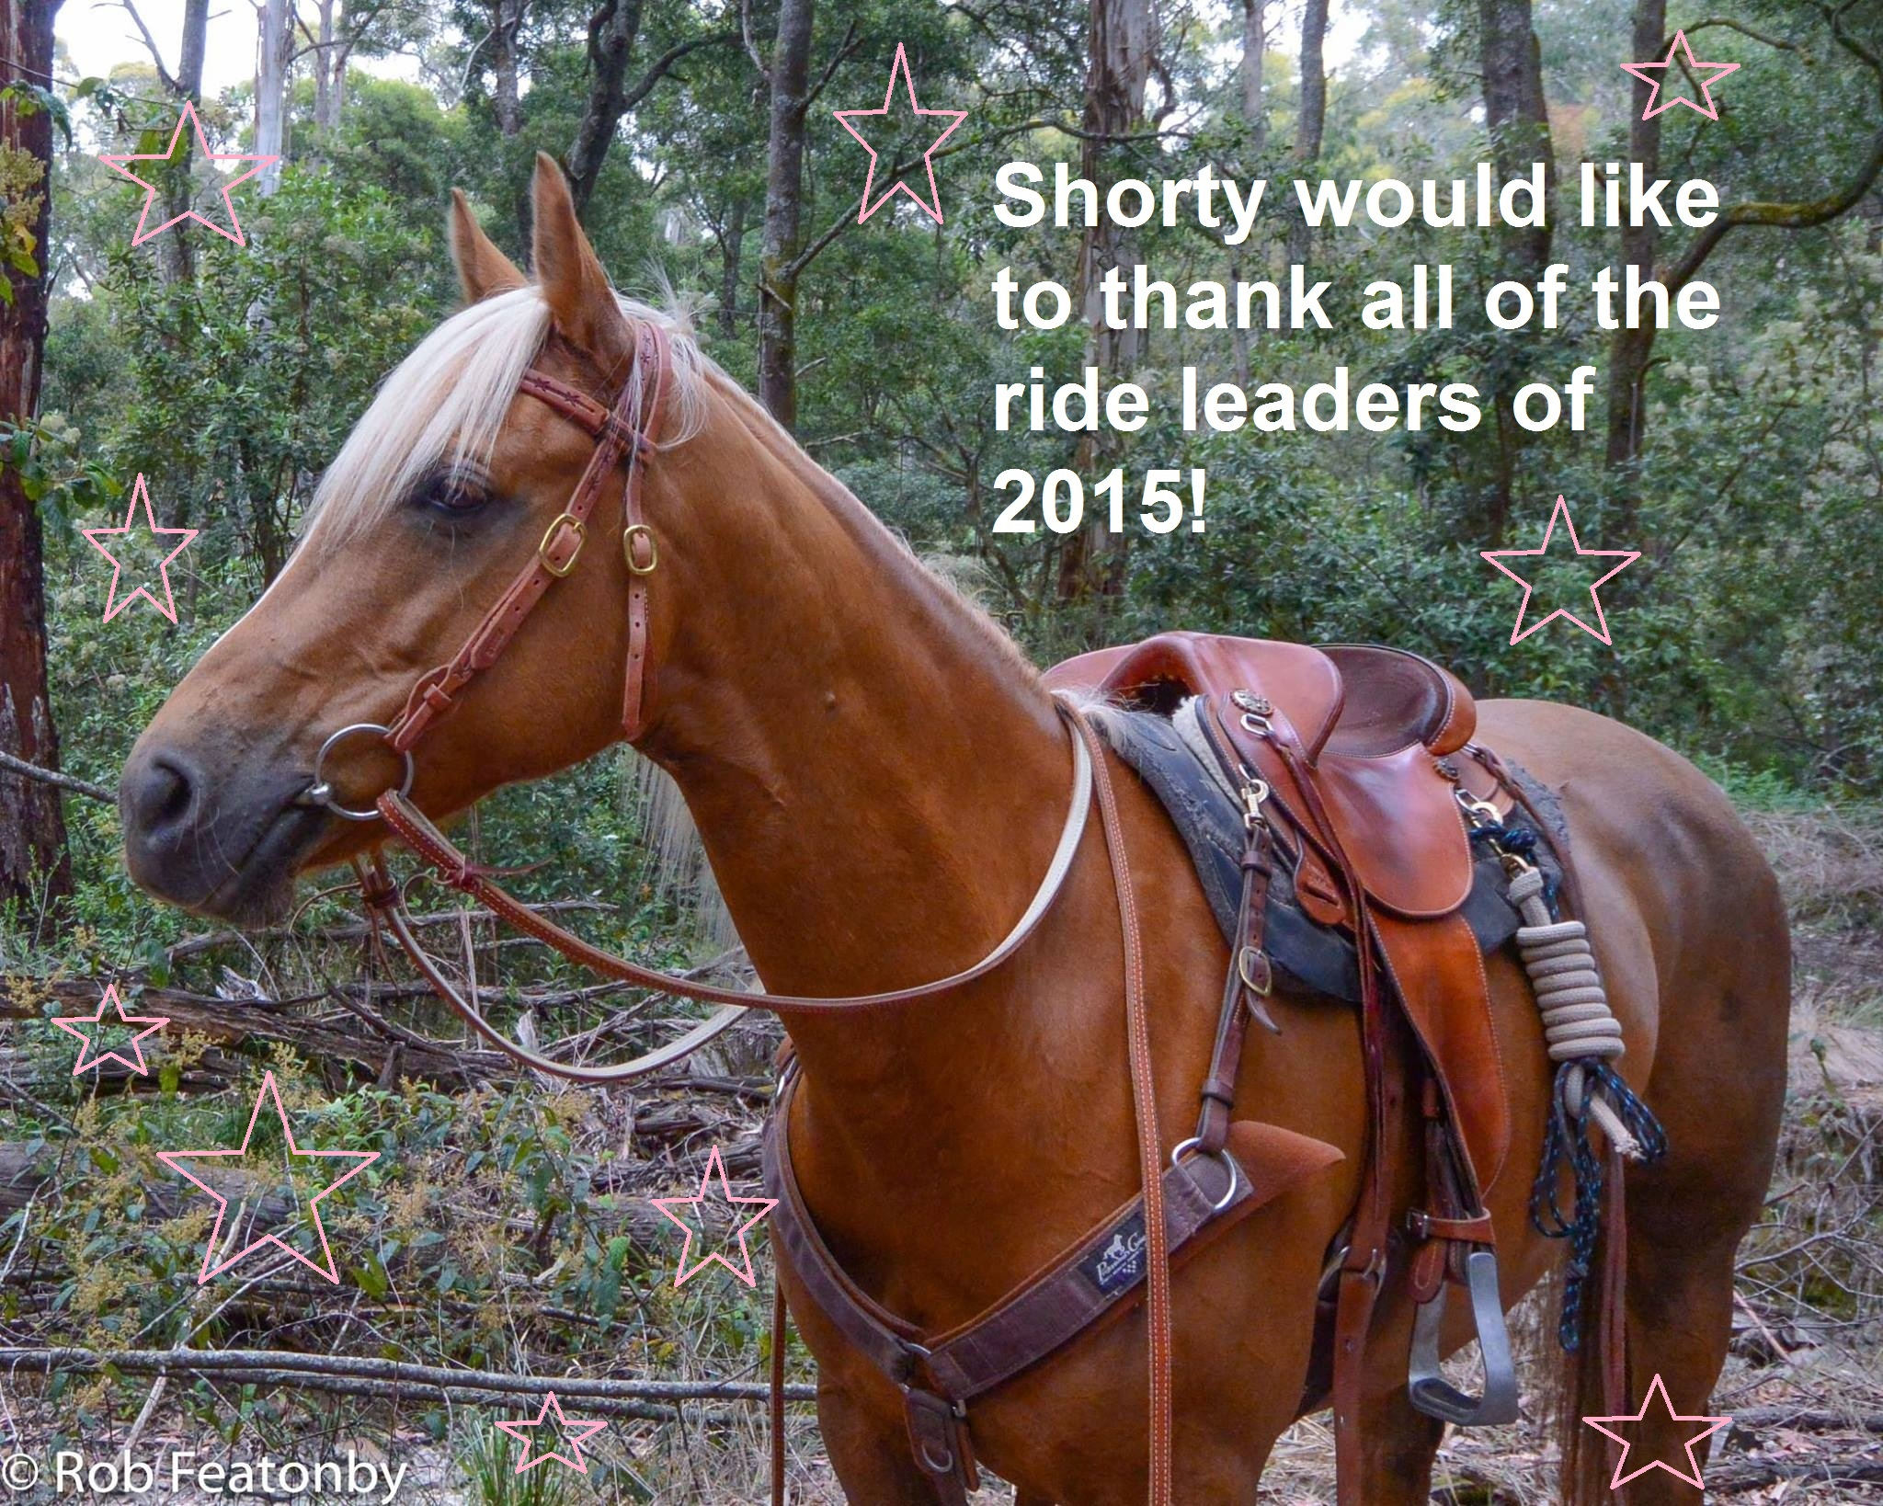

Shorty was looking particularly stunning in her new bridle on the Newbury weekend! The cameras just couldn’t get enough of her. Just look at that beauty! Horsey Miss Universe here we come! I then however attacked the photo in Paint (yes Paint computer program still exists) in order to thank all of those who led rides in 2015. WE WOULD NOT HAVE A CLUB WITHOUT YOU!

**FOR SALE**

We have bargain basement prices on our lovely **KDTRC jumpers** for only **$10 each!** We have size M and L available. Have I convinced you yet? These can be purchased at any of our rides or ordered through Amy G. We also have available, **blue KDTRC ‘trucker’ style caps for $5!**

|  |  |  |
| --- | --- | --- |
|  |  |  |

Also for sale….are our **KDTRC** **club vests!** Fresh from the printers, these water resistant reversible vests are very warm and super practical for riding autumn through to spring. I currently have sizes M, L available however can order XS, S, M, L & XL if needed. We make orders in lots of 6 to keep the price down, and I already have requests from 2 people for smaller sizes (I am 6ft and fit in a S so the sizes run pretty large).

**At a special members only price of $40...they are a bargain!**

|  |  |
| --- | --- |
|  |  |

**Are you interested in a KDTRC Polo shirt for summer?!?!?**

Summer is just around the corner, so I have had a look around and found some really nice navy blue polo shirts with white piping from JBs Work Wear that we have can have embroided if members are interested. Please let me know if you if you’d like one and I will put in an order.