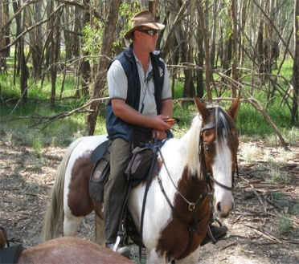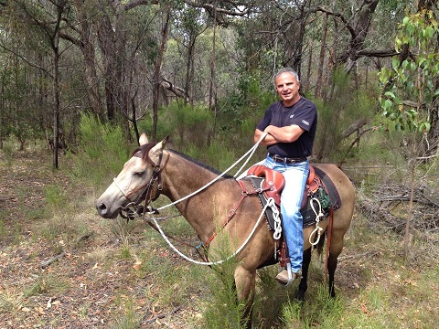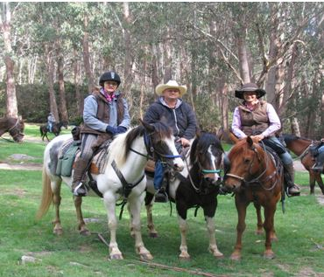

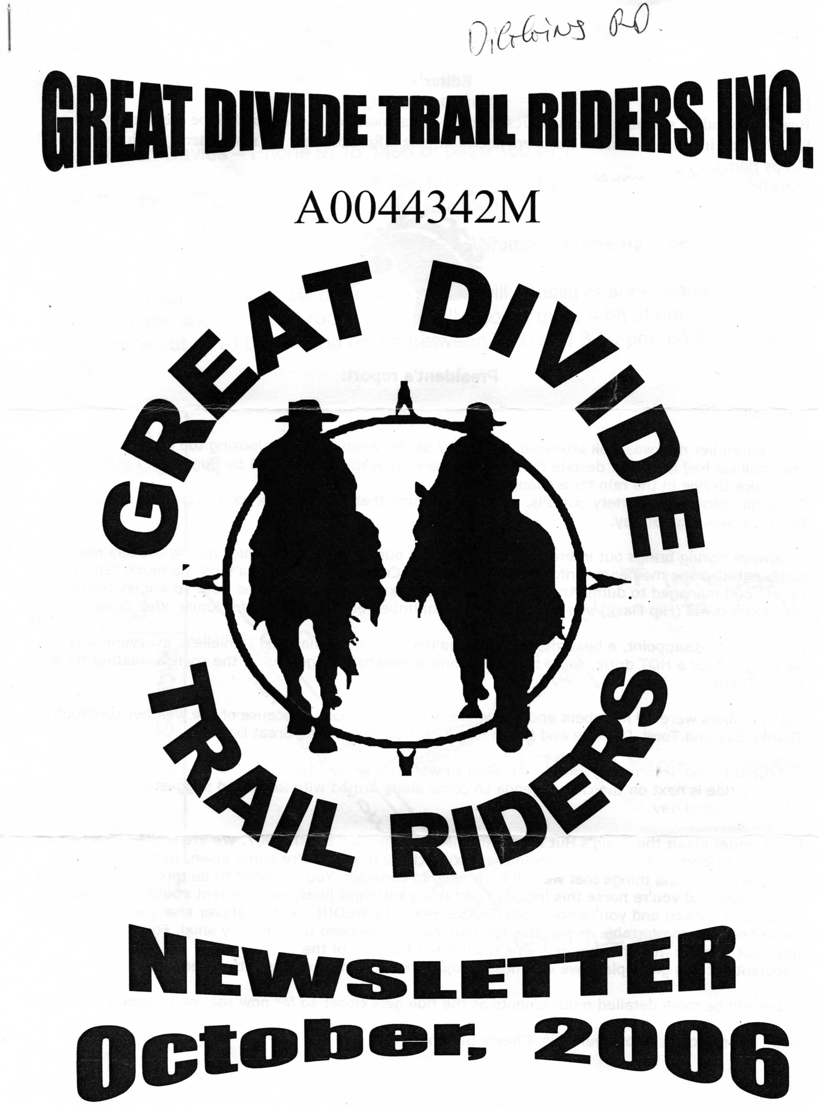

Newsletter

May 2014

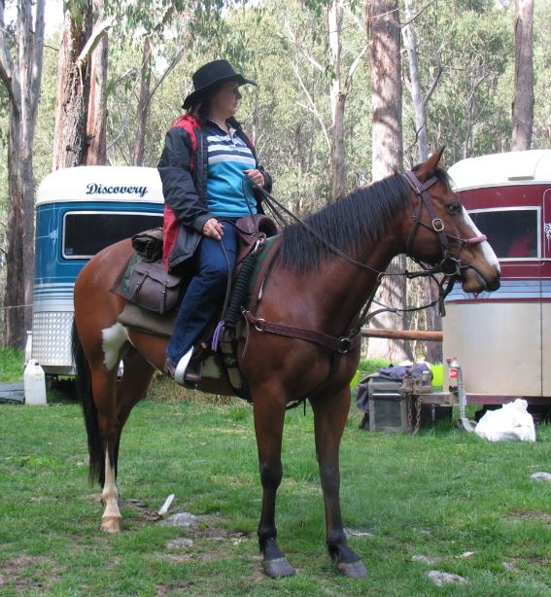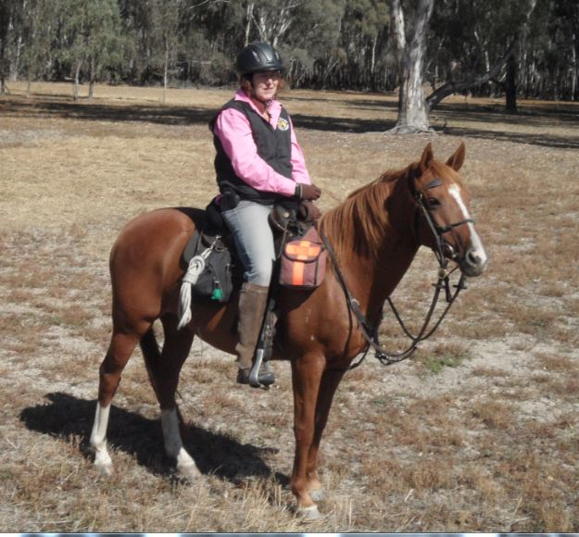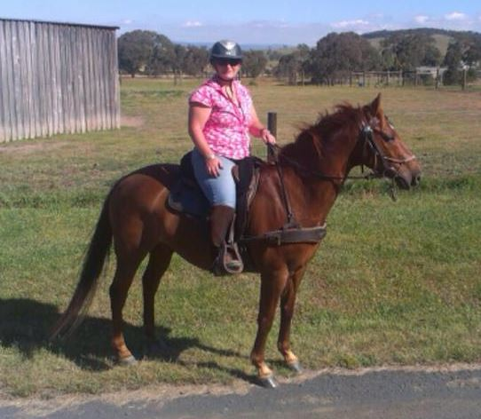

Compiled by Chris Kujus christine.kujus@bigpond.com Mobile 0407 316 711

President Report

G’day all, hope everyone is well. The colder weather is certainly upon us reminding us that Winter is on it’s way. It’s great to have some good rainfall and water in the tanks.

April has been a busy month for us with Corryong, working bees at Healsville in preparation for the Healesville ride and also “Ride for Madi” in 2015 and Easter at Frys Hut. Not much getting done around the house. Never mind!!!!!

Hope people are going to get behind the Barmah Rally for the brumbies coming up on the 4th May, remember they have provided most of us much delight over the years as Barmah is one of GDTR’s favourite places to camp and ride.

There could be possible be an accreditation session in Bendigo in August/September this year. If there is anyone that would be interested in attending please contact me.

Our weekend at Fry’s Hut was a great success. We had a great chat with the local Parks Rangers who followed up with me after the weekend they commended our club for the way we conducted ourselves and respected the environment and also the rules and regulations that are in place. This makes applying for permits to ride in these areas much easier when you have forged good relationships with Parks. Well done everyone.

Anzac weekend at Healesville ( Nikki and Daves) was again a huge success. Great numbers, great rides. Beautiful Hot Showers!!!!!! The best Toilet and Shower facilities ever! Thanks again for all your effort!

Just for your information, it was found that Robinia Trees leaves are highly toxic to horses. Be mindful of the trees around you when you are setting up yards etc. We were lucky that both Buddy and Cooper were not seriously ill and a good lesson was learnt by us all.

The meeting went well and was well attended. The age limit is now officially been reduced to 8 years of age. Thankyou to all that attended and remained after the ride.

Looking forward to Don Todd’s ride at the end of the month at Clonbinane.

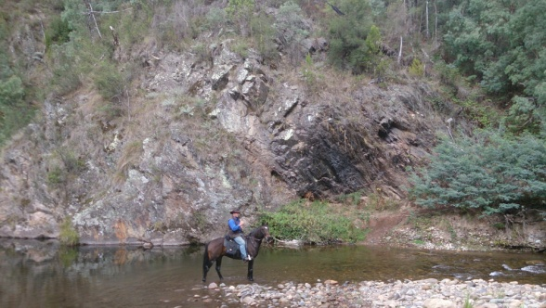Thanks to the committee and members for their enthusiasm and efforts so far this year. And again a huge congratulations to Glen and Kim Spalding on their nuptials last month.

See ya on the trail

Simon

**Secretary Report**

A big thank you to Nikki, Dave and their friends for a fantastic weekend of riding, fun and lots of laughs. It was Glen and my first time there and we loved it so much we will definitely be back.

As per the minutes the Alteration of Rule number 5 Classes of Members (2) Junior Members was voted on at the meeting. In essence it means that members have voted in favour of changing the rule of the minimum age of junior members from 12 yrs to 8 yrs it will need to be sent into Consumer Affairs for acceptance, so until they approve it our rules will need to remain as is.

There may be some mid-month rides coming up so keep a look out in the newsletters and if you have anything you wish to share with other members let Chris Kujus know and she will post it for you.

Kim Spalding

GDTRC Secretary

**Hi All**

* **Gee whizz April has been a busy busy month. A few of us caught up at the Man From Snowy River Bushamns Festival at Corryong, then we were off to Fry’s Hut for Easter, then we came home and we were off to Dave & Nikki’s ride at Healesville. The month has just flown by.**
* **Fry’s Hut Easter Ride was great – lovely scenery & lots of river crossings. The weather was ‘nippy’ but kind to us. We only had a bit of light rain on the Friday afternoon.**
* **Healesville Ride – I only attended the Saturday ride because I was getting over a bout of tonsillitis, so there was no way I was going to camp in a cold float !!  
  I rocked up about 8.30am on Saturday to a lot of hungover & very tired people. A few softies stayed back, but majority soldiered on and we headed out. Unfortunately the rain set in and we came back to camp around 2pm. Refer the ride report attached for the whole weekend…**
* **The general meeting was conducted on Saturday, incorporated after the Healesville Ride.**

**Meeting Minutes will be emailed out once typed out & completed by Kim Fawcus. The age limit of the Club has been agreed upon to be lifted from 12 years to 8 years.**

* **Don’t forget there is a dinner to handover the cheque, for the monies raised on the Ride For Madi on Friday May 23 at the Seymour Club. Monies for the dinner must be paid no later than Thursday May 15. Refer attached details….**
* **Our next Club ride is on Sunday May 25 at Clonbinane. Host is Don Todd. For those on Facebook the ride notice is posted under files, for those that aren’t, ride notice attached.**
* **Facebook Page – please remember the club has a Facebook Page managed by myself. But you are all welcome to place Club Ride Photo’s on. It has all the upcoming Club ride details under events.**
* **A few of the members have purchased Muddy Creek Riding Coats. They are half the weight of your normal drizabone. They are very lightweight and cover you, your saddle and protect your horse also. I have attached a ‘snippet’ from their website. They are highly recommended. The cost is approx around $270 comes in their own bag, can be ordered online or over the phone.**

**Well until next month folks…..**

**  
Chris**

**RIDE CALENDAR  
2014**

|  |  |  |
| --- | --- | --- |
| **DATE** | **HOST** | **DESTINATION** |
| May 25 | Don Todd 5780 1594 | Clonbinane to Reedy Creek |
| June 7-9 **Queens BirthdayWeekend** | Dave Falzon 0402 083 502 | Barmah **(Weather Pending)** |
| June 29 | Kelly Palmateer 0488 540 330 | Glenaroua |
| July 27 | Jo Anderson 0408 532 332 | Lighthorse Park-Seymour |
| August 31 | Jeff Anderson 0434 185 426 | Strath Creek |
| September 27 (Saturday) | Pam McGuire 0431 618 111 Horry Micallef 0422 805 310 | Pyalong |
| October 26 | Chris Kujus 0407 316 711 | Pheasant Creek |
| Nov 1-4 **Cup Weekend** | Linda “Marshy” Bottom 0422 057 097 | Eldorado |
| November 29-30 XMAS PARTY C:\Users\Chris\AppData\Local\Microsoft\Windows\Temporary Internet Files\Content.IE5\959C716N\MC900439773[1].png |  | Yarrawonga |
| Dec 26-Jan 4, 2015 | Simon & Allison Mason 0418 526 960 | Snowy Mountains (Mt Kosciuszko NSW) |
| March 7-9, **2015** | Simon & Allison Mason 0418 526 960 | RIDE FOR MADI (Healesville) |

**If you would like to Host a ride, even though the ride calendar is full.   
PLEASE DO NOT HESITATE TO CONTACT ME – we will accept Mid Month Rides !!!  
Chris Kujus 0407 316 711**

**\*\*\*\*\*\*\*\*\*\*\*\*\*\*\*\*\*\*\*\*\*\*\*\*\*\*\*\*\*\*\*\*\*\*\*\*\*\*\*\*\*\*\*\*\*\*\*\*\*\*\*\*\*\*\*\*\*\*\*\*\*\*\*\*\*\*\*\*\*\*\*\*\*\*\*\*\*\*\*\*\*\*\*\*\*\*\*\*\*\***

**IMPORTANT NOTICE**: If extreme weather conditions are forecast for the day of a planned ride,   
it is your responsibility to phone the ride host and re-confirm that the ride is going ahead !!

 *www.****muddycreekraingear****.com.au/*‎

**

**GREAT DIVIDE TRAIL HORSE RIDING CLUB**CLONBINANE TO REEDY CREEK

Sunday May 25, 2014  
Neills Rd, Clonbinane (refer below directions)

Ride Out Time – 10am SHARP

PLEASE ENSURE HORSES ARE SADDLED UP BY 9.30am  
BYO Saddle Bag Lunch and Drink

Ride Leader – Don Todd – Phone 5780 1594

**Cost: $ Nil GDTRC Members  
 $ 5 ATHRA members (Non GDTRC members)   
 $ 30 Visitors / Non ATHRA Riders**

**Ride Description**

The riding terrain for this ride is quite steep and rocky so breastplates and cruppers are recommended. It will be best if horses are well shod because of the rocky terrain on some tracks.

We will be stopping for lunch at Reedy Creek, so saddle bag lunch & drink will be required, and should return back to floats around 3pm.

**DIRECTIONS:-**From Broadford-Wandong Road, turn 1st left into Spur Rd.  
Turn 1st right into Spur Rd again.  
Take 1st left into McDonalds Road  
Take 1st right into Taits Rd  
At end of Taits Rd, this turns into Neills Rd, turn left into Neills Rd.  
Club signs will be out.  
Park in paddock.

*Fry’s Hut- Easter Weekend 2014*

*Both Simon and I were looking forward to this weekend but also a little apprehensive as well. Our boys remained at home so it was quite a different feeling heading off leaving them behind for the 5 days ALONE!!!!!!*

*We got into Mansfield in the dark , turning off toward Sheepyard flat i was a little nervous as we havn’t driven into here in the dark before and also towing the goosey. I soon relaxed as it actually made it easier as you could see any oncoming traffic well in advance and it was also surprisingly quiet on the roads on the Thursday night.*

*Coming over into Fry’s Hut camp grounds it was lovely seeing the campfires burning. The early arrivers soon made their presence known and before we knew it we were set up, horses yarded and fed and we then positioned ourselves around the campfire for a few drinks before retiring fairly early.*

*Most of the crew were arriving on Friday, but it was decided that we would head out and explore a track Simon and I found whilst driving around one weekend. We were aiming for “Castle Rock”, not knowing exactly what we would find it was quite exciting setting off. The climb was quite a steep one and it seemed to go on for ages, but once up on top we rode along the top with 360degree views of the most beautiful scenery. What goes up must come down and down we went, for it seemed as long as we had climbed. No one minded as we came across what looked like a medieval castle made of very unusual rock formations. It made a great backdrop for photos.*

*We had our lunch and managed to get our wet weather gear on before the sprinkling rain started to fall. This didn’t dampen our spirits either, it just added to the uniqueness of it all.*

*Upon return it was nice to see most of the others had arrived. Marshy’s mum and Dad made a grand entrance with their new Caravan out on it’s maiden voyage.*

*Friday night was a big night with some of us still up to the wee hours of the morning.*

*Saturday we headed off to “Running Creek”, we crossed the Howqua river over 50 times, and at every crossing there was something special to look at and admire. It was a difficult ride due to the amount of crossings but the horses were amazing and we had no trouble negotiating the rocks and fast flowing water.*

*Lunch at Running Creek Camp grounds was lovely, our horses enjoyed the lush green mountain grasses as some of the crew gave some of the little kiddies a few pony rides in full Easter Spirit.*

*Heading back we came home via the high track which offered some beautiful views both up and down toward the river, it was just as lovely with even a school of fish being sighted swimming in one of the deeper ponds in the river.*

*On our return we were all just standing around grazing the horses when we had a very unplanned demonstration of horsemanship. As Lindy really wanted to lay down i gave her a cue and she laid down without hesitation. Simon and Tony then both began showing their skills with Buddy, Louie and Reba and before long all four horses were flaked out on the ground much to everyones delight. We even had other campers coming out with their camera’s. Felt like a celebrity i did !! haha.*

*Sunday morning the Easter Bunny had arrived. It was a nice surprise to find a bundle of eggs by everyone’s camp. Thankyou Easter Bunny, yummy chocolate for breakfast !!!!*

*Today we headed to Gardners Hut via the watercourse track which we loved, we had some great opportunities to move along a bit with some dodging and weaving providing some great riding opportunities. We had just sat down on the verandah when we heard an almighty crack, we all got up to see Tony running from the falling tree and Reba quietly standing under all the outstretched branches with a look of bemusment on her face. The boys were able to get the saddle off without a mark ( much toTony’s relief!!) and then lifted the tree off Reba and backed her out. She immediately began eating, not fussed by the commotion she had just caused.*

*Back in the saddle we headed for Tunnel Bend Historical site. A few game ones entered the old tunnel which goes underground for approx 100metres. We had to negotiated rocks, water and darkness but was well worth the effort.*

*We headed back to camp passing through all the camp grounds that are spread along the river.*

*Back to camp Dave had been busy cooking his famous “ Cowboy Stew” he had promised me this time that it wouldn’t burn our mouths.*

*A small group of us headed for a short fast ride to Tunnel Bend before dinner, just to see if Dave knew anyone. Sadly Not, i think Dave was a bit disappointed and we were surprised as Dave know’s alot of people!! LOL*

*Back again to camp and sat down to a lovely dinner with everyone. A quiet night around the campfire talking about the weekend and other rides we have had.*

*Healsville was the following ride and we couldn’t wait to get the short week over and done with so we could be once again in the saddle.*

*Thanks to Jeff and Simon for leading the rides. We all had a fantastic time*

*Cheers Al and Lindy*

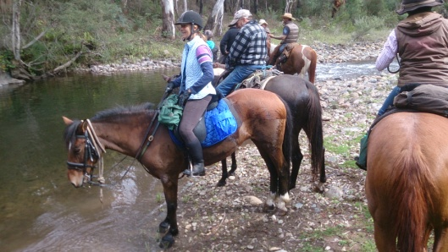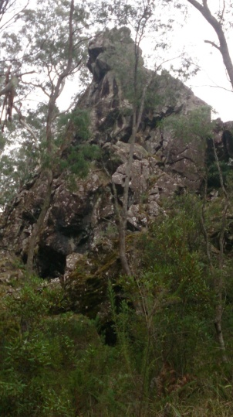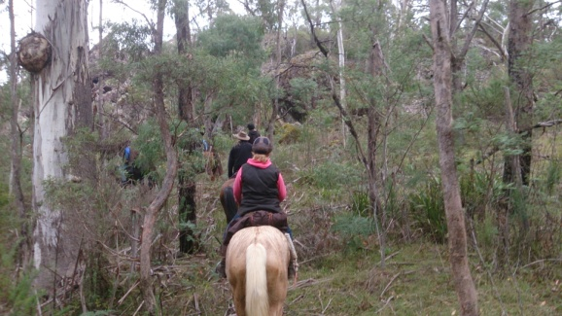

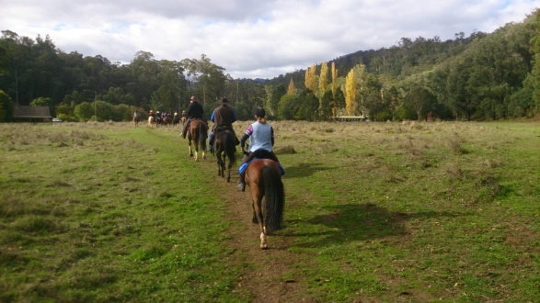

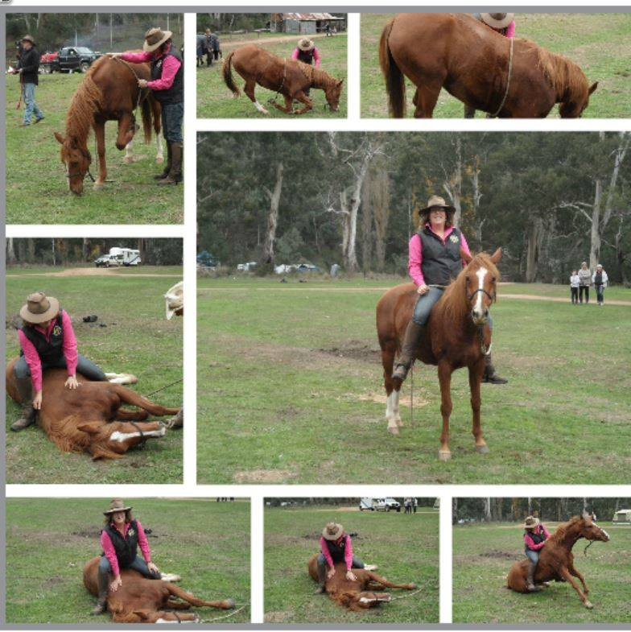

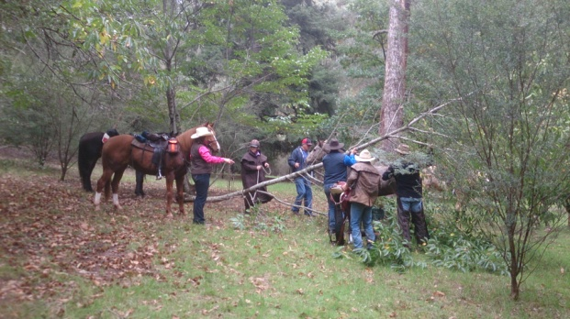

Cheers Al and Lindy

**Healsville Anzac Weekend Ride – April 2014**

Thursday night saw a big group of people around the fires and eating Dave’s stew. We awoke to a cold morning, some campers needing electric blankets (we wont mention these sooks names) , but the promise of a nice day with clear blue skies.

A dozen of us rode out for a short ride along the national trail then past the strawberry farms and back to camp. A few more had turned up so we had lunch and went out again for another short ride up the national trail, some sections of the trails filled with ferns and the smell of the bush amazing.

Even more had arrived back at camp which led to a fun filled night of music and dancing.

On Saturday after a cook up breakfast 35 riders headed out up the National trail we took one of the steep tracks, some horses stopping along the way to catch their breath. We kept riding until the weather started to close in, and instead of stopping for lunch we decided to turn back, luckily we only got the rain just as we were getting into camp.

We had a quick club meeting and it was great to have so many in attendance.

Another fun night with Gavin’s Boom Box complete with large video screen saw many up and dancing, thanks Gavin. Pam and Marshy were in charge of the jelly & easter egg cowboy shots which everyone enjoyed maybe some a little too much ☺.

Sundays ride was mostly on the downhill tracks and back through the strawberry farms with a return to camp for a bbq lunch.

Some memorable moments from the weekend include:

- Murphy in his jarmmies (Jo and Jeff’s dog)

- Jeff Jackson losing his wrestle with Marshy

- Dave F showing the Irish visitors how to fit as many in a swag as possible

- Gavin’s bush disco/theatre on Sat night

- Dave & Nikki’s hospitality which as usual was amazing!!

- Luxury shower and toilet blocks – thanks so much to all those that helped build these in such a short time frame.

Approx. 50 of us had a fantastic weekend in Healesville and we look forward to the next time! Thanks to Dave and Nikki and everyone else that helped make this weekend possible.

Cheers

Marshy

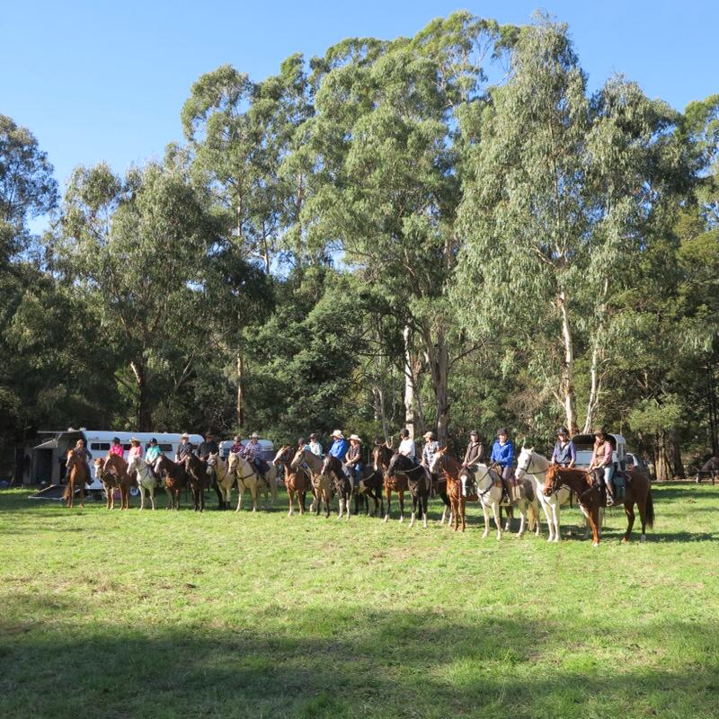

**FOR SALE**

QUARTERHORSE GELDING 13YO (5/11/00) 14.3hh - Freddy is a loving gentle man. He is a sensational allrounder, will do anything to please. He is very hardy, low maintenance. He has done heaps of trail riding and weekend camping trips away. He is good in company, can be a bit 'looky' on his own, but just give him a bit of encouragement and he mosies on his way.

He is fantastic in traffic, nothing phases him, great with motorbikes, dogs etc

Has western pleasure, clinic & ARC experience. He is easy to catch, shoe, rug, wash, worm & float. He is up to date with his worming, teeth & vaccinations.

He is a registered QH with the AQHA. Registered Name "Frecklefex" Currently on the "Horse Back Riding Program" with the AQHA. Has great bloodlines.

Suit intermediate rider.

$5000

Chris 0407 316 711

Based in Kinglake region



**FLOAT FOR SALE**

Ranger extended double float for sale.

Re-furbished, 10’6” in length.

Complete with tack box, storm doors, good wheels & tyres, new brakes (Hydraulic).

$7,500 ono

Call Joe on 0417 016 079

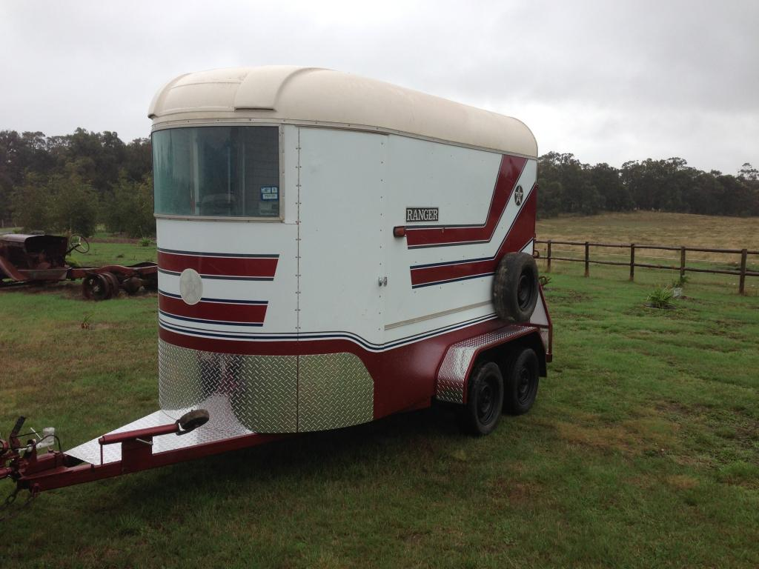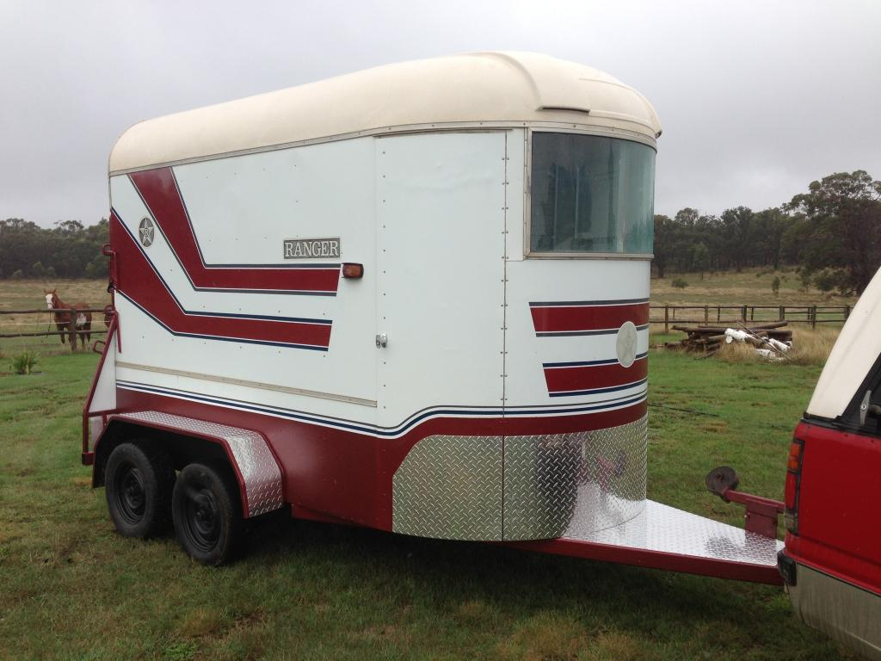

**Club Classfieds**

If you have something to sell or advertise, contact me [christine.kujus@bigpond.com](mailto:christine.kujus@bigpond.com)  
All ads must be in before the 27th of the month.



|  |
| --- |
| **Septic Services** We specialize in Septic Tank Locating & Cleaning Treatment Plants Grease Traps Phone for a no obligation free quote Sean Kujus **0421 764 072** |

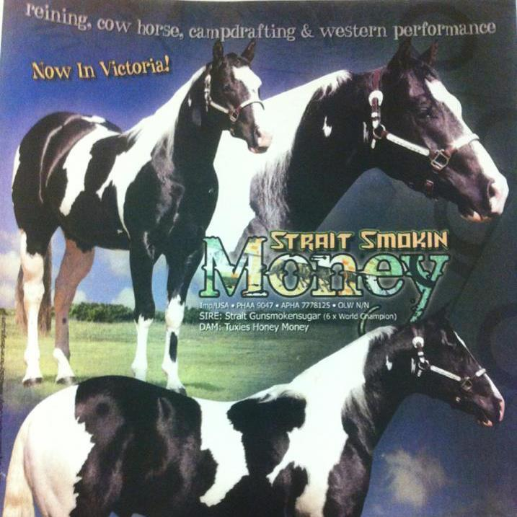  
 **STRAIT SMOKIN MONEY**  
 Service Fee $1000 all inclusive  
 Call Dave 0402 083 502

**GDTRC COMMITTEE  
2014**

* President Simon Mason 0418 526 960
* Vice President Tony Maiolo 0418 324 360
* Secretary Kim Spalding 0400 278 555
* Assistant Secretary Allison Mason 0408 554 480
* Treasurer Lisa Hurley 0437 035 758
* Newsletter Editor Chris Kujus 0407 316 711
* Website & New  
  Member Enquiries Linda Bottom 0422 057 097
* Committee Jeff Anderson

Cheryl Palmateer

Kelly Palmateer

Pam MacGuire

Horry Micallef  
 Dave Falzon

Nikki Hearne

Don Todd

G.D.T.R

Would Like To Acknowledge & Thank Our Sponsors

__________________________________________________________________________________________

Horseland Greensborough Phone- 9435 7544



_____________________________________________________________________________________________________

**SOUTHSIDE STOCK FEEDS**

106A Powlett Street  
Kilmore

Phone 5782 2866

**OPEN**

9am-6pm Mon-Fri

9am-2pm Saturday  
10am-2pm Sunday

_____________________________________________________________________________________________________

[](http://www.google.com.au/url?sa=i&rct=j&q=&esrc=s&frm=1&source=images&cd=&cad=rja&docid=rCeXe4SK8jJM5M&tbnid=Lid_KewaeILElM:&ved=0CAUQjRw&url=http://www.thinline.net.au/#!dealers/c18ru&ei=ZfdVUvbMEcWnkgWcz4DIAw&psig=AFQjCNEWdgEBkgnt6pgfHTfDgk0UORCfBg&ust=1381452002767321)

**125 Northern Hwy  
Kilmore  
Phone – 5781 0901**

**www.highlandsaddlery.com.au**

**_____________________________________________________________________________________________________**



**GREAT DIVIDE TRAIL HORSE RIDING CLUB**

**Club Rules**

* **NO STALLIONS allowed on rides at any time.**
* **Horses are to be reasonably fit, with feet adequately conditioned and / or shod.**
* **Breastplates and cruppers are recommended.**
* **Riders under 18yrs of age are required to wear and approved riding helmet.**
* **Riders under 16yrs must be under supervision of an adult.**
* **Horses known to kick must wear a red ribbon in their tail / or supplied stickers on their rump.**
* **Dogs are not permitted on the rides and must be kept securely on a lead around the float parking area.**
* **Drinking alcohol whilst mounted is strictly forbidden.**
* **ALL RIDERS must adhere to the GDTR rules which incorporate the ATHRA Code of Conduct.**
* **Permission must be obtained to ride in front of the Trail Boss or behind the Drag Boss.**
* **The trail must not be left without permission of a ride official at any time.**
* **Keep left to the roads.**
* **The trail must not be littered (this includes cigarette butts.) What you take with you must be bought back with you.**
* **GDTR recommends that ALL riders have current Ambulance cover.**
* **All riders must be mindful of other riders at all times.**
* **All gates must be left as they are found. Keep to the tracks as defined. Respect private property.**
* **All members are expected to abide by the club constitution, which is available on request.**