|  |  |  |  |  |
| --- | --- | --- | --- | --- |
|  |  | |  | |
|  | | DSCN0737a.JPG | | **TINDERRY TRAIL HORSE RIDERS**  **NEWS**  **APRIL 2016** |

**FEBRUARY RIDE**

The club’s first ride of 2016 was at Michelago on 6 Feb led by Don Munns. The hilly bush country at the foot hills of the Tinderry Mountain Range is great riding with so many different tracks that each ride is never the same. Lots of timber, gullies and creeks to negotiate made for interesting and skilful riding.   
 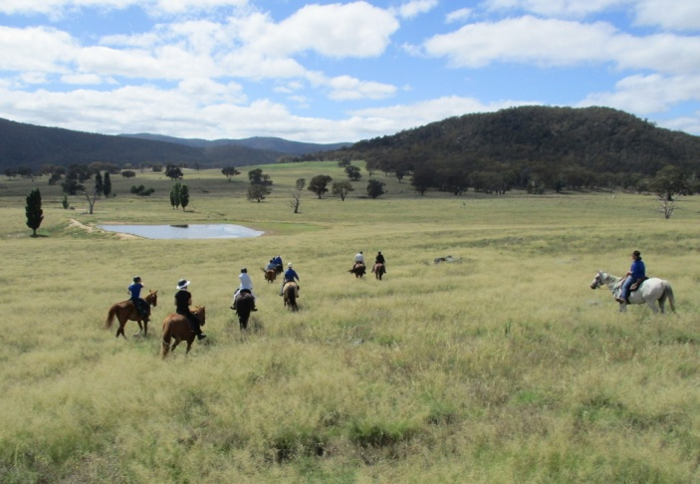 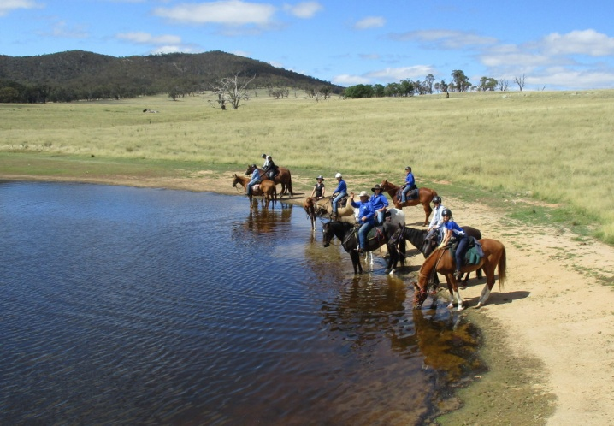

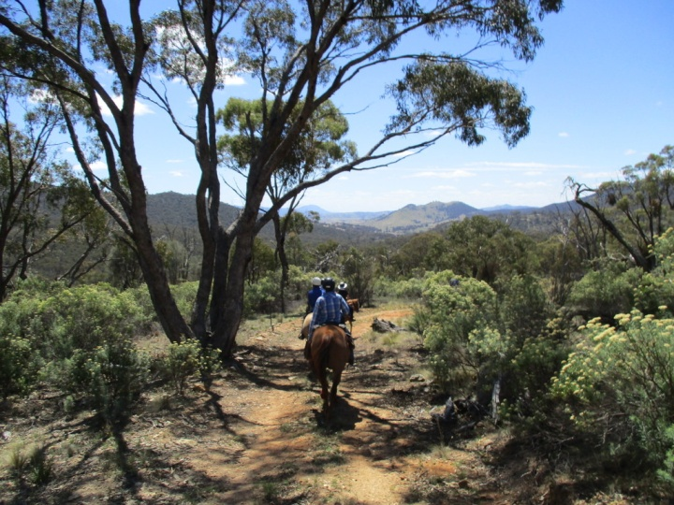 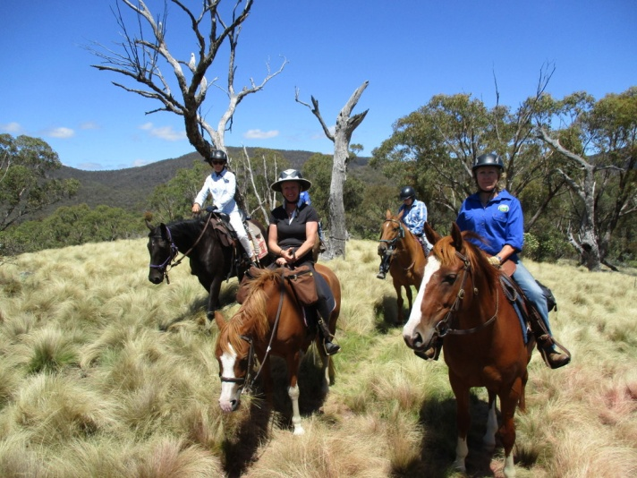

**MARCH 2016**

The club camp at Cooinbil) in Kosciusko NP was attended by 6 riders and very enjoyable. In spite of predictions of showers, we had beautiful weather. On Saturday we rode to Blue Waterholes, via Harris’ Hut using brumby paths and a little bush-bashing, returning via historic Coolamine Homestead and Coolamine Mountain. A chestnut brumby weanling, abandoned by his mob, at the Blue Waterholes campsite was pleased to have our horses company for lunch, but opted to stay with the campers instead of following us home. He was a sad little fellow, very quiet and shy. On Sunday a smaller group rode to Hainsworth Hut.

Trail-riding country doesn’t get much better than Kosciuszko NP.

Here are some photos. Thanks to the contributors.

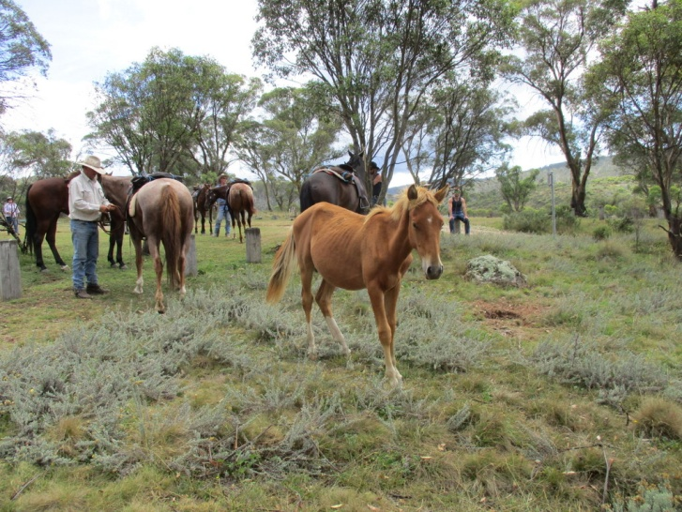 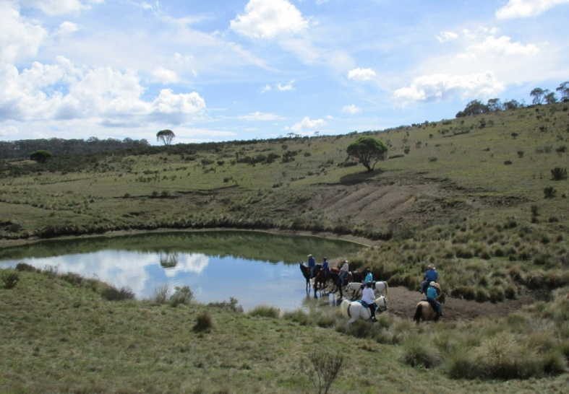

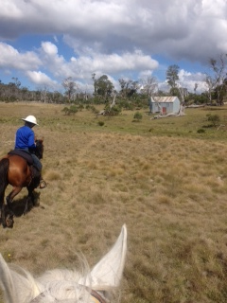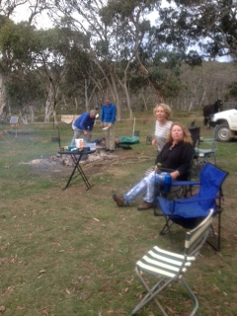

**UPCOMING RIDES**

2 April: Tinderry club Day ride on Booroomba Station Tharwa ACT

10 April: Monaro Horse Trekkers day ride in Tallaganda Forest. Contact Hilary [higunn@gmail.com](mailto:higunn@gmail.com) to attend

7 May: Tinderry day ride at Bredbo. Contact Don [ducka223@gmail.com](mailto:ducka223@gmail.com) to attend

29 May: Monaro Horse Trekkers weekend at Wingello. Contact ASAP Helen Locke [hlocke76@hotmail.com](mailto:hlocke76@hotmail.com) to book

4 June: Tinderry club ride around Red Hill ACT.

**CLUB SHIRTS**

Don’t our blue club shirts look terrific! Very comfortable to wear. Please contact Sandy [sandywynn@iinet.net.au](mailto:sandywynn@iinet.net.au) if you want to order one. Hilary has a club polo shirt to fit a small woman size 8-10 never used (too tight for me) if someone would like to buy. SMS 0407901328 if you would like it.

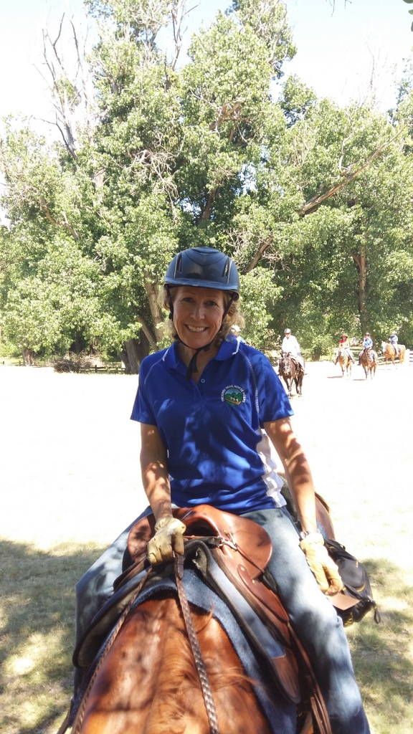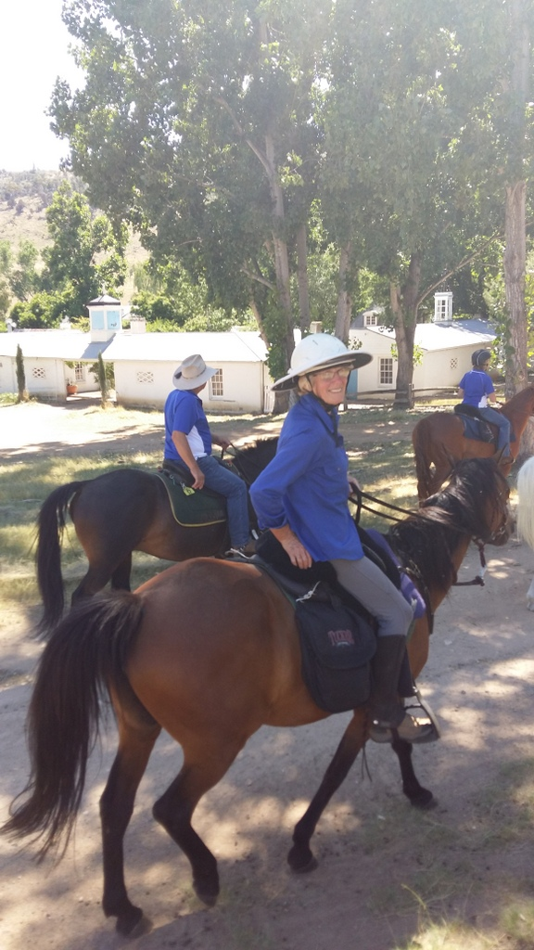

Some more photos from our 2015 Xmas ride

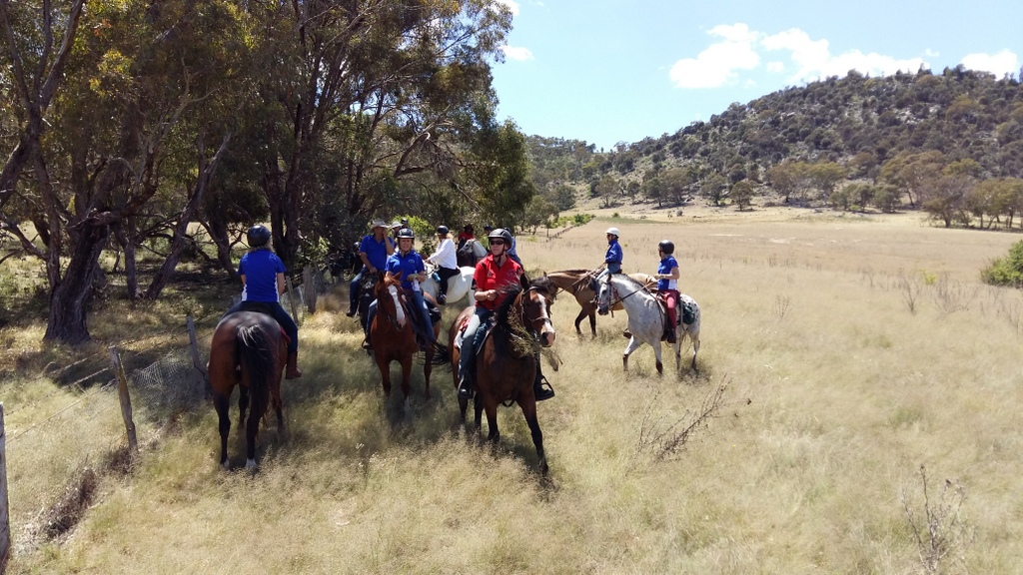

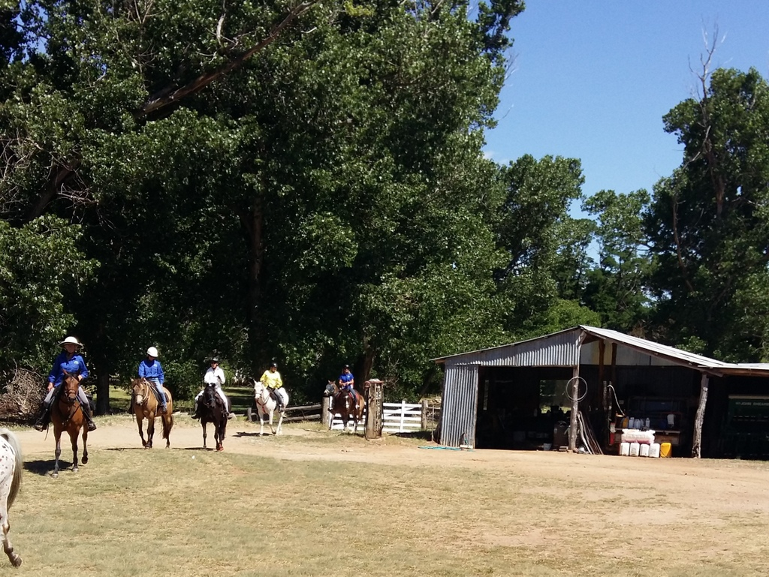

Till next time – HAPPY TRAILS from Hilary