**TAMWORTH BUSHRANGERS TRAIL RIDING CLUB**

Newsletter – MAY 2018

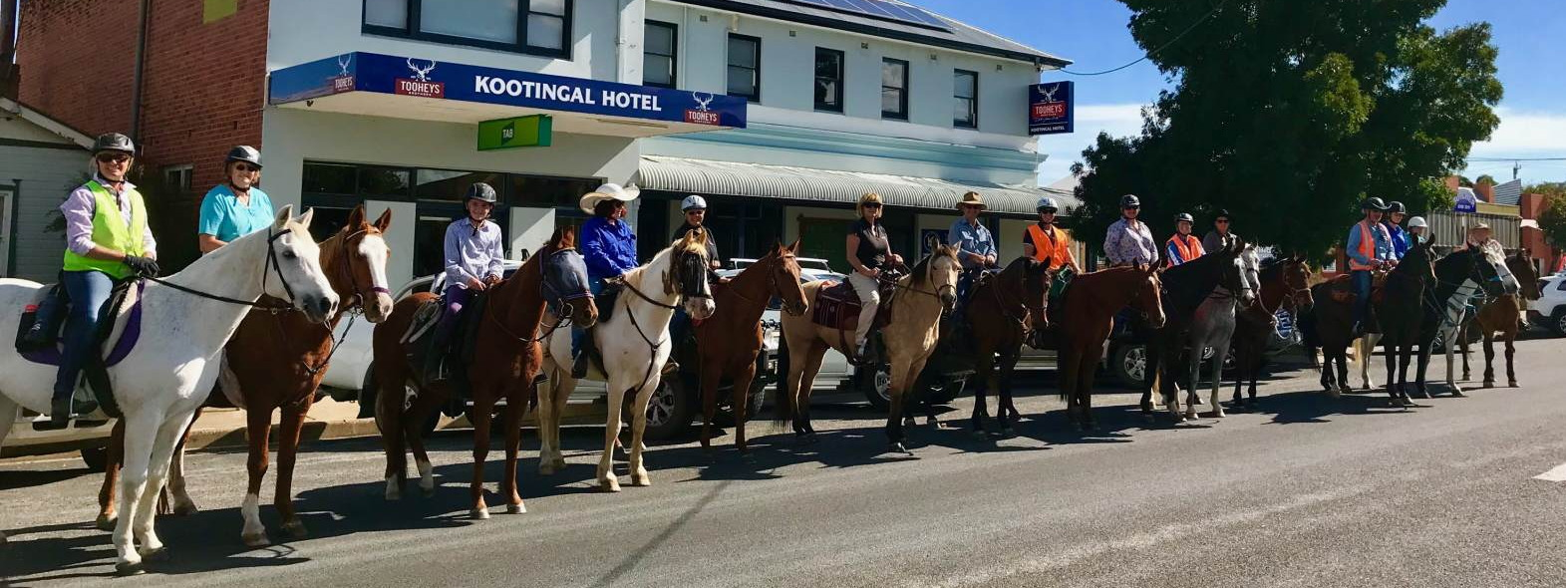

|  |  |
| --- | --- |
|  | *President:* Angela Witherdin  0418234854  [awitherd@bigpond.net.au](mailto:awitherd@bigpond.net.au)  *Vice President:* Bev Fletcher  *Secretary:* Francie MacLean  0407660334  *Treasurer:* Anthony Read  0409362434/67665448 |

|  |
| --- |
| *REMINDER TO* ***ALL*** *ACCREDITED TRAIL BOSSES ……*  Don’t forget to volunteer on our Monthly Rides to help with the smooth running of the ride as either Trial Boss, Ride Co-ordinator, Lead Rider, Drag Rider or Ride Steward – holding a positon will assist your reaccreditation without having to attend another Trail Boss course. |

**STOP PRESS**: ***Bushrangers Meeting***

The next Meeting of the Tamworth Bushrangers Trail Riding Club will be held:

Date: Wednesday 20th June 2018

Venue: Tamworth Hotel *# Note change #*

Time: 7pm meeting start - join us from 6pm for dinner before the meeting

Please let us know if you will be an apology

***BUSHRANGERS OUT AND ABOUT …..***

***Nothing in my Mail Box this month …… so no horsey news on members activities apart from on our***

***Club Day ……… so, don’t forget so if you see something interesting or are involved in other horsey events or attend a ride at another club send a note to*** [barlowpark2@gmail.com](mailto:barlowpark2@gmail.com) ***to be included in the*** ***Newsletter – and don’t forget the ‘selfies’***

***Bushrangers Ride Report May 2018***

***Venue: Somerton***

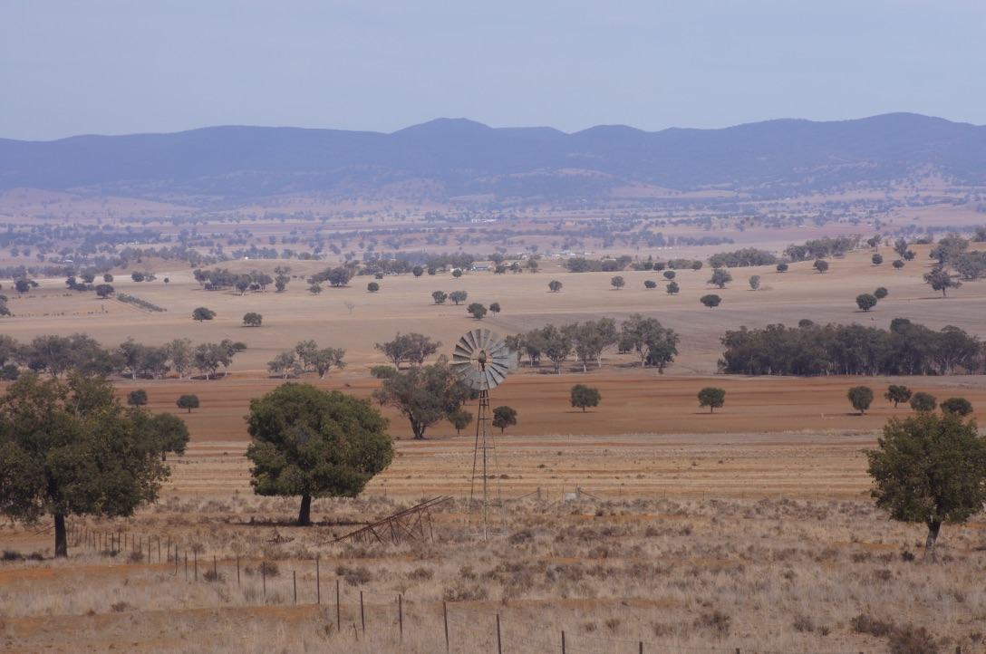

14 riders headed off on a delightful warm and sunny Autumn morning, riding firstly about a kilometre along a quiet country road where we entered a property. Riding past a deserted house hidden in some

|  |  |
| --- | --- |
| trees (a renovators delight!!). Unfortunately, one of our members lovely pony was feeling sprightly and had a ‘pigroot’ landing his owner in the dirt. Quickly on the case was nurses Ange and Helen who quickly and efficiently accessed and treated rider for a suspected broken wrist. Mike (Chuck Wagon, What Would We Do Without Him) Woods was called and took her off to the hospital while her friend and offsiders to help led her pony back to the floats, where she loaded up and took him home. | /Users/angelawitherdin/Pictures/Photos Library.photoslibrary/resources/proxies/derivatives/10/00/1011/UNADJUSTEDNONRAW_thumb_1011.jpg |

The ride continued and the group rode through a lovely but oh so very dry property, up and down dale with a view to Lake Keepit but alas no water to see. The owners of the property were even cutting Kurrajong trees down to feed their cattle and sheep.

|  |  |
| --- | --- |
| /Users/angelawitherdin/Pictures/Photos Library.photoslibrary/resources/proxies/derivatives/10/00/1010/UNADJUSTEDNONRAW_thumb_1010.jpg | /Users/angelawitherdin/Pictures/Photos Library.photoslibrary/resources/proxies/derivatives/10/00/1030/UNADJUSTEDNONRAW_thumb_1030.jpg |

Back at the floats horses fed and watered we were then treated to a delicious barbecue lunch organised by Ange and catered by Helen and expertly cooked by Mike and Col. Thank you guys!!!. Thanks to Alison for the use of her barbie on the side of her gooseneck. Donna also joined us with her delightful granddaughter Annabelle. Thanks also to all who cooked those delicious cakes!!!

Everyone fed and sated, horses were loaded and off home. Thanks to all involved, a great ride, great friends, great time.

|  |  |  |
| --- | --- | --- |
| **/Users/angelawitherdin/Pictures/Photos Library.photoslibrary/resources/proxies/derivatives/10/00/1023/UNADJUSTEDNONRAW_thumb_1023.jpgRide Report by Dot** | /Users/angelawitherdin/Pictures/Photos Library.photoslibrary/resources/proxies/derivatives/10/00/102e/UNADJUSTEDNONRAW_thumb_102e.jpg | ../../../../Pictures/Photos%20Library.photoslibrary/resources/proxies/derivatives/10/00/1006/UNADJUSTEDNONRAW_thumb_1006.jpg |

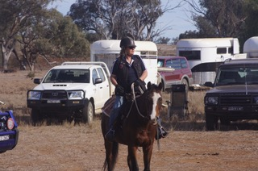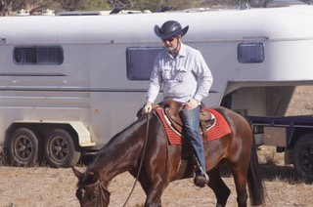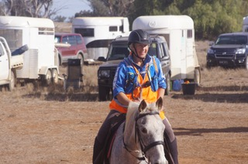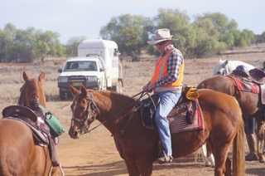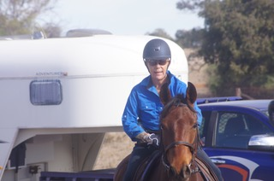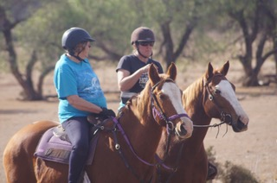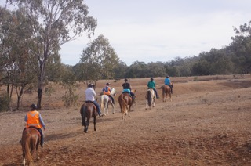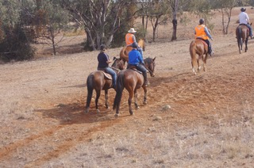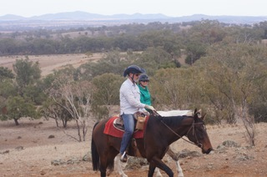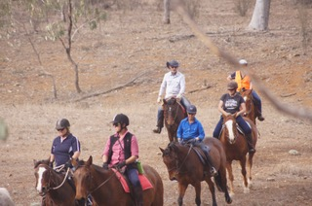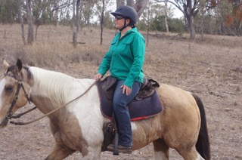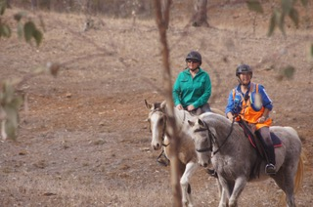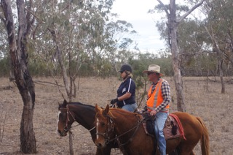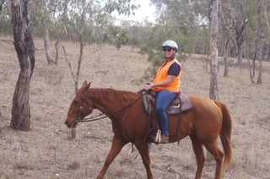

**Postscript from the Editor:**

Having just returned from a holiday to Kangaroo Island and Flinders Ranges in South Australia realised that we are not alone with these drought conditions …. Did not see one dam on KI with any water, relying entirely on bores (for those that are lucky enough to have one) and the logistics of feeding horses and other livestock is scary. No hay that was grown on the Island remains and everything now has to be bought to the Island by ferry – a very expensive exercise. Our feed prices don’t seem quite so bad by comparison.

**NB:** Looking for articles for next month’s Newsletter – if you have any horse feeding tips that may assist other members just jot them down and send in an email or anything else you think of.